**Technical Design Document**

CareConnect

University of Maryland Global Campus

SWEN 670 - Software Engineering Capstone

Dr. Mir Assadullah

August 3rd, 2025

Contributors: Diane Angeles, Torie Bias, Juan Gaucin Calderon, Fang Chen, Luke Curran, Ashenafi Grbreegziabhere, Alyssa Marielle Harding, Astha Malla-Paudel, Maria Ramirez, Edwenson Raphael, Dat Truong, Alex Vecchioni, Christian Yawn

**Revision History**

|  |  |  |  |
| --- | --- | --- | --- |
| **Date** | **Version** | **Description** | **Author** |
| 06/14/2025 | 1.0 | Initial Release | CareConnect Team |
| 07/26/2025 | 2.0 | Updates from feedback | CareConnect Team |
| 08/03/2025 | 3.0 | Updates from milestone 3 feedback | CareConnect Team |

**Sign-off Sheet**

|  |  |  |  |
| --- | --- | --- | --- |
| **Role** | **Name** | **Signature** | **Date** |
| Project Manager | Alireza Minagar |  |  |
| Team Lead | Alyssa Harding |  |  |
| Technical Lead/Architect | Edwenson Raphael |  |  |
| Technical Lead/Architect | Ashenafi Grbreegziabhere |  |  |
| Client | Dr. Mir Assadullah |  |  |

Table of Contents

1. Introduction 1

1.1 Purpose 1

1.2 Intended Audience 1

1.3 Project Documents 1

1.4 Acronyms, Definitions, and Abbreviations 2

1.5 References 2

2. System Overview 2

2.1 Summary 2

2.2 System Users and Stakeholders 3

2.3 System Features and Capabilities 3

2.4 System Architecture Overview 4

2.5 System Architecture Design Rationale 5

2.6 In-scope and Out-of-Scope Features 6

3. Architecture 7

3.1 System Architecture Diagram 8

3.2 Architectural Components 9

4. Technology Stack 10

5. Functional Specifications 11

5.1 Onboarding & Authentication 11

5.1.1. User Registration 11

5.1.2. Login/Logout Flows 14

5.2 Dashboards 19

5.2.1. Caregiver Dashboard 19

5.2.2. Caregiver Action Items 20

5.2.3. Patient Action Items 22

5.2.4. Patient Dashboard 23

5.3 Scheduling and Notifications 26

5.3.1. Custom Task Scheduling 26

5.3.2. Reminder and Escalation Rules 27

5.4 Health Data Tracking 29

5.4.1. Insert a list of default common symptoms 29

5.4.2. Attach default symptoms 31

5.4.3. Add custom symptoms 32

5.4.4. Push symptom notification request 34

5.4.5. Answer symptom notification request 36

5.4.6. List the symptoms of the patient 37

5.4.7. Graph of symptoms 39

5.4.8. Alert Caregiver of symptoms 41

5.4.9. Insert common meal question 42

5.4.10. Add custom meal question and attach to patient 44

5.4.11. Log meal entry 45

5.4.12. Display the meal logs of a patient 47

5.4.13. Display mood trends vs medications/symptoms 49

5.4.14. Notify the caregiver of negative mood 50

5.5 AI Integration 52

5.5.1. AI Mood Detection/Facial tracking 52

5.5.2. Ask AI (AI Assistant for Healthcare) 54

5.6 Communication & Media 56

5.6.1. In-App Messaging 56

5.6.2. Audio and Video Calling 58

5.6.3. Emergency SOS Mode 61

5.6.4. Virtual Check-In Rounds 63

5.6.5. Telehealth Bridge 64

5.6.6. Voice-Activated Commands 66

5.7 Wearable Integration 68

5.8 Smart Home Integration and Monitoring 70

5.9 Gamification 72

5.10 User Roles & Management 77

5.10.1. Caregiver Profile 77

5.10.2. Patient Profile 78

5.10.3. Multi-Caregiver Support 79

5.10.4. Profile Linking 80

5.10.5. Access Control & Permissions 81

5.11 Social Networking 81

6. API Design Specification for CareConnect 87

6.1 Key Design Principles 87

6.2 APIs 88

6.2.1. Authentication & User Onboarding 88

6.2.2. User & Role Management 89

6.2.3. 2.3 Billing & Subscription 90

6.2.4. Scheduling & Notifications 90

6.2.5. Health Data Tracking (Symptoms, Meals, Moods) 91

6.2.6. Communication & Media 92

6.2.7. AI & Assistant Services 92

6.2.8. Telehealth Bridge 93

6.2.9. Analytics & Reporting 93

6.2.10. Wearables Integration 94

6.2.11. Gamification & Rewards 94

6.2.12. Security, Logging, Admin 94

6.3 Error Handling Format 95

6.4 API Versioning 95

6.5 Rate Limiting & Pagination 95

6.6 Security Standards 96

6.7 Compliance & Auditing 97

6.8 Tools & Integrations 97

6.9 OpenAPI Reference 97

7. Data Models 98

7.1 Scope 98

7.2 Conceptual Data Model 99

7.2.1. Key Entities 99

7.2.2. User: core identity (patients, caregivers, family, admins) 99

7.2.3. High-Level Relationships 99

7.3 Logical Data Model 100

7.4 Data Dictionary 103

7.4.1. User 103

7.4.2. Role 104

7.4.3. User Role 104

7.4.4. Patient Profile 104

7.4.5. Caregiver Profile 105

7.4.6. Caregiver Patient 105

7.4.7. Plan 106

7.4.8. Subscription 110

7.4.9. Payment Method 112

7.4.10. Payment 112

7.4.11. Task Template 113

7.4.12. Task 113

7.4.13. Notification 114

7.4.14. Symptom 114

7.4.15. Patient Symptom 115

7.4.16. Symptom Log 115

7.4.17. Meal Question 115

7.4.18. Patient Meal Question 116

7.4.19. Meal Entry 117

7.4.20. Mood Entry 117

7.4.21. Wearable Device 117

7.4.22. Wearable Metric 125

7.4.23. Message 125

7.4.24. Media File 125

7.4.25. Telehealth Session 126

7.4.26. Achievement 126

7.4.27. User Achievement 127

7.4.28. Location 127

7.5 Physical Data Model 128

7.5.1. Schemas & Convention 128

7.5.2. Enum Types 129

7.5.3. Table DDL 129

7.6 Physical Design Considerations 131

7.7 AWS MySQL Deployment 132

7.8 Security & Compliance 133

7.9 Backup & Recovery 134

8. UI/UX Design 136

8.1 Onboarding & Authentication 136

8.1.1. Welcome Screen 136

8.1.2. User Registration 140

8.1.3. Login/Logout Flows 141

8.1.4. Password Reset & Recovery (For all Users) 143

8.2 Billing & Subscription Management 145

8.2.1. Plan Definition & Pricing Tiers 145

8.2.2. Subscription Activation 145

8.2.3. Payment Methods & Failover 145

8.2.4. Billing Failure & Handling 146

8.3 User Roles & Management 146

8.3.1. Caregiver Profile 146

8.3.2. Patient Profile 148

8.3.3. Multi-Caregiver Support 149

8.3.4. Profile Linking 149

8.3.5. Access Control & Permissions 152

8.3.6. Family “Read-Only” Access 153

8.4 Dashboards 155

8.4.1. Caregiver Dashboard 155

8.4.2. Patient Dashboard 157

8.4.3. Patient Action Icons 159

8.4.4. Caregiver Action Icons 161

8.5 Scheduling & Notifications 163

8.5.1. Pre-Defined Care Templates 163

8.5.2. Custom Task Scheduling 165

8.5.3. Notification Channels 166

8.5.4. Reminder & Escalation Rules 167

8.5.5. Caregiver Shift & Scheduling 169

8.6 Health & Data Tracking 170

8.6.1. Patient Symptom Tracking 170

8.6.2. Meal & Nutrition Tracking 170

8.6.3. Mood & Wellness Tracking 171

8.7 AI Integration 171

8.7.1. AI Mood Detection 171

8.7.2. Ask AI 172

8.8 Communication & Media 173

8.8.1. In-App Messaging 173

8.8.2. Audio & Video Calls 175

8.8.3. Emergency SOS Mode 178

8.8.4. Virtual Check-In 179

8.8.5. Media Uploads 182

8.8.6. Voice-Activated Commands 183

8.8.7. Telehealth Bridge 185

8.9 Device Integration & Interactions 186

8.9.1. Wearables 186

8.9.2. Home Monitoring Integration 188

8.9.3. Medication Management 2.0 190

8.10 Gamification 192

8.10.1. Provide rewards to completed tasks 192

8.10.2. Daily motivation messages on dashboard 194

8.11 Social Networking 195

8.11.1. Connect with other users 195

8.11.2. Post Updates and Interact (Community Feed) 197

8.11.3. Chat with Connected Users 198

8.12 Analytics & Reporting 200

8.12.1. Dashboard metrics 200

8.12.2. Report Exports 200

8.12.3. Real-time vs. Batching 200

9. Security Considerations 201

9.1.1. Data Privacy & HIPAA Compliance 201

9.1.2. Authentication & Authorization 201

9.1.3. Secure Data Transmission 201

9.1.4. API Security 202

9.1.5. Data Storage & Backup 202

9.1.6. Mobile Application Security 202

9.1.7. AI-Powered Features 202

9.1.8. Emergency Response Features 202

9.1.9. Subscription Billing Security 203

9.1.10. Security Testing & Monitoring 203

10. Error Handling 203

11. Performance & Scalability 204

11.1.1. Objectives 204

11.1.2. Key Metrics 204

11.1.3. Scalability Strategy 204

11.1.4. Monitoring and Capacity Management 205

11.1.5. Bottleneck Mitigation 205

11.1.6. Review Cadence 205

12. Testing Strategy 205

13. Deployment Strategy 206

13.1 Deployment preparation 206

13.2 CI/CD Flows 207

13.2.1. Backend 207

13.2.2. Frontend 207

14. Known Issues & Limitations 208

# Introduction

## Purpose

The purpose of this document is to detail the technical design of the CareConnect application.

## Intended Audience

The audience for this Software Test Plan Document includes the Clients, Team Lead, Project Manager, Developers, Testers & Test Leaders, Business Analyst & Business Analyst Lead, Technical Lead/Architect, Lead UI/UX Designer, UI/UX Designer, MS Teams & GitHub Mentor, and Users.

## Project Documents

The Technical Design Document is just one artifact in a suite of documents comprising the software development life cycle for CareConnect. These documents contain important information regarding the project planning, implementation, testing, and more about the CareConnect product. A list of documents, their current versions, and delivery dates is provided in Table 1.

**Table 1**

*List of Project Documents for CareConnect*

|  |  |  |
| --- | --- | --- |
| Document | Version | Date |
| Project Plan | 1.0 | 05/31/2025 |
| Software Requirements Document | 1.0 | 05/31/2025 |
| Technical Design Document | 1.0 | 06/14/2025 |
| Software Test Plan | 1.0 | 06/14/2025 |
| Deployment and Operations Guide | 1.0 | TBD |
| Programmer Guide | 1.0 | TBD |
| User Guide | 1.0 | TBD |
| Test Report | 1.0 | TBD |

***Note***.Documents with date labeled TBD have not been delivered yet.

## Acronyms, Definitions, and Abbreviations

A list of the acronyms, definitions, and abbreviations used in this document is provided in Table 2.

**Table 2**

*Document Conventions*

## References

*CareConnect High Level Requirements* (n.d.). UMGC. [Care Connect High Level Requirements.docx](https://umgcdev361.sharepoint.com/:w:/r/sites/SWEN670Summer2025/Shared%20Documents/Joint%20Collab%20(Care%20Connect)/Care%20Connect%20High%20Level%20Requirements.docx?d=w8c0ab524c4fe42eb9ac877d4962b641d&csf=1&web=1&e=YRy6gv)

OpenAI. (2025). *ChatGPT (June 11 version)* [Large language model]. <https://chat.openai.com/>

Software Requirements Document (June 2025). UMGC. [SoftwareRequirementsDocument DRAFT.docx](https://umgcdev361.sharepoint.com/:w:/r/sites/SWEN670Summer2025/Shared%20Documents/Joint%20Collab%20(Care%20Connect)/Milestone%201/Project%20Plan%20%26%20SRS/SoftwareRequirementsDocument%20DRAFT.docx?d=wd28d3f38bb0d48dbba7e8d643bb501ae&csf=1&web=1&e=uEEbaS)

# System Overview

## Summary

The CareConnect system is designed to enhance the quality of care for patients by improving communication, scheduling, and adherence to health routines between patients and their designated caregivers. The application aims to bridge the gap between home-based care and remote health management through an intuitive, cross-platform mobile and web application.

CareConnect leverages Flutter for a unified user interface and integrates with a scalable, microservices-based backend hosted on AWS. The backend, composed of containerized Spring Boot services, manages data routing, care coordination, analytics, billing, and notifications. Payment handling is facilitated through integration with the Stripe API, enabling secure and flexible subscription management.

Supporting services include Amazon RDS, DynamoDB, Timestream, and S3, enabling efficient storage and retrieval of structured, semi-structured, and time-series data.

The system’s goal is to empower patients and caregivers with real-time insights, personalized dashboards, and actionable notifications that foster trust, engagement, and accountability within the caregiving relationship.

## System Users and Stakeholders

CareConnect has two primary user groups and multiple supporting stakeholders:

**Primary Users:**

* **Caregivers:** Includes both family members and professionals who assist patients with daily care. They can assign tasks, send messages, track health reports, and receive alerts or updates.
* **Patients:** Individuals receiving care. They can complete assigned tasks, view motivational content, track their progress, and request assistance.

**Secondary Stakeholders:**

* **Clients / Sponsors:** Provide product requirements, high-level vision, and critical feedback on project progress. Fund or endorse the project from a client-facing perspective.
* **Project Mentors:** Offer professional guidance, review deliverables upon request, and ensure the solution aligns with practical standards and user needs.
* **Class Project Manager:** Monitors and organizes project progress across all teams, acting as a liaison between project groups and the course professor.
* **Platform & Tools Mentor:** Maintains and manages MS Teams and GitHub infrastructure, schedules collaborative meetings, and ensures smooth technical coordination.
* **Product Manager, Team Leads & UI/UX Designers:** Ensure the user experience aligns with stakeholder expectations and usability goals. They help guide the product’s look and feel.
* **Development Team:** Software developers, testers, and analysts responsible for implementing, validating, and documenting the application.

## System Features and Capabilities

The CareConnect mobile application includes the following core modules and capabilities:

* **User Onboarding & Role-Based Access:**
  + Welcome screens tailored to patients or caregivers
  + Secure login and registration
  + Role-specific dashboard after login
* **Care Plan and Task Management:**
  + Caregivers can assign and schedule daily health task (e.g., medication, exercise)
  + Patients can view, complete, and mark tasks with timestamps
  + Push notifications for scheduled tasks via FCM/APNs
  + Task data is stored and managed via backend microservices and Amazon RDS
* **Gamification Elements:**
  + Users earn points for completing assigned tasks
  + Daily motivational messages displayed in user dashboard
  + Visual indicators of progress through badges, ranks, or levels
  + Gamification logic handled via analytic service and client logic
* **Secure Messaging & Communication:**
  + Private caregiver-patient chat functionality through the communication service
  + Emergency alert system interface for caregivers and patients
  + Virtual check-in scheduling and chat history access
  + Real-time message delivery handled via managed APIs and backend routing
* **Social Networking & Community Support:**
  + Optional group messaging for shared caregiving experiences
  + Ability to view public milestones and shared motivational posts
  + Peer-to-peer connection requests for trusted caregivers
* **Health Data Tracking:**
  + Patients can manually enter mood, symptoms, and routine health activities
  + Health vitals synced from wearable devices (e.g., Fitbit API)
  + Data visualizations (charts, trends) generated from stored time-series data
  + Health metrics stored in Amazon Timestream; log in DynamoDB
* **Data Storage and Sync:**
  + Structured and transactional data stored in Amazon RDS
  + Media notes and health metadata stored in Amazon DynamoDB
  + Vitals and time-series data tracked in Amazon Timestream
  + Media assets (e.g., reports, voice notes) stored in Amazon S3
  + All components communicate via API Gateway and Lambda services

## System Architecture Overview

CareConnect follows a client-server microservices architecture hosted on Amazon Web Services (AWS). The system separates front-end client, backend services, and data layers, following modern best practices for scalability, maintainability, and secure deployment.

* **Frontend:** Flutter is used as the cross-platform development framework for both mobile and web interfaces.
* **API Gateway & Routing:** Amazon API Gateway (REST + WebSocket) acts as the primary interface between the client and backend microservices. It handles request routing, authorization, and load distribution.
* **Backend Services:** Deployed on Lambda, a Spring Boot microservices, grouped by functional domain:
  + User Service: Handles user authentication, authorization, and profile management. Supports login, registration, password reset, and role-based access control for patients and caregivers
  + Billing Service: Manages subscription billing and payment processing through integration with Stripe. Supports secure transactions, invoice generation, and subscription tier management
  + Communication Service: Facilitates secure messaging between caregivers and patients. Includes Realtime chat, emergency notifications, and virtual check-in scheduling.
  + Scheduling Service: Manages care plan scheduling, task assignments, and reminder logic. Integrates with notification services to trigger alerts for scheduled tasks.
  + Analytic Service: Collects and processes usage data to support gamification, engagement metrics, and reporting features. Uses Amazon Timestream to store and query time-series activity data.
* **API-BFF (Backend-for-Frontend):** serves as the intermediary between frontend clients and microservices. Aggregates and formats data responses, ensuring optimized delivery to Flutter-based mobile and web interfaces.

## System Architecture Design Rationale

The architecture of CareConnect is designed to ensure scalability, modularity, and cross-platform compatibility while addressing the needs of diverse user roles in healthcare support context. The system adopts a microservices-based architecture hosted on AWS to ensure independent deployment, maintainability, and fault isolation for each functional component.

**Client-Server Model**

CareConnect follows a traditional client-server model, where mobile and web clients (developed using Flutter) interact with backend services via RESTful and WebSocket APIs. The architecture supports both synchronous HTTP communication and real-time features, such as chat and notifications, using WebSocket-based channels through Amazon API Gateway.

**Rationale for Key Technology Choices**

* **Flutter (Frontend Framework):** Selected for its ability to deliver high-quality, native performance across both Android, iOS, and web platforms using a single codebase. This choice reduces development effort and ensures consistent UI/UX across devices.
* **Spring Boot (Backend Framework):** Enables the development of lightweight, containerized microservices with built-in support for REST APIs, security, and data access layers. Chosen for its scalability, maturity, and developer familiarity within the team.
* **AWS Lambda:** A function as a Service, that is triggered on events to run to answer the requests from the user. It simplifies infrastructure by reducing the footprint an potentially the cost.
* **Amazon API Gateway:** Chosen as the entry point for client-server communication. It simplifies API management, enforces security policies, supports throttling and logging, and integrates seamlessly with AWS lambda and container backends.
* **Stripe (Billing):** Integrated for secure and scalable payment processing. Stripe was selected due to its developer-friendly APIs, support for subscriptions, and HIPAA-eligible compliance framework.
* **Amazon RDS, DynamoDB, and Timestream (Databases):**

The system uses a polyglot persistence strategy:

* **RDS** stores relational data such as user profiles and billing metadata.
* **DynamoDB** stores semi-structured data such as care tasks and messages.
* **Timestream** handles time-series data related to user activity, useful for analytics and gamification.

**Security and Compliance Considerations**

The architecture supports HIPAA-aligned data practices by:

* Using HTTPS across all communication layers
* Securing API endpoints with JWT-based authentication
* Implementing fine-grained access control via role-based authorization.

**Extensibility and Future Growth**

This architecture is modular and extensible, allowing future integration with:

* Wearable APIs (e.g., Fitbit, Apple Health)
* Machine learning modules for predictive health analytics

## In-scope and Out-of-Scope Features

**In-Scope Features:**

* Patient and Caregiver role selection and onboarding
* Secure login and role-based dashboard navigation
* Care task creation, scheduling, and completion tracking
* Push notifications for scheduled tasks
* Gamification basics: points and motivational messages
* Private messaging between caregivers and patients
* Health data manual entry (e.g., mood and symptoms)
* Initial data storage using Amazon RDS and DynamoDB
* Basic analytics visualization (e.g., completed task count)
* Frontend and backend integration via API Gateway
* Lambda function
* Integration with wearable APIs (Fitbit, Apple Health)

**Out-of-Scope Features:**

* Emergency alert systems
* Peer-to-peer caregiver support community
* Advanced analytics dashboards and ML-driven recommendations
* Full subscription billing integration with Stripe
* Group messaging and shared milestone posting
* Dynamic gamification features (levels, badges, ranks)
* Export or reporting features (PDF, CSV, data sharing)
* Role-based admin management or audit logs
* Offline functionality and local storage caching

# Architecture

CareConnect will handle a lot of sensitive personal information. Mainly the data will be health related, thus the system is required to be compliant with many regulations. We are also aiming to bring a level of robustness, elasticity, resiliency and security to the system. Therefore, we will take advantage of a Cloud Service Provider (CSP); our primary choice is Amazon Web Services (AWS). This CSP will help to spin up most of our underling infrastructure. We invite you to review the subsections below to gain a deeper understanding of the benefits outlined in this section.

## System Architecture Diagram

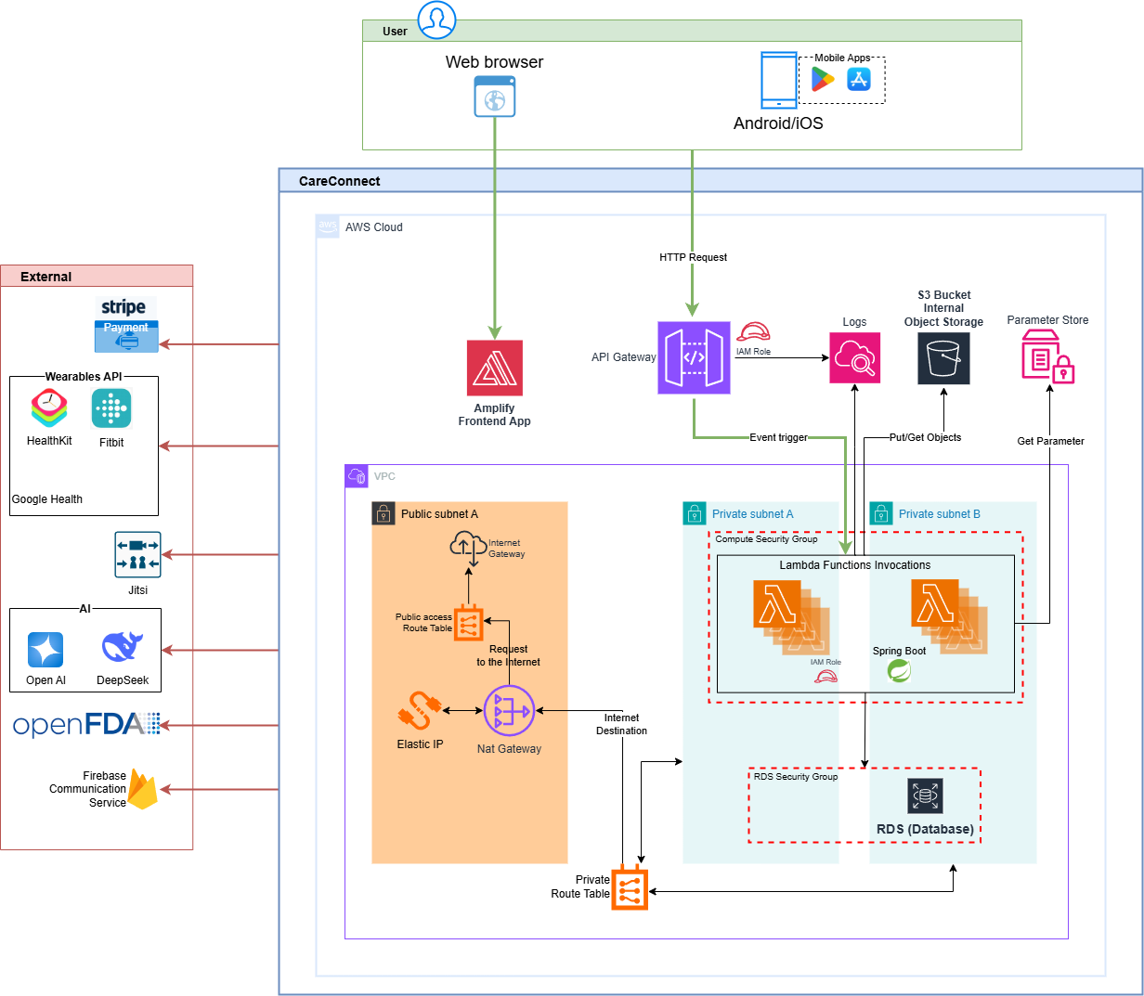Figure - CareConnect System Architecture Diagram

## Architectural Components

A list of the architectural components for CareConnect is provided in Table 3.

**Table 3**

*Architectural Components*

|  |  |  |  |
| --- | --- | --- | --- |
| Tier | Logical component | Responsibilities | Tech choice |
| Client | Flutter Mobile + Web | UI, device APIs (camera, microphone), local cache, Stripe Elements, WebSocket listener | Dart / Flutter |
| Edge | Amazon,CloudFront, CloudMap | TLS termination, SPA hosting, DDoS & OWASP rules | CloudFront, Lambda Version SnapStart |
| API Gateway | REST & WebSocket endpoints | Routing, JWT validation (Cognito), request throttling | Amazon API Gateway |
| BFF (Service Mesh) | Spring Boot API-BFF | Aggregates downstream calls for mobile performance | Lambda Function (Java 17) |
| Domain Micro-services | User-Service, Billing-Service, Scheduling-Service, Communication-Service, Analytics-Service | Each owns a business area | Spring Boot -> Lambda |
| Data | Relational DB, Object Storage | RDS (MySQL), DynamoDB, Timestream, S3 | Managed AWS |
| Integration | Stripe, Fitbit, Nest, FCM/APNs | External REST APIs / Webhooks | HTTPS, JWT mutual-TLS |
| Analytics | Athena / QuickSight | Ad-hoc queries, dashboards | Nightly ETL via Glue-Jobs |
| Security & Ops | SSM Parameter Store, IAM, CloudWatch, EventBridge | AuthN/Z, secrets, logs, scheduled jobs | AWS native |

# Technology Stack

The technology stack for CareConnect is provided in Table 4.

**Table 4**

*Technology Stack*

|  |  |  |
| --- | --- | --- |
| Layer | Technology used | Purpose |
| Frontend | Flutter (Dart) | Allows Cross-platform UI for both iOS and Android. |
| Backend | Java + Spring Boot | RESTful services that handle business logic and APIs. |
| API Gateway | AWS | Entry point for mobile app to backend(manages routing) |
| Compute | AWS Lambda Function | Short-live event based invocation of our Spring Boot app upon reception of HTTP requests. |
| Infrastructure Provisioning | Terraform | Infrastructure as Code (Iac) to deploy AWS services reproducibly. |
| Database | Amazon RDS(MySQL) | Stores core relational data. |
| Notification System | Firebase Cloud Messaging (FCM)/ Apple Push Notification (APNs) | Allows to send notification to patients and caregivers. |
| Authentication | Spring Security(Custom JWT Authentication), or Amazon Cognito | User login and session management |
| Payment Processing | Stripe | Handles caregiver subscriptions and billing securely |
| AI/LLM Integration | DeepSeek | Summarizes notes and supports conversation healthcare assistant/chat (“Ask”) |
| Vitals & Wearables | FitbitAPI | Sync and analyzes patient vitals from wearable devices |
| CI/CD Pipeline | CodeMagic, Github Actions | Automates building and publishing Flutter apps |
| Security Compliance | HIPAA AND GDPOR compliant | Ensures every component is secure and compliant. |
| File & Media Storage | Amazon S3 | Stores images, videos, PDFs |

# Functional Specifications

## Onboarding & Authentication

### User Registration

**Description:** The user registration process enables new users (patients or caregivers) to create an account. Users can register by providing an email and password, by verifying a phone number with an SMS one-time password (OTP), or by using Single Sign-On (SSO) via a provider like Google. This creates a new user profile and establishes initial credentials for future authentication.

**Actors:** Primary – End User (Patient or Caregiver); Secondary – System (authentication/backend service).

**Flow:**

The user launches the app and navigates to the registration option (e.g., taps “Register” on the Welcome/Login screen).

The system displays the registration form (email, password, phone number, etc.).

The user fills in the form: for email/password registration, the user enters a valid email and chooses a secure password; or the user enters a phone number to receive an SMS OTP; or the user chooses to register via Google SSO.

For email/password or phone number registration: the user submits the form. The system validates the input. For phone registration, an OTP is sent and the user must enter the received code.

For SSO registration: the user is redirected to the Google (or other provider) OAuth login page, authenticates with their Google account, and the system receives a confirmation.

Upon successful validation (and OTP verification if applicable), the system creates a new user account in the database and logs the user in (generating a session/token). The user is redirected to the appropriate post-registration screen.

A confirmation message or email may be sent to verify the user’s address.

**Inputs/Outputs:**

*Inputs*: Email address, chosen password, phone number (for OTP), OTP code (if SMS used), or OAuth token from Google.

*Outputs*: New user account record in the database; authentication token/session for the user; confirmation email or SMS (OTP delivery) as needed.

**Edge Cases:**

*Duplicate Email/Phone*: The submitted email or phone number is already registered, the system should show an error like “Email/phone already in use.”

*Invalid Input*: The email format is invalid, the password is too weak, or the phone number is incorrectly formatted, prompt the user to correct the input.

*OTP Failure*: OTP SMS fails to send or the user enters an incorrect/expired OTP, allow retry or resend.

*SSO Failure*: Google SSO authentication fails or is cancelled by the user, display an error and allow retry or alternative registration.

*Connectivity Issues*: Network errors during registration should display an appropriate error and not create a partial account.

**UI/UX:**

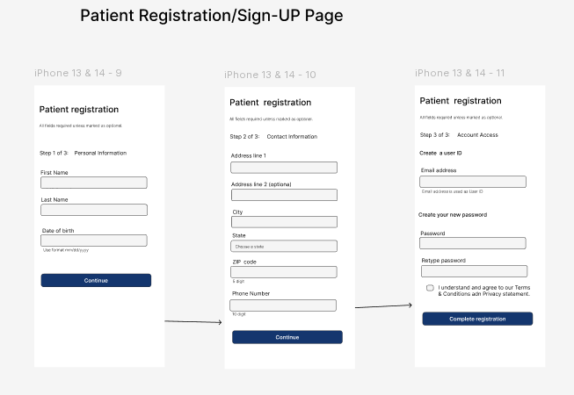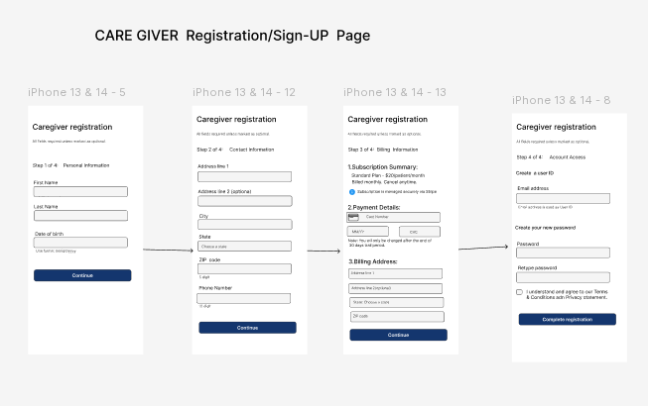

**Table 5.1.2**

The user registration function-to-screen mapping is provided in Table 5.

**Table 5**

*User Registration Function-To-Screen Mapping*

|  |  |  |
| --- | --- | --- |
| Function | Screen names or #’s | Trigger/Action |
| Navigate to Registration Screen | Welcome/Login Screen | User taps “Register” button |
| Register with username/password | Registration screen | User submits email/password form |
| Register with OTP | Registration Screen | User presses “Register with OTP”; User provides phone number for OTP sign in |
| Register with Google SSO | Registration Screen | User presses “Register with Google”; User authenticates through Google SSO |

### Login/Logout Flows

**Description:** The login flow lets existing users authenticate and access the app, while the logout flow ends their session. Users may log in with their registered email/password, an SMS OTP (phone number login), or via SSO. The system maintains session persistence (e.g., via tokens) and enforces session timeouts for security. Logging out immediately invalidates the session and returns the user to the login screen.

**Actors:** Authenticated User (Patient or Caregiver); Secondary – System (authentication/backend service).

**Flow:** The user opens the app and sees the login screen.

The user enters credentials: either email and password, or phone number and OTP; alternatively, the user may tap a Google SSO login button.

The system validates the credentials: for email/password, it checks them against the database; for phone login, it verifies the OTP; for SSO, it performs OAuth.

If authentication is successful, the system creates a session (issues an access token and refresh token) and redirects the user to the appropriate dashboard (patient or caregiver). The session may be persisted (e.g., stored securely on device) for continued use until logout or timeout.

For logout, the user taps “Logout” from a menu or settings. The system immediately invalidates the session on the server (revokes the token) and clears any local session data. The app then navigates back to the login screen.

**Inputs/Outputs:**

*Inputs*: Email/password credentials; phone number and OTP; or OAuth token from SSO provider.

*Outputs*: On login – an authenticated user session (access and refresh tokens, user role); on logout – session termination (tokens revoked).

**Edge Cases:**

Invalid Credentials: Incorrect password or OTP – display an error like “Invalid login” and allow retry.

Unverified Account: Email not confirmed or account inactive – prompt user to verify or reactivate.

Session Timeout: If the session expires during use, force re-authentication and display a timeout message.

Network Errors: Show an appropriate error if login request cannot reach the server.

Concurrent Login: If the same user logs in elsewhere invalidating the current token, prompt re-login.

**UI/UX:** 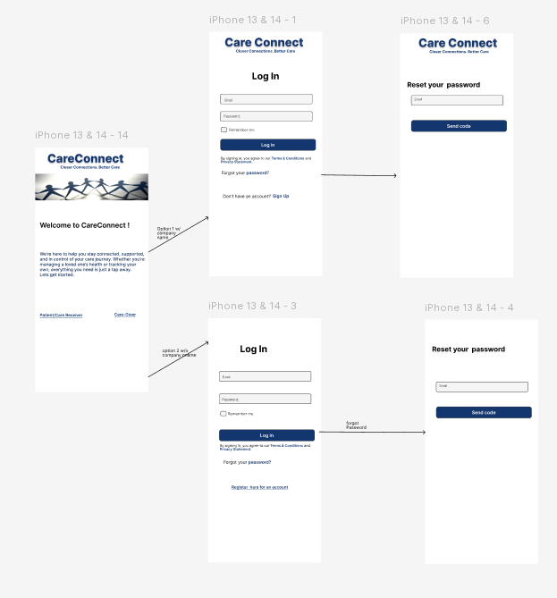

The login/logout flows function-to-screen mapping is provided in Table 6.

**Table 6**

*Login/Logout Flows Function-To-Screen Mapping*

|  |  |  |
| --- | --- | --- |
| Function | Screen Names or #’s | Trigger/Action |
| Perform Username/Password Login | Login Screen | User enters credentials and taps “Login”; provides username/password; create session |
| Logout | Dashboard (Any) | User taps “Logout”; Invalidate session; clear tokens |
| Perform Google SSO login | Login Screen | User taps “Login with Google”; Authentication through Google SSO; create session |
| Perform OTP Login | Login Screen | User taps “Login with OTP”; authenticate with OTP; create session |
| Initiate password reset or OTP resend | Login Screen | User taps “Forgot Password” or “Resend OTP” |

**5.1.4 Password Reset and Account Recovery**

**Description**:

This module guides users through the process of recovering their account and resetting their password when access is lost. The process includes identity verification using personal details, security question validation, and setting a new password.

**Actors**:

Primary Actor:User

Secondary Actor: Application (System)

**Flow**:

On the login screen, the User clicks on “Forgot Password / Account Recovery.”

The system navigates to a recovery screen requesting the patient’s date of birth and address.

The patient inputs the required details and proceeds.

The system presents security questions.

Upon successful validation, the patient is prompted to create a new password and confirm it by entering it again.

The system validates the matching passwords and completes the reset process, restoring access.

The patient password reset and account recovery inputs and outputs are as follows:

* Click on ***Forget Password/Account Recovery*** → Navigates to recovery form
* Provide date of birth and address → If data matches, accesses security questions
* Answer security questions → If answers are correct, accesses the password reset screen
* Enter the new password and confirm by retyping → Confirmation of successful password reset and login access

**Edge Cases**:

Incorrect DOB or address: System should prompt with an error message and option to retry.

Incorrect answers to security questions: Limit retries and display warning.

Password mismatch: System must alert user and prevent submission.

Weak password: Display real-time validation to ensure strong password creation.

Lost access to recovery details: Offer contact support as a fallback method.

**UI/UX**:

“Forgot Password” should be clearly visible on the login screen.

Input fields must follow mobile accessibility best practices (large tap targets, high contrast).

Form steps should be shown in a clear sequence with progress indicators if multi-screen.

Provide success or failure messages after each submission step.

Confirm successful password reset with visual feedback and redirect to login screen.

**Function-To-Screen Mapping Table**

The User password reset function-to-screen mapping is provided in Table 7.

**Table 7**

*User Password Reset Function-To-Screen Mapping*

|  |  |  |
| --- | --- | --- |
| Function | Screen names or #’s | Trigger/Action |
| Initiate Password Recovery | Login Screen | The user taps “Forgot Password / Account Recovery” |
| Enter Personal Verification Info | Account Verification Screen | The user inputs DOB and address, taps Submit |
| Answer Security Questions | Security Questions Screen | The user t answers security questions, taps Submit |
| Access Password Reset Form | Password Creation Screen | Application verifies answers and shows password input fields |
| Submit New Password | Password Creation Screen | The user enters new password twice, taps Submit |
| Confirmation & Redirect | Success Screen → Login Screen | Application resets password and navigates user back to login |

## Dashboards

### Caregiver Dashboard

**Description:**

Patient Dashboard provides the grid view of patient showing their names, last interaction and quick action menus like view/edit/archive and a Floating ‘+” button to add new patients.

**Actors:**

Caregiver (Primary Actor)

System (Secondary)

**Flow:**

Below is the flow process:

1. Caregivers Logs in
2. Dashboard auto-loads with linked patient cards
3. Each card has options like View, Edit, Archive
4. Caregivers click “+” to add new patients. This opens form (name, relation, contact

with notes)

5. Caregiver clicks on the hamger Menu. This opens up list of items(Billing and Subscription, Schedule Management, Tracking & Monitoring, Notification Setting, TeleHealth Bridge, Health Care Notes, SOS notification.

**Inputs:**

* Caregivers’ session token: Authenticates the caregiver and grants access to the linked patient data.
* Patient records from DB (linked to the caregiver): Retrieves the list of patients associated with the associated caregiver.
* Media (patient image) during add/edit: Upload the patient’s profile picture for visual display on the dashboard.

**Outputs:**

* Real time dashboard list: Displays the list of the patients as soon as the caregiver signs up.
* Patient data cards: Shows the patient data cards with all the required information (Profile, last interaction, action menu).
* Add/Edit/Archived patient updates: Reflect immediate changes performed on the patient (Add/Edit/Archived).

**Edge Cases:**

* No patients linked: Show empty state “Add your first patient”.
* Archiving a patient: Should confirm and move to hidden list.
* Backend timeout: Show retry option or error toast.
* Duplicated patient: Show warning “Patient already exists”.

### Caregiver Action Items

**Description:** This feature describes the action icons available to caregivers in the Caregiver Dashboard of a mobile application, allowing them to manage patients, access communication tools, settings, and AI assistance.

**Actors:** Primary: Caregiver

Secondary (Indirect): Patient, Family Member

**Flow:**

Caregiver logs into the dashboard.

Action icons are displayed on the screen.

Caregiver selects an icon based on the task (e.g., add patient, call patient).

The system executes the function (e.g., opens screen, initiates call, sends message).

UI updates dynamically based on action (e.g., new patient added, menu expands, call interface opens).

**Inputs:** Tap on icon (e.g., plus sign, three dots), Selection of patient, User menu selection

**Outputs:** Navigation to screen or action performed (e.g., Add Patient, Edit Patient), Initiates communication or brings up related options, Display or transition to selected settings/subscreens

**Edge Cases:**

No patient selected: Tapping the call or chat icon may be disabled or prompt a message.

Network issues: Calls, messages, or AI assistant may fail; fallback messaging should appear.

Unauthorized access: Editing or subscription settings should be permission-validated.

Empty patient list: “Add Patient” becomes the primary CTA (Call to Action).

**UI/UX:**

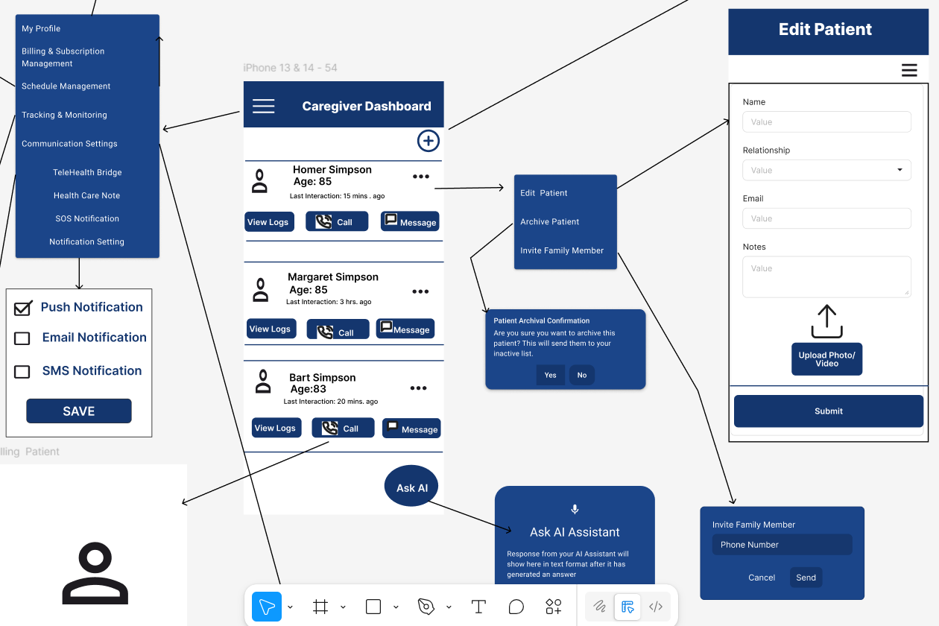

The caregiver action items function-to-screen mapping is provided in Table 8.

**Table 8**

*Caregiver Action Items Function-To-Screen Mappin*

|  |  |  |
| --- | --- | --- |
| Function | Screen Names or #’s | Trigger/Action |
| Add Patient | Add Patient Screen | Tap on plus sign icon |
| Edit/Archive/Invite Family (Patient) | Patient Options Menu | Tap on three dots icon > select Edit, Archive, or Invite |
| Access Profile and App Settings | Caregiver Menu Screen | Tap on three horizontal lines icon |
| Ask AI Assistant | AI Assistant Screen | Tap on circular Ask AI icon |
| Call Patient | In-App Dialer / Call Screen | Tap on telephone icon after selecting a patient |
| Message Patient | Chat Screen | Tap on chat box icon after selecting a patient |

### Patient Action Items

**Description**: This feature enables patients to interact with their caregivers and record their personal health status via icons on the Patient Dashboard. Key functionalities include archiving caregivers, initiating communication, updating mood and pain levels, and triggering emergency support (SOS).

**Actors:**

Primary: Patient

Secondary (Indirect): Caregiver, Emergency Contacts, EMS (911)

**Flow**:

Patient logs into the dashboard.  
Caregiver list and interactive icons are displayed.

Patient can archive, call, message, or edit caregiver entries.

Patient selects their current mood and pain level using face icons.

In emergencies, patient taps the SOS button, triggering alert sequence.

UI updates to reflect actions (e.g., caregiver hidden, pain recorded, SOS activated).

The patient action items inputs and outputs are as follows:

* Tap on moon icon → Caregiver is archived from dashboard view
* Tap on phone or chat icon → Initiates call or opens messaging system
* Tap on pencil or trashcan icon → Opens edit screen or removes caregiver
* Tap on face icons → Record mood or pain level
* Tap on red SOS phone → Alerts caregiver, backup contacts, and/or EMS

**Edge Cases**:

No caregiver selected: Action icons (call, message, edit) remain inactive.

SOS fails: If location sharing is denied or GPS fails, user is prompted to enable settings.

Network offline: Communication icons are disabled; warning displayed.

Pain/mood icons tapped repeatedly: Should allow updates but show confirmation of latest selection.

**UI/UX**

The patient action items function-to-screen mapping is provided in Table 9.

**Table 9**

*Patient Action Items Function-To-Screen Mapping*

|  |  |  |
| --- | --- | --- |
| Function | Screen names or #’s | Trigger/Action |
| Archive Caregiver | Patient Dashboard | Tap on **moon icon** next to selected caregiver |
| Call Caregiver | In-App Dialer / Call Screen | Tap on **telephone icon** after selecting caregiver |
| Message Caregiver | Chat Screen | Tap on **chat box icon** after selecting caregiver |
| Edit Caregiver | Edit Caregiver Screen | Tap on **pencil icon** next to caregiver |
| Delete Caregiver | Confirmation + Removal | Tap on **trashcan icon** next to caregiver |
| Record Mood | Mood Selection Overlay | Tap on **mood face icon** to set emotional state |
| Record Pain Level | Pain Scale Selection | Tap on **pain scale face (numbered)** to record level |
| Emergency SOS Alert | SOS Sequence Screen | Tap on **red phone icon** to trigger caregiver → backup contacts → EMS flow |

### Patient Dashboard

**Description:**

The Patient Dashboard is the primary interface through which patients interact with the CareConnect system. It provides an intuitive and streamlined view of daily tasks, health tracking inputs, mood/pain reporting tools, assigned caregiver information, and quick access to emergency support features. The dashboard is personalized per patient and dynamically updates based on task completion, caregiver communication, and symptom logging.

**Actors:**

**Primary Actor:** Patient

**Secondary Actor:** System (Scheduling Service, Symptom Service, Communication Service), Caregiver (indirect interaction)

**Flow:**

Patient logs into the application using secure credentials.

The system retrieves patient-specific data and displays:

Scheduled care tasks for the day

Mood and pain level trackers

Messages or alerts from caregivers

Assigned caregiver list with quick action buttons

Recent health metrics or progress summaries

The patient may:

Complete and mark tasks

Update their mood and pain level using icons

Contact caregivers via message or call

Access emergency SOS support

View reminders or motivational content

The dashboard updates in real time to reflect status changes and caregiver responses.

**Inputs/Outputs:**

**Inputs:**

Patient session token

Scheduled tasks and symptom configuration

Mood/pain selection

Patient interactions with icons and menus

**Outputs:**

Updated task status

Recorded mood/pain logs

Alerts sent to caregivers if critical thresholds are triggered

Real-time updates to UI

**Edge Cases:**

**No caregiver assigned:** Display message “No caregivers linked. Please contact support.”

**No scheduled tasks:** Show empty state with message and motivational quote.

**Network error:** Alert the user with retry option and offline caching fallback.

**Critical symptoms recorded:** Alert system escalates notification to caregiver automatically.

**Repeated mood/pain updates:** Only latest entry is stored but history is retained in backend.

**UI/UX:**

The Patient Dashboard emphasizes accessibility and emotional ease:

Vertical list of daily tasks with checkboxes or sliders

Horizontal row of emoji-based icons for mood and pain tracking

Caregiver contact panel with chat, call, and edit buttons

Prominent SOS button for emergencies

“Today’s Motivation” banner at the top for engagement

Accessibility support (high contrast, large tap targets, readable fonts)

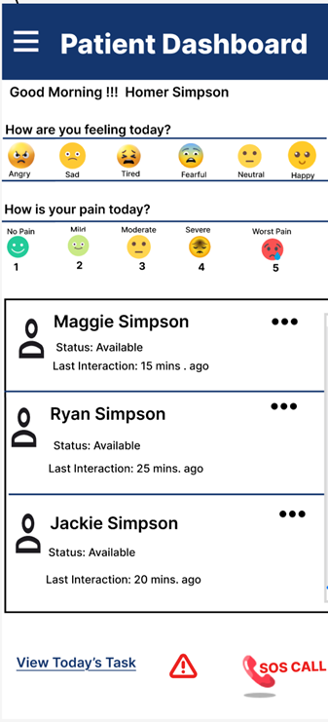 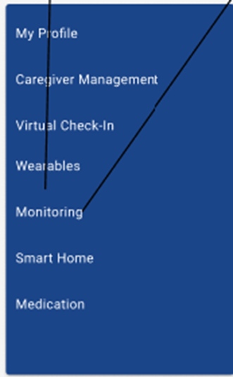

The patient dashboard function-to-screen mapping is provided in Table 10..

**Table 10**

*Patient Dashboard Function-To-Screen Mapping*

|  |  |  |
| --- | --- | --- |
| Function | Screen name | Trigger/Action |
| Load Patient Dashboard | Dashboard Home | Patient logs in; dashboard loads assigned data |
| Complete a Scheduled Task | Task Card /Checklist | Tap checkbox or slider to mark task complete |
| Record Mood | Mood Tracker Overlay | Tap face icon to log current mood |
| Record Pain Level | Pain Tracker Overlay | Tap numeric or emoji pain scale |
| Call or Message Caregiver | Caregiver Panel | Tap phone or chat icon |
| View Task Details | Task Detail Model | Tap on task card for expanded view |
| Trigger SOS Alert | SOS Button | Tap red emergency icon to initiates alert chain |
| View Motivational Message | Dashboard Header | Displays daily rotating quote or message |
| Refresh Dashboard | Pull to Refresh /Auto Load | Manual or automatic UI refresh |

## Scheduling and Notifications

### Custom Task Scheduling

**Feature Overview**

Through Custom Task Scheduling, caregivers can organize and handle responsibilities for the people they look after. This tool allows caregivers to help patients follow health routines, such as remembering medicine and doing specific exercises. Users can personalize each task's title, schedule, how often it occurs, and how important it is. The tasks are maintained in the backend and shared with all connected devices for simple use.

**Actors**

* **Primary Actor**: Caregiver (the person creating and managing the tasks).
* **Secondary Actor**: System (the backend infrastructure responsible for storing and processing tasks).

**Flow**

1. **Caregiver Logs In**: The caregiver logs into the system and accesses the dashboard.
2. **Navigate to Task Scheduling**: The caregiver clicks on a button or link to access the Custom Task Scheduling screen.
3. **Task Creation**: The caregiver enters the task details: task name, time, recurrence, and priority.
4. **Form Validation**: The system validates that the task title is not empty, the time is valid (in the future), and the recurrence is selected correctly.
5. **Save Task**: The caregiver clicks the “Save” button, which triggers the backend API to save the task data.
6. **Confirmation**: After the task is saved, a confirmation message notifies the caregiver that the task has been added successfully.
7. **Sync Across Devices**: The task is synchronized across the caregiver’s devices (mobile, tablet, etc.) in real-time.

**Inputs/Outputs**

* **Inputs**: Task name (text), time (DateTime), recurrence (dropdown selection), priority (dropdown selection), caregiver ID.
* **Outputs**: Task data is saved in the backend database, and confirmation messages are synced in real time across devices.

**Edge Cases**

* **Invalid Time**: If the caregiver selects a past time, the system should prompt the user to select a future time.
* **Duplicate Tasks**: If a task with the same name already exists, the system should notify the caregiver that the task is a duplicate.

**Network Failure**: If there is a network issue while saving the task, the system should store the task locally until the connection is restored.

### Reminder and Escalation Rules

Description:

The Reminders and Escalation subsystem in CareConnect enables time-sensitive task management through automated alerts. It supports daily routines supported by CareConnect. When a reminder is missed, the system activates escalation protocols, which may involve notifying alternate caregivers and amily members depending on severity and elapsed time. The system ensures reliability and accountability through reminders.

**Actors:**

**Patient:** Receives reminders and can respond to confirm completion.

**Primary Caregiver:** Receives escalation alerts for missed actions.

Family Member: Can receive escalated alerts based on permissions.

**Flow:**

1. **Schedule Creation**: Caregiver or patient defines a tasks.
2. **Reminder Dispatch**: System sends reminders at the scheduled time.
3. **User Response Monitoring**: System waits for task confirmation.
4. **Grace Period Evaluation**: If no response is received within the grace window the task enters an "Unacknowledged" state.
5. **Escalation Triggered**: Escalation rule executes, e.g., notify caregiver, then family member.
6. **Alert Propagation**: Notifications sent to designated contacts.
7. **Confirmation Capture**: Any recipient may acknowledge the escalation alert to stop propagation.

**Inputs/Outputs:**

**Inputs:**

* Task Definitions: Title, time, frequency
* Escalation Rules: Escalation chain, grace period
* User Interaction: Response confirmations ("Taken", "Dismiss")

**Outputs:**

* Reminder Alerts: Sent via system notification.
* Escalation Notifications: Secondary alerts if the initial reminder is missed
* Audit Logs: Timestamped records of reminders and responses
* Dashboard Status: Missed/confirmed status shown to caregiver

**Edge Cases:**

* **Device Offline (Push Fail):** Fail to send escalation notification to caregiver.
* **Missed Response but Action Taken:** Patient can retroactively confirm task completion within the configured grace window.
* **No Escalation Configured:** The reminder is marked as “Missed” with no further automated actions taken.

The **Reminder and Escalation** function-to-screen mapping is provided in Table 11.

**Table 11**

***Reminder and Escalation Function-to-Screen Mapping***

|  |  |  |
| --- | --- | --- |
| ****Function**** | ****Screen Name**** | ****Trigger/Action**** |
| Create Reminder | Task Scheduler | Tap “Add Reminder”; define time, frequency, priority |
| Receive Reminder | Push | Scheduled time triggers system to send alert |
| Confirm Task Completion | Notification, Health Dashboard | Tap “Mark Complete” on alert or task card |
| Grace Period Monitoring | System Background Service | Countdown begins after no response |
| Escalation Notification | Caregiver Dashboard | Triggered if task unacknowledged past grace period |
| View Task Status | Patient Dashboard | Task shown as Complete / Missed / Escalated |
| Acknowledge Escalation | Notification Alert | Tap “Acknowledge” to stop alert chain |

## Health Data Tracking

### Insert a list of default common symptoms

**Description**

This feature ensures that a predefined list of common symptoms is available in the system for patient use. During deployment, the system checks for the existence of the symptoms table and inserts any missing default symptoms. This process prevents duplication and ensures data consistency.

**Actors**

* **System Administrator**: Initiates the deployment process.
* **Deployment Service**: Executes the initialization logic.

**Flow**

1. Deployment is triggered.
2. The system checks if the symptoms table exists.
   1. If not found, the deployment is aborted.
3. If the table exists:
   1. The system compares the default symptom list with existing entries.
   2. Only missing symptoms are inserted.
   3. If all symptoms exist, insertion is skipped.
4. The system logs the outcome of the operation.

**Inputs/Outputs**

* Inputs:
  + - Predefined list of default symptoms in Comma Separated Value (CSV) file format.
    - Database connection/configuration.
* Outputs:
  + - Updated symptoms table with new entries (if applicable).
    - Deployment logs indicating success, partial insertions, or failure.

**Edge Cases**

* Symptoms table missing: Deployment halts with an error.
* Partial match: Some symptoms exist, others don’t — only missing ones are inserted.
* All symptoms exist: No insertion occurs; operation is logged as a no-op.
* Database connection failure: Deployment fails and logs the error.
* Duplicate symptom names with different casing or formatting: May require normalization logic.

**UI/UX**

This feature is backend-only and does not have a direct user interface. However, administrators may view logs or deployment status via:

* AWS CloudWatch Logs
* Deployment dashboard (e.g., AWS CodeDeploy, custom admin UI)

The **default common symptoms** function-to-screen mapping is provided in Table 12.

**Table 12**

Default Common Symptoms **Function-to-Screen Mapping**

|  |  |  |
| --- | --- | --- |
| Function | Screen names or numbers | Trigger/Action |
| Trigger deployment | Admin Console / CI/CD Tool | Admin initiates deployment via CLI or pipeline |
| Check for symptoms table | Backend (no UI) | System automatically checks during deployment |
| Compare default symptoms with existing | Backend (no UI) | System inserts only non-existing symptoms |
| Log deployment outcome | AWS CloudWatch / Admin Console | System logs success, partial insert, or failure |
| View symptom data | DB Admin Tool / Patient onboarding screen | Admin queries or views the symptoms table |
| Handle missing table error | Admin Console / Logs | System logs error and halts deployment |

### Attach default symptoms

**Description**

When a new patient is created, the system automatically displays a list of default symptoms on the symptom screen. Caregivers can activate a symptom by selecting a start date, which creates an entry in the symptom log with an active status.

**Actors**

* **Caregiver**: Interacts with the symptom screen to activate symptoms.
* **System**: Handles data retrieval, UI rendering, and database operations.
* **Patient**: The subject for whom symptoms are being tracked (passive actor).

**Flow**

* + - 1. A new patient is created in the system.
      2. The caregiver navigates to the symptom screen.
      3. The system retrieves and displays all default symptoms.
      4. The caregiver clicks the “+ Start Date” button next to a symptom.
      5. The system displays a date picker.
      6. The caregiver selects a date and submits.
      7. The system sets the symptom status to active and inserts a record into the symptom log table.

1. If the caregiver cancels the date selection, the system returns to the default symptom list view.

**Inputs/Outputs**

* Inputs:
* Patient creation event
* Default symptoms from the symptoms table
* Start date selected by caregiver
* Outputs:
* Displayed list of symptoms
* New entry in the symptom_log table with status = "active"
* UI feedback (confirmation, error, or cancellation)

**Edge Cases**

* No default symptoms found: System should display a message or empty state.
* Caregiver cancels date selection: No changes are made; UI returns to default view.
* Invalid date input: System should validate and prompt for correction.
* Database insertion failure: System should log the error and notify the caregiver.
* Duplicate symptom log entry: System should prevent or handle gracefully.

**UI/UX**

* Symptom Screen:
  + Displays a list of symptoms with a “+ Start Date” button next to each.
  + Clicking the button opens a date picker modal or inline component.
  + Submitting the date updates the UI to reflect the symptom’s active status.
  + Canceling the date picker returns to the default symptom list view.

The attach **default symptoms** function-to-screen mapping is provided in Table 13.

**Table 13**

*Attach Default Symptoms* ***Function-to-Screen Mapping***

|  |  |  |
| --- | --- | --- |
| Function | Screen names or numbers | Trigger/Action |
| Display default symptoms | Symptom Screen | Triggered when a new patient is created |
| Show date picker | Symptom Screen | Caregiver clicks “+ Start Date” next to a symptom |
| Submit selected date | Symptom Screen | Caregiver selects a date and confirms |
| Insert symptom log entry | Backend (no UI) | System inserts record with active status in DB |
| Cancel date selection | Symptom Screen | Caregiver closes or cancels the date picker |
| View symptom log | Symptom Screen | The system displays updated symptom log entries |

### Add custom symptoms

**Description**

Caregivers can add symptoms that are not part of the system’s default symptom list. When a caregiver attempts to add a new symptom, the system checks if it already exists. If not, it adds the symptom to the global list and associates it with the patient. If it exists, the system either links it to the patient or prevents duplication if already linked.

**Actors**

* **Caregiver**: Enters and submits custom symptom data.
* **System**: Validates, stores, and associates symptoms.
* **Patient**: The subject to whom the symptom is linked (passive actor).

**Flow**

1. Caregiver clicks the “Add Symptom” button on the patient’s symptom screen.
2. System displays input fields for symptom name, category, and critical level.
3. Caregiver enters symptom details and submits.
4. System checks if the symptom exists in the global symptom list.
   1. If not found:
      1. Adds the symptom to the global list.
      2. Associates it with the patient with the current date and active status.
   2. If found:
      1. If not already linked to the patient, it is associated.
      2. If already linked, a message is shown to prevent duplication.

**Inputs/Outputs**

* Inputs:
  + Symptom name, category, and critical level (entered by caregiver)
  + Patient ID
* Outputs:
  + New or updated entries in the symptoms and symptom log tables
  + UI feedback (confirmation, error, or duplication message)

**Edge Cases**

* Symptom already exists globally and is linked to the patient: System prevents duplication and shows a message.
* Symptom exists globally but not linked to the patient: System links it.
* Symptom does not exist: System adds it and links it.
* Empty or invalid input: System prompts for correction.
* Database failure: System logs the error and notifies the caregiver.

**UI/UX**

* Symptom Screen:
  + - “Add Symptom” button is visible to caregivers.
    - Clicking the button opens a form with fields for name, category, and critical level.
    - On submission, the system validates and processes the input.
    - Feedback is shown based on the result (success, already exists, or error).

The add custom **symptoms** function-to-screen mapping is provided in Table 14.

**Table 14**

*Add Custom Symptoms* ***Function-to-Screen Mapping***

|  |  |  |
| --- | --- | --- |
| Function | Screen names or numbers | Trigger/Action |
| Show “Add Symptom” button | Symptom Screen | Caregiver views patient’s symptom section |
| Display custom symptom form | Symptom Screen | Caregiver clicks “Add Symptom” |
| Submit custom symptom | Symptom Screen | Caregiver enters details and submits |
| Validate symptom existence | Backend (no UI) | System checks global symptom list |
| Add new symptom to global list | Backend (no UI) | System inserts new symptom if not found |
| Associate symptom with patient | Backend (no UI) | System links symptom to patient with active status |
| Prevent duplicate association | Symptom Screen | System shows message if symptom already linked |

### Push symptom notification request

**Description**

To ensure consistent symptom tracking and caregiver awareness, the system will send daily notifications to patients prompting them to update their symptoms. These notifications will remain active until acknowledged by the patient. The timing and frequency of notifications can be configured by caregivers or patients.

**Actors**

* **Patient**: Receives and acknowledges daily symptom update notifications.
* **Caregiver**: Configures notification preferences.
* **System**: Schedules, sends, and tracks notification status.

**Flow**

1. A scheduled time for daily symptom update is reached.
2. The system sends a notification to the patient’s device.
3. The notification includes a prompt to update symptoms.
4. The notification remains active until the patient acknowledges it.
5. The patient opens the notification and updates symptoms.
6. The system logs the acknowledgment and symptom update.
7. Caregivers can view update compliance and configure future notification settings.

**Inputs/Outputs**

* Inputs:
  + Configurable notification settings (time, frequency)
  + Patient device registration
  + Symptom update prompt content
* Outputs:
  + Notification sent to patient
  + Acknowledgment status
  + Updated symptom log
  + Notification logs for caregiver review

**Edge Cases**

* Patient does not acknowledge: Notification remains active; system may escalate or remind.
* Patient device offline: Retry logic or fallback notification method may be needed.
* Invalid configuration: System should validate and reject incorrect settings.
* Duplicate notifications: System should prevent sending multiple active notifications for the same update window.

**UI/UX**

* Patient Portal:
  + Displays persistent notification with symptom update prompt.
  + Allows acknowledgment and direct access to symptom update screen.
* Caregiver Portal:
  + Interface to configure notification preferences (time, frequency).
  + Dashboard to monitor patient acknowledgment and compliance.

The push **symptom notification request** function-to-screen mapping is provided in Table 15.

**Table 15**

*Push Symptom Notification Request* ***Function-to-Screen Mapping***

|  |  |  |
| --- | --- | --- |
| Function | Screen names or numbers | Trigger/Action |
| Schedule daily notification | Backend Scheduler / Config UI | System schedules based on configured time |
| Send notification to patient | Patient App Notification Center | Triggered at scheduled time |
| Display symptom update prompt | Patient App | Notification opens symptom update screen |
| Acknowledge notification | Patient App | Patient taps or interacts with notification |
| Log acknowledgment and update | Backend (no UI) | System records acknowledgment and updates log |
| Configure notification settings | Caregiver Portal / Patient App | User sets time and frequency preferences |

### Answer symptom notification request

**Description**

The system enables patients to respond to symptom update notifications using multiple input methods. Notifications remain visible until acknowledged. Patients can either select a severity level using a slider or provide a text-based description of their symptoms. This flexibility supports more accurate and user-friendly symptom reporting.

**Actors**

* **Patient**: Receives and responds to symptom notifications.
* **System**: Sends notifications, validates input, stores responses, and tracks acknowledgment.
* **Caregiver**: (Indirect) May review patient responses later.

**Flow**

1. Patient receives a symptom update notification.
2. Notification remains active until the patient responds.
3. Patient chooses one of the following input methods:
   1. Selects a severity level using a slider.
   2. Enters a description in a text field.
4. Patient submits the response.
5. System validates the input and stores it with a timestamp.
6. System marks the notification as acknowledged.

**Inputs/Outputs**

* Inputs:
  + Notification trigger
  + Patient input (slider value or text description)
* Outputs:
  + Stored response in the symptom log
  + Acknowledgment status with timestamp
  + UI confirmation to the patient

**Edge Cases**

* No input provided: System should prompt the patient to enter or select a value.
* Both inputs provided: System should accept and store both.
* Invalid input (e.g., empty text or out-of-range slider): System should validate and prompt correction.
* Patient closes app without responding: Notification remains active.
* Duplicate submission: System should prevent or handle gracefully.

**UI/UX**

* Patient Portal:
  + Displays persistent notification until acknowledged.
  + Offers two input options: slider for severity and text field for description.
  + Allows submission of either or both inputs.
  + Shows confirmation once the response is submitted and stored.

The answer **symptom notification request** function-to-screen mapping is provided in Table 16.

**Table 16**

*Answer Symptom Notification Request* ***Function-to-Screen Mapping***

|  |  |  |
| --- | --- | --- |
| Function | Screen Names or numbers | Trigger/Action |
| Display symptom notification | Patient App Notification Center | Triggered by system scheduler or caregiver action |
| Show input options (slider, text) | Symptom Response Screen | Patient opens notification |
| Submit response | Symptom Response Screen | Patient submits slider value and/or text |
| Validate and store response | Backend (no UI) | System processes and stores input |
| Mark notification as acknowledged | Backend (no UI) | System updates notification status |
| Display confirmation | Symptom Response Screen | Patient sees success message |

### List the symptoms of the patient

**Description**

This feature allows caregivers to view a real-time list of all active symptoms associated with a specific patient. Each symptom entry includes its current status and the most recent response submitted by the patient. This enables caregivers to monitor patient conditions efficiently and take timely action when needed.

**Actors**

* **Caregiver**: Views the list of active symptoms and patient responses.
* **System**: Retrieves and displays symptom data from the backend.
* **Patient**: Provides symptom responses (indirect actor).

**Flow**

1. Caregiver navigates to a patient’s profile and opens the symptom section.
2. System queries the backend for all active symptoms linked to the patient.
3. If active symptoms are found:
   1. The system displays each symptom’s name, status, and most recent response.
4. If no active symptoms are found:
   1. The system displays a message indicating that there are no active symptoms.

**Inputs/Outputs**

* Inputs:
  + Patient ID (from caregiver selection)
  + Symptom log data (status and latest response)
* Outputs:
  + List of active symptoms with status and latest response
  + Message indicating no active symptoms (if applicable)

**Edge Cases**

* No active symptoms: System should clearly indicate this with a user-friendly message.
* Stale data: System should refresh data in real-time or on user action.
* Backend failure: System should show an error message and retry option.
* Multiple symptoms with same timestamp: System should display all relevant entries clearly.

**UI/UX**

* Caregiver Portal:
  + The Symptom section displays a list view of active symptoms.
  + Each item shows:
    - Symptom name
    - Status (e.g., Active, Resolved)
    - Most recent patient response (slider value or text)
  + If no symptoms are active, a message such as “No active symptoms for this patient” is shown.
  + Option to refresh the list manually or auto-refresh periodically.

The list patient **symptoms** function-to-screen mapping is provided in Table 17..

**Table 17**

*List Patient Symptoms* ***Function-to-Screen Mapping***

|  |  |  |
| --- | --- | --- |
| Function | Screen names or numbers | Trigger/Action |
| Retrieve active symptoms | Symptom Section (Patient Profile) | Caregiver opens symptom section |
| Display symptom list | Symptom Section | System shows active symptoms with status and responses |
| Display “no active symptoms” message | Symptom Section | Triggered when no active symptoms are found |
| Refresh symptom list | Symptom Section | Manual refresh or automatic update |

### Graph of symptoms

**Description**

This feature provides caregivers with a visual, time-series representation of a patient’s symptom data. By displaying symptom severity and responses over time in a line chart, caregivers can identify trends, spot anomalies, and make more informed decisions about patient care.

**Actors**

* **Caregiver**: Views and interacts with the symptom trend graph.
* **System**: Retrieves historical data, renders the graph, and updates it based on user input.
* **Patient**: Provides symptom data (indirect actor).

**Flow**

1. Caregiver navigates to the graph view in the patient’s symptom section.
2. System retrieves historical symptom data for the selected patient.
3. A line chart is rendered showing symptom severity or response trends over time.
4. Caregiver can filter the graph by:
   1. Specific symptom(s)
   2. Date range
5. System dynamically updates the graph based on the selected filters.
6. Caregiver can hover or tap on data points to view exact values and timestamps.

**Inputs/Outputs**

* Inputs:
  + Patient ID
  + Filter selections (symptom type, date range)
* Outputs:
  + Line chart displaying symptom trends
  + Tooltip or label showing value and timestamp
  + Updated graph view based on filters

**Edge Cases**

* No historical data available: System should display a message like “No data available for the selected range.”
* Large data sets: Graph should paginate or aggregate data to remain readable.
* Invalid date range: System should validate and prompt correction.
* Multiple symptoms selected: Graph should differentiate lines clearly (e.g., color-coded).
* Mobile view: Graph should remain responsive and accessible on smaller screens.

**UI/UX**

* Caregiver Portal:
  + Graph view accessible from the patient’s symptom section.
  + Line chart with:
  + X-axis: Time
  + Y-axis: Symptom severity or response metric
  + Filter controls for symptom type and date range.
  + Tooltips or labels on hover/tap showing exact values and timestamps.
  + Responsive design for desktop, tablet, and mobile.

Table 5.4.7 – Function-To-Screen Mapping Table

|  |  |  |
| --- | --- | --- |
| Function | Screen Names or numbers | Trigger/Action |
| Retrieve historical symptom data | Symptom Graph View | Caregiver opens graph view for a patient |
| Display line chart | Symptom Graph View | System renders graph with retrieved data |
| Filter by symptom or date range | Symptom Graph View | Caregiver selects filters |
| Update graph dynamically | Symptom Graph View | System re-renders graph based on filter selection |
| Show tooltips/labels | Symptom Graph View | Caregiver hovers/taps on data points |
| Handle no data or invalid input | Symptom Graph View | System displays appropriate message or prompt |

### Alert Caregiver of symptoms

**Description**

This feature ensures that caregivers are immediately alerted when a patient submits a symptom response that exceeds predefined critical thresholds. The system continuously monitors incoming symptom data and triggers real-time alerts containing essential details to help caregivers respond quickly and appropriately.

**Actors**

* Patient: Submits symptom responses.
* System: Monitors responses, evaluates severity, and sends alerts.
* Caregiver: Receives alerts and takes necessary action.

**Flow**

1. Patient submits a symptom response (e.g., severity score or description).
2. System evaluates the response against predefined critical thresholds.
3. If the response is identified as critical:
4. System generates an alert.
5. Alert is sent in real-time to the assigned caregiver.
6. Alert includes patient ID, symptom name, and critical value.
7. System logs the alert for auditing and future reference.

**Inputs/Outputs**

* Inputs:
  + Symptom response data (e.g., severity score)
  + Predefined critical threshold values
  + Patient-caregiver assignment data
* Outputs:
  + Real-time alert notification to caregiver
  + Logged alert entry with timestamp and details

**Edge Cases**

* Symptom value near threshold: System must use precise comparison logic to avoid false positives/negatives.
* Multiple critical symptoms submitted at once: System should batch or prioritize alerts.
* Caregiver not assigned: System should not send alerts and should log the issue.
* Alert delivery failure: System should retry and log the failure.
* Thresholds misconfigured or missing: System should validate configuration and alert admins if needed.

**UI/UX**

* Caregiver Portal:
  + Receives real-time alerts with:
  + Patient name or ID
  + Symptom name
  + Critical value or score
  + Alerts are visually distinct (e.g., red banner, icon)
  + Option to acknowledge or mark as reviewed
  + Interface to define and manage critical thresholds per patient
  + View alert logs for auditing

Table 5.4.8 – Function-To-Screen Mapping Table

|  |  |  |
| --- | --- | --- |
| Function | Screen Names or numbers | Trigger/Action |
| Evaluate symptom response | Backend (no UI) | Triggered when patient submits symptom data |
| Compare against critical thresholds | Backend (no UI) | System checks value against predefined limits |
| Send real-time alert | Caregiver Portal | Triggered when critical value is detected |
| Display alert with details | Caregiver Portal | System shows patient ID, symptom, and value |
| Log alert for auditing | Backend (no UI) | System stores alert with timestamp and metadata |
| Restrict alert delivery to assigned users | Backend (no UI) | System checks caregiver-patient assignment |

### Insert common meal question

**Description**

This feature enables the system to automatically insert a predefined list of meal and nutrition-related questions into the database during the initial deployment. These questions, provided by the client, are designed to support dietary assessments and enhance patient engagement. The system ensures that only missing questions are inserted, avoiding duplication and ensuring data integrity.

**Actors**

* **System (Pipeline Agent)**: Executes the logic to check and insert default questions during deployment.
* **Administrator / DevOps Engineer**: Initiates the deployment process.

**Flow**

1. Deployment process is initiated.
2. System checks if the meal question table exists.
3. If not found, deployment is halted.
4. If the table exists:
5. System checks which default questions are already present.
6. Only missing questions are inserted.
7. If all questions are already present, insertion is skipped.
8. System logs the outcome of the operation.

**Inputs/Outputs**

* Inputs:
  + Predefined list of meal and nutrition questions (from base code or configuration)
  + Database schema and connection
* Outputs:
  + Inserted questions (if any)
  + Deployment logs indicating success, partial insert, or failure

**Edge Cases**

* Table not found: Deployment exits with an error.
* All questions already exist: System skips insertion and logs the result.
* Partial match: System inserts only missing questions.
* Database access error: System logs the error and halts the process.
* Duplicate entries with different formatting: May require normalization logic.

**UI/UX**

This is a backend-only feature with no direct user interface. However, outcomes may be visible through:

* Deployment logs
* Admin database tools

Table 5.4.9 – Function-To-Screen Mapping Table

|  |  |  |
| --- | --- | --- |
| Function | Screen Names or numbers | Trigger/Action |
| Check for meal_questions table | Backend (no UI) | Triggered during deployment |
| Compare default questions with existing | Backend (no UI) | System checks for duplicates |
| Insert missing questions | Backend (no UI) | System inserts only non-existing questions |
| Skip insertion if all exist | Backend (no UI) | System logs and skips if no new questions are needed |
| Exit deployment if table not found | Backend (no UI) | System halts deployment and logs error |

### Add custom meal question and attach to patient

**Description**

This feature allows caregivers to add custom meal or nutrition-related questions directly from a patient’s profile. If the question does not already exist in the global question list, it is added and automatically associated with the current patient. If the question exists but is not linked to the patient, it is associated without duplication. If the question is already linked, the system notifies the caregiver to avoid redundancy.

**Actors**

* **Caregiver**: Enters and submits custom meal questions.
* **System**: Validates, stores, and associates questions.
* **Patient**: The subject to whom the question is linked (passive actor).

**Flow**

1. Caregiver navigates to a patient’s profile and accesses the meal question section.
2. Caregiver enters a new meal or nutrition-related question.
3. System checks if the question exists in the global question list.
   1. If not found:
      1. Adds the question to the global list.
      2. Associates it with the current patient.
   2. If found:
      1. If not already linked to the patient, it is associated.
      2. If already linked, the caregiver is notified and duplication is prevented.
4. System ensures only authorized caregivers can perform this action.

**Inputs/Outputs**

* Inputs:
  + Custom question text (entered by caregiver)
  + Patient ID
* Outputs:
  + New or updated entries in the global question list and patient-question association table
  + UI feedback (confirmation, duplication warning, or error)

**Edge Cases**

* Question already exists and is linked: System prevents duplication and notifies the caregiver.
* Question exists globally but not linked: System links it to the patient.
* Empty or invalid input: System prompts for correction.
* Unauthorized caregiver: System blocks the action and shows an error.
* Database failure: System logs the error and notifies the user.

**UI/UX**

* Caregiver Portal:
  + Input field for entering a custom meal question.
  + Submit button to add and associate the question.
  + Real-time validation and feedback:
    - Success message if added or linked
    - Warning if already associated
    - Error if unauthorized or invalid

**Table 5.4.10**

*Function-To-Screen Mapping Table*

|  |  |  |
| --- | --- | --- |
| Function | Screen Names or numbers | Trigger/Action |
| Enter custom meal question | Patient Profile – Meal Section | Caregiver types a new question |
| Validate question existence | Backend (no UI) | System checks global question list |
| Add new question to global list | Backend (no UI) | Triggered if question is not found |
| Associate question with patient | Backend (no UI) | Triggered if question is new or not yet linked |
| Notify caregiver of duplication | Patient Profile – Meal Section | Triggered if question is already linked |
| Restrict unauthorized access | Backend (no UI) | System checks caregiver permissions |

### Log meal entry

**Description**

This feature allows patients to respond to meal-related questions using various input formats—text, voice, or images. These responses are logged with timestamps and associated with the corresponding question and patient. This flexible input model supports more accurate, accessible, and personalized dietary tracking.

**Actors**

* **Patient**: Views meal questions and submits responses.
* **System**: Displays questions, captures and stores responses, and maintains response history.
* **Caregiver**: (Indirect) Reviews patient responses for dietary assessment.

**Flow**

1. Patient opens the meal tracking section in their profile.
2. System displays all meal-related questions associated with the patient.
3. Patient selects a question and responds using:
   1. Text input
   2. Voice recording
   3. Image upload or capture
4. System captures the response, timestamps it, and stores it with the question and patient ID.
5. Patient may submit multiple responses over time.
6. System maintains a history of all responses for caregiver review.

**Inputs/Outputs**

* Inputs:
  + Meal question list (linked to patient)
  + Patient responses (text, audio, image)
  + Patient ID and timestamp
* Outputs:
  + Stored response entries with metadata
  + Updated response history
  + UI confirmation of successful submission

**Edge Cases**

* No questions linked to patient: System should display a message like “No meal questions available.”
* Unsupported file format (voice/image): System should validate and prompt correction.
* Large file uploads: System should enforce size limits and compress if needed.
* Duplicate responses: System should allow multiple entries but clearly timestamp each.
* Connectivity issues: System should retry or allow offline caching and later sync.

**UI/UX**

* Patient Portal:
* Displays a list of meal questions.
* For each question, provides:
  + Text input field
  + Voice recording option
  + Image upload/capture option
* Submit button for each response type
* Confirmation message after successful submission
* Option to view response history

**Table 5.4.11**

*Function-To-Screen Mapping Table*

|  |  |  |
| --- | --- | --- |
| Function | Screen Names or numbers | Trigger/Action |
| Display meal questions | Meal Tracking Screen | Patient opens meal section |
| Submit text response | Meal Tracking Screen | Patient types and submits answer |
| Submit voice response | Meal Tracking Screen | Patient records and submits audio |
| Submit image response | Meal Tracking Screen | Patient uploads or captures image |
| Timestamp and store response | Backend (no UI) | System logs response with metadata |
| Maintain response history | Backend / Caregiver Portal | System stores and retrieves past responses |

### Display the meal logs of a patient

**Description**

This feature enables caregivers to view a chronological timeline of meal entries submitted by a patient. Each entry includes the associated meal question, the patient’s response (in text, voice, or image format), and the timestamp. This timeline helps caregivers monitor dietary habits and identify nutritional patterns over time.

**Actors**

* **Caregiver**: Views and filters the patient’s meal log timeline.
* **System**: Retrieves, formats, and displays meal log data.
* **Patient**: Submits meal responses (indirect actor).

**Flow**

1. Caregiver navigates to the meal log section of a patient’s profile.
2. System retrieves all meal entries associated with the patient.
3. Entries are displayed in a chronological timeline format.
4. Each entry includes:
   1. The meal question
   2. The patient’s response (text, voice, or image)
   3. The timestamp of submission
5. Caregiver may apply filters to view entries within a specific date or time range.
6. System updates the timeline view based on the selected filters.

**Inputs/Outputs**

* Inputs:
  + Patient ID
  + Optional filters (date or time range)
* Outputs:
  + Timeline of meal entries with question, response, and timestamp
  + Filtered view based on caregiver selection

**Edge Cases**

* No meal entries available: System should display a message like “No meal entries found for this patient.”
* Unsupported media format: System should gracefully handle or exclude invalid files.
* Large number of entries: System should paginate or virtualize the timeline for performance.
* Unauthorized access: System should restrict access and show an appropriate error message.
* Corrupted or missing media: System should show a placeholder or error icon.

**UI/UX**

* Caregiver Portal:
* Timeline view showing meal entries in chronological order.
  + Each entry includes:
  + Meal question
  + Patient response (rendered as text, playable audio, or image preview)
  + Timestamp
* Filter controls for selecting date or time range.
* Responsive layout for desktop and tablet use.

**Table 5.4.12**

*Function-To-Screen Mapping Table*

|  |  |  |
| --- | --- | --- |
| Function | Screen Names or numbers | Trigger/Action |
| Retrieve meal log entries | Meal Log Timeline View | Caregiver opens meal log section |
| Display entries with details | Meal Log Timeline View | System shows question, response, and timestamp |
| Support multiple response formats | Meal Log Timeline View | System renders text, audio, and image responses |
| Present entries in chronological order | Meal Log Timeline View | System sorts and displays entries by timestamp |
| Filter entries by date/time | Meal Log Timeline View | Caregiver selects a date or time range |
| Restrict access to authorized caregivers | Backend (no UI) | System validates caregiver permissions |

### Display mood trends vs medications/symptoms

**Description**

This feature provides caregivers with visual insights into a patient’s emotional and physical health by displaying synchronized graphs that correlate mood trends with medication intake and active symptoms. These visualizations help caregivers identify patterns and better understand how treatments and symptoms may be influencing the patient’s mental state over time.

**Actors**

* **Caregiver**: Views and filters the mood correlation dashboard.
* **System**: Retrieves and visualizes mood, medication, and symptom data.
* **Patient**: Provides mood entries and receives medications (indirect actor).

**Flow**

1. Caregiver accesses the mood trends dashboard from the patient’s profile.
2. System retrieves:
   1. Historical mood data
   2. Medication administration records
   3. Active symptom logs
3. System displays three synchronized graphs:
   1. Mood trends over time
   2. Medication usage over time
   3. Active symptoms over time
4. Caregiver applies filters (e.g., date range, medication type, symptom category).
5. System updates all graphs to reflect the selected filters and maintains timeline synchronization.

**Inputs/Outputs**

* Inputs:
  + Patient ID
  + Mood entries, medication logs, symptom logs
  + Filter selections (date range, medication type, symptom category)
* Outputs:
* Three synchronized graphs:
  + Mood trend line chart
  + Medication usage bar or line chart
  + Active symptom timeline or heatmap
* Filtered and updated visualizations

**Edge Cases**

* No data available: System should display a message like “No data available for the selected range.”
* Partial data (e.g., mood but no medication logs): System should still display available graphs and indicate missing data.
* Large datasets: System should paginate or aggregate data for performance.
* Unauthorized access: System should restrict access and show an appropriate error.
* Overlapping data points: System should use tooltips or zoom features for clarity.

**UI/UX**

* Caregiver Portal:
  + Dashboard with three synchronized graphs:
    - Mood trend (line chart)
    - Medication usage (bar/line chart)
    - Active symptoms (timeline or stacked chart)
  + Filter panel for:
    - Date range
    - Medication type
    - Symptom category
  + Tooltips on hover to show exact values and timestamps
  + Responsive layout for desktop and tablet

**Table 5.4.13**

*Function-To-Screen Mapping Table*

|  |  |  |
| --- | --- | --- |
| Function | Screen Names or numbers | Trigger/Action |
| Retrieve mood, medication, and symptom data | Mood Trends Dashboard | Caregiver opens dashboard for a patient |
| Display synchronized graphs | Mood Trends Dashboard | System renders mood, medication, and symptom graphs |
| Filter data by date, medication, symptom | Mood Trends Dashboard | Caregiver selects filters |
| Update graphs dynamically | Mood Trends Dashboard | System refreshes graphs based on selected filters |
| Restrict access to authorized caregivers | Backend (no UI) | System validates caregiver permissions |

### Notify the caregiver of negative mood

**Description**

This feature continuously monitors a patient’s mood entries and automatically alerts the assigned caregiver if the patient logs a negative mood (e.g., “sad”) for three or more consecutive days. The alert includes relevant details to help caregivers intervene early and provide timely support.

**Actors**

* Patient: Logs daily mood entries.
* System: Tracks mood trends, detects negative streaks, and sends alerts.
* Caregiver: Receives alerts and reviews mood history.
* Administrator: (Indirect) Configures mood thresholds and alert rules.

**Flow**

1. Patient logs daily mood entries.
2. System stores each entry with a timestamp and mood label.
3. System evaluates mood trends daily.
4. If a negative mood is logged for three or more consecutive days:
   1. System triggers an alert to the assigned caregiver.
   2. Alert includes patient ID, dates of negative moods, and any associated notes or symptoms.
5. System logs the alert and its delivery status.
6. If the streak continues, no duplicate alerts are sent unless the streak is broken and reoccurs.

**Inputs/Outputs**

* Inputs:
* Daily mood entries (mood label, timestamp, optional notes)
* Configurable threshold (e.g., 3 consecutive days)
* List of negative mood labels (e.g., “sad”, “depressed”)
* Patient-caregiver assignment data
* Outputs:
  + Alert notification to caregiver
  + Alert log with metadata (patient ID, dates, delivery status)

**Edge Cases**

* Mood streak broken and resumed: System should reset the streak counter and allow a new alert.
* Multiple caregivers assigned: System should notify all authorized caregivers.
* Unauthorized caregiver: System should block access and log the attempt.
* Missing mood entries: System should handle gaps in data gracefully.
* Incorrect mood label configuration: System should validate and alert admin if misconfigured.

**UI/UX**

* Patient Portal:
  + Interface for logging daily mood with optional notes.
* Caregiver Portal:
  + Real-time alert notifications with:
    - Patient ID
    - Dates of negative mood entries
    - Linked notes or symptoms
  + Mood history timeline for context
  + Configuration panel for:
    - Defining negative mood labels
    - Setting alert thresholds (e.g., 3, 5 days)
    - Managing caregiver assignments

**Table 5.4.15**

*Function-To-Screen Mapping Table*

|  |  |  |
| --- | --- | --- |
| Function | Screen Names or numbers | Trigger/Action |
| Log daily mood entry | Patient Mood Tracker | Patient submits mood with optional notes |
| Detect negative mood streak | Backend (no UI) | System evaluates mood data daily |
| Trigger caregiver alert | Caregiver Portal / Notification | System sends alert when threshold is met |
| Display alert details | Caregiver Portal | System shows patient ID, dates, and notes/symptoms |
| Configure mood labels and thresholds | Caregiver Portal | Admin sets rules for what counts as “negative” |
| Log alert and delivery status | Backend | System stores alert metadata for auditing |

## AI Integration

### AI Mood Detection/Facial tracking

**Description**

This feature leverages artificial intelligence to detect a patient’s mood by analyzing multimodal inputs such as facial expressions (from images or video), voice tone (if applicable), and text entries. The system processes these inputs using trained AI models to infer emotional states, enhancing the automation and accuracy of mood tracking for caregivers.

**Actors**

* **Patient**: Submits text, image, or video entries.
* **System (AI Engine)**: Processes inputs and infers mood.
* **Caregiver**: Views AI-inferred mood data alongside manual mood logs.
* Administrator: Manages AI model updates and ensures compliance.

**Flow**

1. Patient submits text entries, images, or videos through the app.
2. System securely stores the input and preprocesses it to extract relevant features:
   1. Facial landmarks from images or videos
   2. Sentiment from text
   3. Voice tone (if applicable)
3. AI models analyze the features and infer a mood label (e.g., “happy”, “sad”, “anxious”).
4. The system assigns a confidence score and logs the result with a timestamp.
5. The inferred mood is added to the patient’s mood history.
6. Caregiver accesses the mood dashboard and views both AI-inferred and manually entered mood entries.

**Inputs/Outputs**

* Inputs:
  + Patient-submitted text, images, or video
  + AI model configurations
  + Consent and privacy settings
* Outputs:
  + Inferred mood label with confidence score
  + Timestamped mood entry
  + Mood history view for caregivers

**Edge Cases**

* Low-quality or corrupted input: System should flag and request resubmission.
* Conflicting signals across modalities: System should use weighted scoring or fallback logic.
* Patient opts out of AI analysis: System should respect preferences and disable processing.
* Model drift or bias: Admins should be able to retrain or update models.
* Privacy violations: System must enforce encryption, access control, and compliance with HIPAA/GDPR.

**UI/UX**

* Patient Portal:
  + Interface for submitting text, images, or video
  + Consent prompt for AI-based mood detection
* Caregiver Portal:
  + Mood dashboard showing:
  + AI-inferred mood entries with input type and confidence score
  + Manual mood logs for comparison

**Table X**

*Function-To-Screen Mapping Table*

|  |  |  |
| --- | --- | --- |
| Function | Screen Names or numbers | Trigger/Action |
| Submit text/image/video input | Patient Mood Input Screen | Patient uploads or enters data |
| Preprocess and analyze input | Backend (AI Engine) | Triggered upon input submission |
| Infer mood and assign confidence score | Backend (AI Engine) | AI model processes and logs result |
| Store and display mood entry | Mood History / Dashboard | System updates mood history with AI-inferred data |
| Compare AI and manual mood logs | Caregiver Mood Dashboard | Caregiver views both types of entries |

### Ask AI (AI Assistant for Healthcare)

**Description**

This feature enables caregivers to interact with an AI assistant to ask simple, non-clinical healthcare-related questions. The assistant provides informative, conversational responses that do not require the expertise of a licensed medical professional. Questions can be submitted via text or voice input, offering flexibility and ease of use.

**Actors**

* **Caregiver**: Submits questions and receives AI-generated responses.
* **System (AI Assistant)**: Processes input, generates responses, and flags clinical inquiries.

**Flow**

1. Caregiver accesses the AI assistant interface.
2. Caregiver submits a question via:
   1. Text input
   2. Voice input (converted to text via speech-to-text)
3. System processes the input using natural language understanding (NLU).
4. If the question is non-clinical:
   1. AI model generates a conversational, informative response.
   2. Response is labeled as AI-generated and not medical advice.
5. If the question may require clinical judgment:
   1. System flags the input.
   2. Response advises the caregiver to consult a licensed healthcare professional.
6. All interactions are logged for quality monitoring.

**Inputs/Outputs**

* Inputs:
  + Caregiver-submitted question (text or voice)
  + AI model and NLU configuration
  + Authorization credentials
* Outputs:
  + AI-generated response or clinical referral message
  + Label indicating non-clinical nature of the response
  + Logged interaction record

**Edge Cases**

* Ambiguous or borderline clinical questions: System should err on the side of caution and flag them.
* Poor voice input quality: System should prompt for re-entry or fallback to text.
* Unauthorized access: System should block usage and log the attempt.
* Inappropriate or off-topic questions: System should respond with a polite redirection or clarification prompt.
* AI model failure or timeout: System should notify the user and retry or offer fallback options.

**UI/UX**

* Caregiver Portal:
  + Chat-style interface for submitting questions
  + Toggle or button for voice input
  + Clearly labeled AI responses with disclaimers
  + Visual indicator when a question is flagged as clinical

**Table X**

*Function-To-Screen Mapping Table*

|  |  |  |
| --- | --- | --- |
| Function | Screen Names or numbers | Trigger/Action |
| Submit question via text | AI Assistant Chat Interface | Caregiver types and submits a question |
| Submit question via voice | AI Assistant Chat Interface | Caregiver speaks; system converts to text |
| Process question with AI model | Backend (AI Engine) | System interprets and generates a response |
| Flag clinical questions | Backend (AI Engine) | System detects clinical language and flags it |
| Display AI-generated response | AI Assistant Chat Interface | System shows response with disclaimer |
| Log interaction for monitoring | Backend / Admin Portal | System stores question, response, and metadata |
| Restrict access to authorized users | Backend (no UI) | System validates caregiver credentials |

## Communication & Media

### In-App Messaging

**Description:** In-App Messaging provides a secure, real-time chat interface for caregivers and patients. Signed-in caregivers and patients shall be able to send and receive text messages through CareConnect. Each message is transmitted securely (with end‑to‑end encryption) and includes metadata such as timestamp and delivery receipt. Conversation history is maintained so users can review past messages. This feature enables private one‑on‑one communication (similar to a chat) within the app, without relying on external SMS or email.

**Actors:**

* *Caregiver:* Primary user who can send messages to and receive messages from the patient.
* *Patient:* Primary user who can send messages to and receive messages from their caregiver.
* *System:* Secondary actor handling message routing, storage, and notifications.

**Flow:**

* **Open Chat:** User navigates to the messaging interface (e.g. taps a “Messages” icon on the dashboard or patient’s profile).
* **Select or Open Conversation:** User selects a contact (the assigned patient or caregiver) from a conversation list or initiates a new chat.
* **Compose Message:** User types a text message in the input field.
* **Send Message:** User taps the “Send” button. The app sends the text and recipient ID to the backend messaging service via a secure API.
* **Message Routing:** The communication service processes and routes the message. It is stored in the database (for history) and forwarded in real-time to the recipient’s device.
* **Notify Recipient:** The recipient’s device (if online) receives a push notification or in-app alert and displays the incoming message immediately.
* **Read Receipt (optional):** If supported, the sender’s app receives confirmation when the recipient reads the message.
* **Reply:** The recipient can repeat steps 3–5 to reply, creating a back-and-forth conversation.

**Inputs/Outputs:**

*Inputs*: Message text (string); sender ID; recipient ID; conversation ID (if existing); timestamp (client or server); user authentication token.

*Outputs*: Message stored in backend (persisted chat record); delivery acknowledgement to sender; updated message view on both sender and recipient; (optional) read receipts; real-time push notifications for the recipient.

**Edge Cases:**

*No Internet Connectivity*: The sender’s message is queued locally; the app shows a “retry” or “pending” status. On reconnection, pending messages are sent automatically.

*Recipient Offline*: Messages sent are delivered when the recipient next comes online; incoming message notifications are sent via push services.

*Unauthorized Chat Attempt*: If a caregiver attempts to message a patient not assigned to them, the system rejects the action and shows an error.

*Large Message*: If text exceeds a reasonable limit, the app should truncate or prompt the user (e.g. limit messages to a few thousand characters).

*System Latency*: If message delivery is delayed or fails, the app should show an error/timeout and allow retry.

*Duplicate Messages*: Unlikely if UI disabled “Send” after tap, but if a duplicate send is detected, the server may ignore the second send or collapse duplicates.

**UI/UX:**

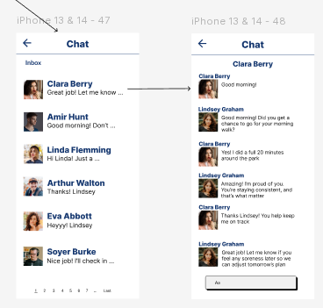

**Table 5.6.1**

*Function-To-Screen Mapping Table*

|  |  |  |
| --- | --- | --- |
| **Function** | **Screen Names or #’s** | **Trigger/Action** |
| Open conversation list | Chat/Inbox Screen | Tap “Messages” icon |
| Open conversation (patient/caregiver) | Chat Detail Screen | Select a conversation from list |
| Send text message | Chat Detail Screen | Tap **Send** button |
| Recieve New Message | Chat Detail Screen | Incoming message event / Push notification |

### Audio and Video Calling

**Description:** Audio and Video Calling enables caregivers and patients to conduct real-time voice or video conversations within the CareConnect app. Caregivers and patients shall be able to initiate an in-app call (audio or video) with one another, using the device’s microphone and camera as needed. The feature establishes a peer-to-peer (or server‑mediated) media session so both parties can see/hear each other live. Calls are secured and integrated into the app; no external teleconferencing app is required for one-on-one caregiver–patient calls. (Separate “Telehealth Bridge” handles calls with healthcare providers via Zoom.)

**Actors:**

* *Caregiver:* Initiates or answers calls to/from the patient; primary participant in call.
* *Patient:* Initiates or answers calls to/from the caregiver; primary participant.
* *System:* Secondary actor that manages call setup, signaling, and media relay.

**Flow:**

**Initiate Call:** User (caregiver or patient) navigates to a contact/chat screen and taps an **Audio Call** or **Video Call** button next to the contact’s name.

**Permission Check:** The app checks for microphone (and camera, for video) permissions. If not granted, it prompts the user to allow access.

**Outbound Signaling:** The app sends a call invitation to the backend communication service, indicating the call type (audio/video) and target user.

**Incoming Ring:** The recipient’s app receives a push notification or in-app alert showing an incoming call (with caller name and audio/video choice). The recipient taps “Accept” or “Decline.”

**Call Setup:** On “Accept,” both parties establish a real-time media connection (e.g. WebRTC). Audio (and video if selected) streams begin flowing between devices. The app shows the live call screen (with speaker, mute, camera on/off, end buttons).

**In-Call State:** Both users communicate until one ends the call. The UI may display connection status and manage switching cameras, muting mic, etc.

**End Call:** Either party taps **End Call**; the app tears down the media session. The system logs the call metadata (timestamp, duration, participants). Users return to the previous screen (e.g. chat or dashboard).

**Inputs/Outputs:**

*Inputs*: Audio stream data (microphone), video stream data (camera, if video call); call control signals (mute, camera toggle).

*Outputs*: Live audio/video streams to the other party; call metadata (start/end time, call type) recorded in backend; (optional) push notifications for incoming call; call duration metrics.

**Edge Cases:**

* **Permission Denied:** If the user denies mic/camera access, the app should cancel the call setup and show an error (e.g. “Cannot start call without microphone access.”).
* **Network Issues:** Poor bandwidth may degrade call quality or cause disconnection. The app should attempt to adjust quality (e.g. reduce video resolution) and notify users if the call disconnects.
* **No Answer:** If the recipient does not answer within a timeout period (e.g. 30 seconds), the call attempt ends and the caller is notified (“No answer”).
* **Call Busy:** If one user is already on another call, the app should show “User is busy” and fail the new call attempt.
* **App in Background:** If the app is backgrounded or killed, incoming calls should still trigger a push notification (if device supports it); otherwise, the call may be missed.
* **Device Interruptions:** Incoming phone calls or other interruptions should pause/end the CareConnect call gracefully.

**UI/UX:**

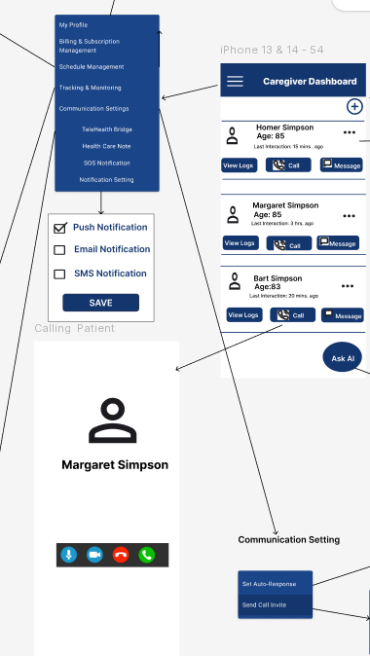

**Table 5.6.2**

**Function-To-Screen Mapping Table**

|  |  |  |
| --- | --- | --- |
| **Function** | **Screen Name or #** | **Trigger Action** |
| Start Audio Call | Call Screen | Tap Audio Call button |
| Start Video Call | Call Screen | Tap Video Call button |
| Answer Incoming Call | Call Screen | Tap Accept on call alert |
| End Call | Call Screen | Tap End/Hang Up button |

### Emergency SOS Mode

**Description:**

This feature shall allow a caregiver to respond to an emergency notification from their assigned patient. This feature shall also allow a patient to press a button to send an emergency notification to a chosen caregiver. If an emergency SOS is created and the patient wants to cancel, the patient may cancel the emergency SOS notification. If the notification is not acknowledged by the caregiver in a configured amount of time, the backup caregiver will be notified of the emergency SOS notification. If the backup caregiver does not acknowledge the emergency SOS notification, the emergency services will be notified. When a caregiver acknowledges the emergency SOS notification, the patient’s live location and last 30 seconds of audio will be presented to the caregiver.

**Actors:**

Caregiver: Receives and acknowledges Emergency SOS notification, views patient’s location, listens to audio.

Patient: Sends Emergency SOS notification, confirms sending live location and last 30 seconds of audio.

External System: Amazon S3

**Flow:**

Patient taps “Emergency SOS” button on patient dashboard.

Application double checks if emergency SOS notification should be sent to caregiver.

If patient cancels, process stops.

If patient confirms, the application makes request to retrieve patient’s live location. Application also makes request to in program to start and stop recording message to send to caregiver.

Location and audio message are shared in Amazon S3 table. The audio message is saved in the Message table. The location data is saved in the Location table.

Notification with information is sent to the caregiver on schedule.

Notification shows up in caregiver’s device.

Caregiver acknowledges the emergency sos notification.

Application retrieves the stored location and audio message of the patient sending the emergency sos notification.

If, caregiver ignores the notification. The backup caregiver is notified.

If the backup caregiver does not acknowledge the notification, emergency services are called.

**Inputs/Outputs (OpenAI, 2025):**

Inputs:

**GPS sensor**: Gets satellite-based position

**Wi-Fi / Cell triangulation**: Approximate location when GPS is weak

**User permission**: Must be granted for location access

**Flutter plugin**: Uses geolocator, location, or google_maps_flutter packages

Outputs:

**Coordinates**: Latitude & longitude

**Map visualization**: Location showed on a map

**Backend update**: Location and audio sent to server for tracking or alerts

**Edge Cases (OpenAI, 2025):**

* **No Internet Connectivity:** Queue SOS locally and retry sending; show “Pending” status and retry in background
* **Location Services Disabled or Denied:** Prompt user for permission; fall back to last known location or prompt for manual entry.
* **Microphone Permission Denied:** Notify user to enable permissions; send SOS with location only and log the issue.
* **Caregiver Unavailable or Offline:** Escalate to backup caregiver after timeout.
* **Backup Caregiver Also Unreachable:** System triggers alert to emergency services (911 integration, or third contact fallback).
* **False Alarm or Accidental Trigger:** Add confirmation prompt or 5-second countdown with a “Cancel” option.
* **Audio Not Recorded or Corrupted:** Still send SOS and location; log error; consider a retry for audio or fallback to text summary.
* **Location Incorrect or Outdated:** Send both current and last known location; show timestamp of GPS fix; use Wi-Fi fallback.
* **User Cancels SOS After It’s Sent:** Notify caregiver of cancellation but allow caregiver to check in anyway if needed.

**UI/UX:**

**Table X**

*Function-To-Screen Mapping Table for Emergency SOS*

|  |  |  |
| --- | --- | --- |
| Function | Screen Names or #’s | Trigger/Action |
| Notify caregiver of Emergency SOS | Patient Dashboard | Press button to notify Emergency SOS |
| Confirm send Emergency SOS notification to caregiver | Emergency SOS confirmation screen | Capture live location  Capture audio  Notify caregiver of emergency SOS |
| Cancel Emergency SOS | Emergency SOS cancel screen | Cancels Emergency SOS notification |
| Acknowledge Emergency SOS notification | Emergency SOS Notification screen | Acknowledge Emergency SOS notification |
| Share location and audio | Emergency SOS Details screen | Share live location and audio to caregiver. |

Emergency SOS API Design:

Endpoint: POST /api/emergency/sos

Purpose: Implements emergency alert feature as described in SRS REQ-5.8.3.1 to REQ-5.8.3.3.

Request Example:

POST /api/emergency/sos

Authorization: Bearer {token}

Content-Type: application/json

{ "latitude": 39.12345, "longitude": -76.54321 }

Response Example:

{ "status": "success", "message": "SOS alert sent to caregivers." }

Method Signature (Java/Spring Boot):

public class EmergencySOSService { public void triggerSosAlert(UUID patientId, double latitude, double longitude) { /* implementation */ } }

### Virtual Check-In Rounds

**Description:**

When a caregiver is signed into their account, they shall create a set of questions regarding the patient’s physical care to send and notify the patient on the application. The patient shall answer the questions, and the caregiver shall receive the patient’s responses. When a patient is signed into their account, they shall receive a notification from the application of the need to complete a virtual check-in questionnaire. The patient shall answer the questions, and the caregiver shall receive the patient’s responses.

**Actors:**

Caregiver: Create set of questions and cadence for check-in. Notified when check-in is completed or not by patient.

Patient: Notified of the need to complete check-in. Sends check-in answers.

External: Amazon S3 to store check-in data.

**Flow:**

Caregiver creates a set of questions to ask the patient during a check-in

Caregiver selects an hourly cadence for when to notify the patient of the need to complete a check-in

Caregiver submits the check-in selections

Patient is notified in set cadence of need to complete check-in

Patient completes the questions

Patient submits the answers to the application

The application saves the answers in corresponding Mood/Meal/Symptom tables

Caregiver is notified of check-in submission

**Inputs/Outputs (OpenAI, 2025):**

Inputs:

**Caregiver check-in setup**: Custom questions created (e.g., mood, meal, symptom)

**Notification cadence**: Frequency selected (e.g., hourly, daily)

**Patient response data**: Answers entered through form interface

**User authentication**: Caregiver and patient must be signed in

**UI interaction**: Flutter form screens to input and submit responses

**Backend API**: Receives and processes form configurations and responses

Outputs:

**Patient notifications**: Alerts triggered on patient device per cadence

**Check-in form display**: UI renders questions for patient to complete

**Caregiver notifications**: Confirmation when patient completes (or misses) check-in

**Data storage**: Responses saved to backend in Mood/Meal/Symptom tables

**Status dashboard**: Caregiver can view submission status and historical responses

**Edge Cases (OpenAI, 2025):**

**Patient dismisses or ignores notification repeatedly**: Trigger escalation or reminders after a threshold is reached

**Notification service fails or is delayed**: Allow for retries to notify patient

**Backend receives malformed or empty response data**: Add validation logic to prevent database corruption

**UI/UX:**

Table X

*Function-To-Screen Mapping Table*

|  |  |  |
| --- | --- | --- |
| Function | Screen Names or #’s | Trigger/Action |
| Caregiver check-in setup | Caregiver dashboard | Create set of questions for check-in  Select hourly cadence for patient notification  Send check-in to storage |
| Patient notified of check-in | Virtual check-in notification screen | Request patient to complete check-in process |
| Patient completes check-in questions | Virtual check-in screen | Save check-in answers to storage tables |

### Telehealth Bridge

**Description:**

CareConnect shall integrate with Zoom to enable telehealth bridge calls between patients and their healthcare providers. Within CareConnect, a one-click button shall be available on the calendar to allow for a one-click action to join the scheduled telehealth bridge call. The telehealth bridge shall provide functionality to let patients prepare a set of questions for reference during the telehealth bridge.

Actors:

Caregiver: Create telehealth session. Join zoom call. Add to questions/appointment notes.

Actor: Join zoom call. Add to questions/appointment notes.

External: Zoom API to handle telehealth session. Microphone to record patient voice for notes.

Flow:

Telehealth session is created by caregiver.

Session is added to caregiver and patient’s calendar

Patient may add notes or questions in notes of appointment.

Notes are added to Notes storage.

Application notifies patient and caregiver of telehealth session.

Patient and caregiver may join telehealth session.

Application launches Zoom API call to direct caregiver and patient to Zoom telehealth session with the click of the telehealth link.

**Inputs/Outputs (OpenAI, 2025):**

Inputs:

* **Caregiver session creation**: Initiates the scheduling of a Zoom session (e.g., selects date/time).
* **Zoom API credentials**: Required for creating/joining the Zoom meeting (OAuth token or API key).
* **Patient and caregiver profiles**: Must have valid user accounts to associate with session.
* **Patient notes/questions**: Optional notes submitted by the patient before the session.
* **Calendar integration**: Accepts session details to update both caregiver and patient calendars.
* **Join request (clicking join link)**: User action to initiate the session.

Outputs:

* **Zoom meeting created**: Meeting ID, URL, and metadata returned from Zoom API.
* **Calendar update**: Telehealth session appears in patient and caregiver calendars.
* **Notes saved**: Patient’s pre-visit notes stored in a secure Notes table or S3 bucket.
* **Notifications sent**: Both parties receive reminders via app (push/email/SMS).
* **Zoom link launched**: App opens Zoom client or browser to begin the session.

**Edge Cases (OpenAI, 2025):**

**Zoom API token is expired or invalid**: App should catch error, prompt re-authentication, or retry.

**Caregiver schedules overlapping sessions**: Warn or block if double-booking is not supported

**Notification fails to send**: Retry with fallback

**Zoom link is broken, expired, or invalid**: Show an error and provide troubleshooting steps or an alternate way to join

**Pre-visit notes fail to save**: Alert the patient and queue retry, or store locally until sync is successful.

**UI/UX:**

**Table X**

*Function-To-Screen Mapping Table*

|  |  |  |
| --- | --- | --- |
| Function | Screen Names or #’s | Trigger/Action |
| Patient adds appointment questions/notes to telehealth session details | Telehealth Add Notes Screen | Input text or use microphone to input patient questions  Send questions to storage |
| Patient and caregiver are notified on their respective calendars of telehealth session | Telehealth notification screen | Alert patient to join telehealth session |
| Caregiver and patient join telehealth session | Join telehealth session screen | Call Zoom API to launch telehealth session |
| Caregiver and/or patient refer to notes during telehealth session | Telehealth details screen | Retrieve notes for telehealth session from storage |

### Voice-Activated Commands

Description:

The Voice-Activated Commands feature enhances the accessibility of CareConnect by enabling users to interact with the application via voice inputs. Users can perform key tasks and navigation by issuing spoken commands, significantly improving usability for individuals with mobility or visual impairments.

Actors:

**User**: Initiates and speaks voice commands into the microphone to interact with CareConnect.

**Speech Recognition Module**: Captures audio input from the user, processes and converts it into actionable textual commands.

**System UI**: Provides visual and auditory indicators and feedback to users about the current state (listening, executing commands, errors).

**Command Processor**: Matches transcribed voice inputs with predefined commands and initiates the corresponding actions within the application.

Flow:

* + - 1. User initiates voice command functionality by activating the microphone icon or using a specific activation keyword (e.g. “Hey CareConnect”).
      2. The system enters listening mode, indicated visually and audibly.
      3. User speaks a clearly articulated command.
      4. The Speech Recognition Module processes and transcribes the voice input into actionable text.
      5. The Command Processor matches transcribed text with predefined commands.
      6. Appropriate action or navigation is executed.
      7. Feedback is provided through visual and auditory confirmation.

**Inputs/Outputs:**

Inputs:

* **Audio Input**: User voice captured through the microphone.

Outputs:

* **Transcribed Text**: Converted audio input into textual command.
* **Execution Response**: Visual/auditory confirmation indicating the action taken.

Edge Cases:

* **Unrecognized Commands**: User command is not recognized; system responds with a prompt to repeat clearly or offers command suggestions.
* **Ambient Noise**: High levels of background noise impacting clarity; system prompts the user to repeat in a quieter environment.
* **Multiple Commands in Quick Succession**: System queues commands and attempts to execute them sequentially, providing appropriate feedback after each action.
* **Misinterpretation of Similar Sounding Commands**: System asks for clarification or confirmation before proceeding.

UI/UX:

**Table X**

*Voice-Activated Commands* *Function-To-Screen Mapping Table*

|  |  |  |
| --- | --- | --- |
| Function | Screen Names or #’s | Trigger/Action |
| Activate Voice Input | Main Navigation Bar, Interaction Screens | When the User taps icon/button or uses activation keyword(s), the System enters Listening mode. |
| Indicate Listening | Main Interaction Screens | When the system enters Listening mode, the UI displays visual and auditory cue. |
| Confirm Command Execution | Main Interaction Screens, Command Confirmation Screen | Upon execution of a command, the UI displays a visual and auditory confirmation reports the result to the user. |
| Prompt for Clarification | Main Interaction Screens, Prompt Clarification Screen | When a command is unclear or misinterpreted, the UI displays a visual and auditory prompt for clarification |

## Wearable Integration

Description:

The Wearable Integration subsystem enables CareConnect to seamlessly collect, synchronize, and analyze health data from popular wearable devices and health platforms including Apple Health, Fitbit, and Google Health Connect. This integration provides real-time and historical health metrics such as heart rate, step count, sleep patterns, blood oxygen levels, and activity data to support comprehensive patient monitoring and care plan optimization. The system employs secure OAuth 2.0 authentication flows, and data synchronization to ensure accurate, timely, and secure health data collection. The integration supports both automatic periodic synchronization and manual data refresh capabilities, enabling caregivers to access up-to-date patient health insights for informed care decisions and early detection of health pattern changes.

Actors:

* **Primary Caregiver**: Monitors patient health data, receives alerts based on wearable data anomalies.
* **Patient**: Authorizes device connections, manages settings, views personal health data trends.
* **Family Member**: Views aggregated health summaries.
* **External Systems**: Apple Health, Fitbit API, Google Health Connect platform

Flow:

1. **Initial Setup Phase**: Patient or caregiver initiates wearable device connection from the CareConnect settings menu.
2. **Authentication Flow**: System redirects to device-specific OAuth authorization (Apple HealthKit permissions, Fitbit OAuth, Google Health Connect authorization)
3. **Permission Configuration**: User grants specific data access permissions (heart rate, steps, etc.)
4. **Connection Validation**: The System validates API credentials.
5. **Synchronization Setup**: Automatic sync schedules are configured.
6. **Data Processing**: Retrieved data normalized, validated, and stored.
7. **Alert Processing**: The System analyzes incoming data against predefined thresholds and generates alerts for caregivers when anomalies are detected.
8. **Dashboard Updates**: Real-time health metrics are updated in patient dashboards and caregiver monitoring views.
9. **Trend Analysis**: Historical data processed for pattern recognition and health trend visualization.
10. **Maintenance Cycle**: Periodic token refresh, connection health checks, and data integrity validation.

Inputs/Outputs:

**Inputs:**

* **Apple Health Data**: Heart rate (BPM), step count, distance walked, calories burned, sleep analysis, blood oxygen saturation, ECG readings (if available), workout sessions
* **Fitbit Data**: Heart rate zones, active minutes, sleep stages and other available data.
* **Google Health Connect Data**: Heart rate (BPM), step count, distance walked, calories burned, sleep analysis, blood oxygen saturation, ECG readings (if available), workout sessions.
* **User Configurations**: Sync frequency preferences, data sharing permissions, alert threshold settings
* **Authentication Tokens**: OAuth access tokens, refresh tokens, API keys with appropriate scopes

**Outputs:**

* **Normalized Health Metrics**: Standardized health data format across all platforms for consistent display and analysis.
* **Alerts**: Notifications to caregivers for health changes (irregular heart rate, extended inactivity, poor sleep patterns).
* **Health Trend Reports**: Health summaries with visualizations and insights.
* **Dashboard Widgets**: Live health metric displays in patient and caregiver interfaces

Edge Cases:

* **Connection Failures**: Handle API rate limiting, network timeouts, and temporary service outages with automatic retry mechanisms and user notifications
* **Data Inconsistencies**: Validation algorithms to detect and handle conflicting data from multiple sources, duplicate entries, and impossible values
* **Partial Data Availability**: Handling when only subset of requested data types is available from specific platforms
* **Sync Conflicts**: Resolution strategies for competing data from multiple devices.
* **Offline Scenarios**: Data queuing and batch synchronization when connectivity is restored
* **Account Linking Errors**: Clear error messaging and recovery paths for failed OAuth flows or account mismatches

**Table 5.9**

***Wearable Integration Function-To-Screen Mapping Table***

| **Function** | **Screen Names or #'s** | **Trigger/Action** |
| --- | --- | --- |
| Initiate Device Connection | Settings > Connected Devices | Tap "Add Wearable Device" button |
| Apple Health Authorization | OAuth Web View | Redirect to HealthKit permission screen |
| Fitbit OAuth Flow | OAuth Web View | Redirect to Fitbit authorization portal |
| Google Health Connect Setup | OAuth Web View | Redirect to Google Health Connect permissions |
| View Connected Devices | Connected Devices Dashboard | Navigate from the main settings menu |
| Manual Data Sync | Connected Devices Dashboard | Tap refresh icon on device card |
| Configure Sync Settings | Device Settings Modal | Tap gear icon on connected device |
| View Health Data Trends | Health Dashboard | Automatic display after successful sync |
| Disconnect Device | Device Settings Modal | Tap "Disconnect" with confirmation dialog |

## Smart Home Integration and Monitoring

Description:

The Smart Home Integration and Monitoring subsystem seamlessly connects CareConnect with popular smart home ecosystems to provide comprehensive home environment monitoring. Through Amazon Alexa Smart Home Skills integration, patients and caregivers can use voice commands for hands-free interaction with connected devices. The Google Nest API integration enables real-time home monitoring through security cameras. This dual integration approach creates enhanced visibility into patient well-being and home safety.

Actors:

* **Patient**: Uses voice commands for device interaction.
* **Primary Caregiver**: Monitors home environment for patient.
* **Family Members**: Monitors home environment for patient.
* **Smart Home Devices**: Amazon Echo devices, Google Nest cameras, motion sensors, environmental sensors
* **External APIs**: Amazon Alexa Skills Kit, Google Nest Device Access API.

Flow:

1. **Smart Home Discovery**: System scans for compatible devices on local network and prompts user for integration setup
2. **Alexa Skills Configuration**: User enables CareConnect Alexa Skill and links account through secure OAuth flow
3. **Google Nest Authorization**: Caregiver authorizes Nest device access through Google OAuth with specific camera and sensor permissions
4. **Device Registration**: Compatible devices registered in CareConnect with custom names and monitoring preferences
5. **Real-time Monitoring**: Continuous data collection from Nest devices.
6. **Maintenance Monitoring**: Automated device health checks, and connectivity validation.

Inputs/Outputs:

**Inputs:**

* **Voice Commands**: Alexa voice interactions for smart device control.
* **Nest Camera Data**: Motion detection events.
* **Device Status**: Smart home device connectivity.
* **User Preferences**: Voice commands.

**Outputs:**

* **Alerts**: Immediate notifications for camera actions.

Edge Cases:

* **Device Connectivity Loss**: Graceful handling of temporary Wi-Fi outages with automatic reconnection.
* **Voice Recognition Failures**: Fallback mechanisms when Alexa misunderstands commands.
* **Camera Privacy Concerns**: Immediate camera disabling capabilities and clear visual indicators when monitoring is active
* **Account Linking Failures**: Clear troubleshooting paths for OAuth failures and account permission issues

**Table 5.10**

***Smart Home Integration Function-To-Screen Mapping Table***

| **Function** | **Screen Names or #'s** | **Trigger/Action** |
| --- | --- | --- |
| Smart Home Setup Hub | Smart Home Dashboard | Navigate from main settings menu |
| Enable Alexa Skill | Alexa Integration Screen | Tap "Connect Alexa Device" button |
| Alexa Account Linking | OAuth Web View | Redirect to Amazon OAuth portal |
| Nest Device Authorization | Nest Integration Screen | Tap "Connect Google Nest" button |
| Google Nest OAuth Flow | OAuth Web View | Redirect to Google Nest permissions |
| View Connected Devices | Smart Home Dashboard | Automatic display after successful connection |
| Configure Device Settings | Device Configuration Modal | Tap gear icon on device card |
| Disconnect Smart Devices | Device Management Screen | Individual device disconnection options |

## Gamification

**Description:**

The Gamification feature incentivizes patient engagement through rewards such as XP (experience points), levels, and achievements. It tracks user activity, especially task completions, and provides motivational feedback in the form of visual progress, badges, and goal statuses.

This system motivates continued interaction with CareConnect by turning health-related behaviors into a reward-based structure.

**Actors:**

Primary Actor: Patient

Secondary Actor: Caregiver, Gamification Microservice, Backend API

**Flow**

**Patient Side:**

Patient logs in and accesses the dashboard.

The patient completes one or more health-related tasks (e.g., mood log, hydration tracking, medication check-in)

Each task completion triggers a backend event through the /v1/tasks/complete API.

The Gamification Microservice calculates, updates XP, badge progress, and achievement unlocks.

The patient navigates to the “Gamification” screen via the navigation drawer to view:

Current XP and level

A visual progress bar

A list of earned and locked achievements

(Optional) A leaderboard for comparative insights (future enhancement)

**Caregiver Side:**

The caregiver logs into the system and navigates to the caregiver Dashboard.

The caregiver selects a patient profile from the list.

The system displays patient-specific gamification metrics, including:

XP trends over time (daily or weekly)

Earned badges and levels

Task completion streaks and compliance history

The caregiver may optionally send motivational messages to patients based on progress (future enhancement).

**Input/Output**

|  |  |  |
| --- | --- | --- |
| User Type | Inputs | Outputs |
| Patient | Task completion events, daily logins, system-triggered streaks | XP points, level updates, unlocked achievements, updated user interface (UI) |
| Caregiver | Selected patient profile | Patient XP stats, badge records, last activity, consistency tracking logs |

**Edge Cases**

**Duplicate Task Event:** The backend includes logic to debounce duplicate inputs, preventing multiple XP awards from rapid repeated submissions.

**Offline Task Completion:** If the patient is offline, tasks are stored locally and synchronized once connectivity is restored.

**Backend Timeout:** If the backend does not respond in time, a cached version of the gamification screen is displayed, with a prompt to retry.

**Caregiver Access Error:** If a caregiver lacks appropriate permissions, the system provides an error screen explaining access restrictions.

**XP Overflow or Level Skipping:** XP thresholds and progression logic are validated server-side to prevent unauthorized leveling.

**UI/UX Design**

**Patient View – Gamification Screen**

Header with application name and gamification icon

XP progress bar showing current level progress

Section for earned badges and locked achievements

Visual tracker for task streaks

(Optional) Leaderboards section to display top participants

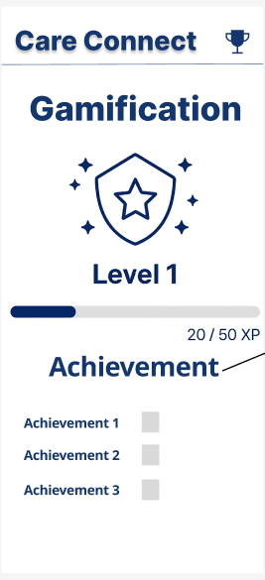

Achievement Detail Screen

Achievement title (e.g., “Three-Day Streak”)

Description outlining the criteria to unlock the badge

Visual Progress indicator (e.g., 2 out of 3 tasks completed)

Status indicator: either a checkmark for completed or a lock symbol for locked achievements

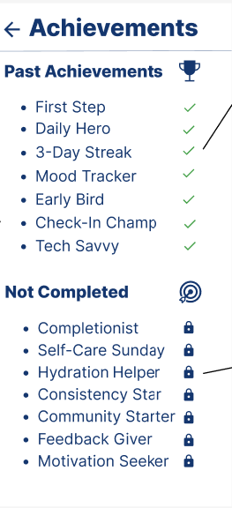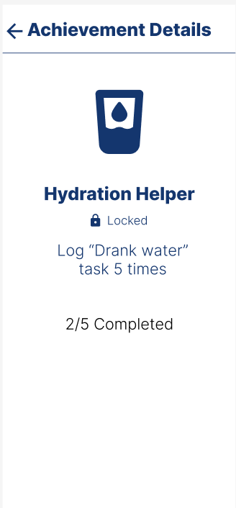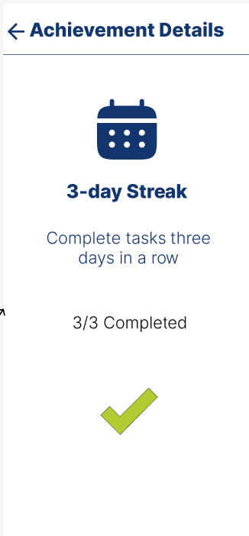

Caregiver View – Gamification Stats Panel

XP trend charts (e.g., bar or line graphs)

Badge distribution visuals (e.g., pie charts or categorized lists)

Compliance consistency data (e.g., heat maps or logs showing activity frequency)

(Optional) A button labeled “Send Encouragement” for motivational outreach

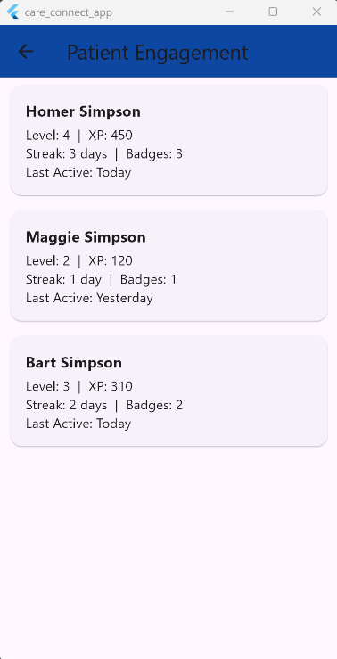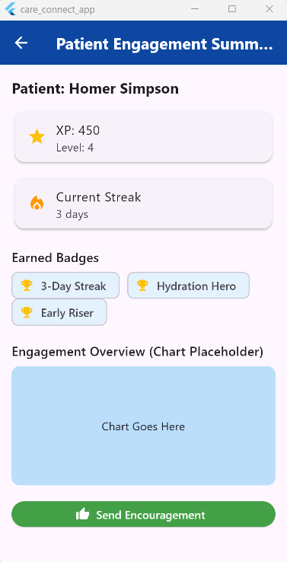

**Table X**

*Function-to-Screen Mapping Table*

|  |  |  |
| --- | --- | --- |
| Function | Screen Name(s) | Trigger/Action |
| View Gamification Summary | GamificationScreen (Patient) | Tap “Gamification” from mthe navigation drawer |
| Award XP and Unlock Badge | Backend Microservice | Automatically triggered upon task completion |
| View Badges and Level | GamificationScreen | Auto-loaded r by tapping the badges section |
| View Achievement Detail | AchievementDetailScreen | Tap an individual badge or XP element |
| View Patient Progress | CaregiverGamificationScreen | Select patient in caregiver dashboard |
| Send Encouragement (optional) | CaregiverGamificationScreen | Tap “Send Encouragement” button (future implementation) |
| View Leaderboard (optional) | GamificationScreen | Tap “Leaderboard” Tab (future implementation) |

## User Roles & Management

### Caregiver Profile

**Description:**

This feature shall allow a caregiver to view and edit their profile information that is displayed or used within the CareConnect application. The caregiver has the ability to view and edit their display name, email address, phone number, physical address, specialties, and profile picture. The display name and profile picture will be shown to the caregiver’s patients on the Patient Dashboard screen. The caregiver’s specialties will be shown to the patient on the caregiver details of the Patient Dashboard.

**Actors:**

Caregiver: Views and edits their profile information into the CareConnect app.

**Flow:**

The caregiver logs into CareConnect.

The caregiver opens the Caregiver Dashboard.

The caregiver opens the settings/management hamburger menu for more actions.

The caregiver opens My Profile.

The caregiver views/edits their profile information as needed.

If the caregiver exits the screen without clicking Save, the information is not saved to the database.

The caregiver clicks the “Save” button.

All caregiver information is saved to the database.

**Inputs/Outputs:**

**User changes**: Information was changed and Saved on the Caregiver Profile screen.

**Backend update**: Information is saved to the caregiver’s profile within the database.

**Edge Cases:**

**Loss of Internet Access**: The backend call to store caregiver information to the database may be unsuccessful without internet connectivity present on the device.

**Table X**

Function-To-Screen Mapping Table for Caregiver Profile

|  |  |  |
| --- | --- | --- |
| Function | Screen Names or #’s | Trigger/Action |
| Opens the Caregiver Profile screen. | Caregiver Dashboard | Press the menu button for user settings / management. |
| Sends information to backend database. | Caregiver Profile | Edits information and presses save. |

### Patient Profile

**Description:**

This feature shall allow a patient to view to edit their profile information that is displayed or used within the CareConnect application. The patient has the ability to view and edit their display name, email address, phone number, physical address, and profile picture. The display name and profile picture will be shown to the patient’s caregiver(s) on the Caregiver Dashboard screen. The patient’s unique QR Code can also be viewed from the Caregiver Dashboard. This QR Code can be scanned by a caregiver from the Add New Patient screen menu to autofill all the form information including patient’s name, relationship, email, and notes.

**Actors:**

Patient: Views and edits their profile information into the CareConnect app. Accesses their QR Code for Profile Linking to caregiver(s).

**Flow:**

The patient logs into CareConnect.

The patient opens the Patient Dashboard.

The patient opens the settings/management hamburger menu for more actions.

The patient opens My Profile.

The patient views/edits their profile information as needed.

If the patient exits the screen without clicking Save, the information is not saved to the database.

The patient clicks the “Save” button.

All patient information is saved to the database.

**Inputs/Outputs:**

**User changes**: Information was changed and Saved on the Patient Profile screen.

**Backend update**: Information is saved to the patient’s profile within the database.

**Edge Cases:**

**Loss of Internet Access**: The backend call to store patient information to the database may be unsuccessful without internet connectivity present on the device.

**Table X**

Function-To-Screen Mapping Table for Patient Profile

|  |  |  |
| --- | --- | --- |
| Function | Screen Names or #’s | Trigger/Action |
| Opens the Patient Profile screen. | Patient Dashboard | Press the menu button for user settings / management. |
| Sends information to backend database. | Patient Profile | Edits information and presses save. |

### Multi-Caregiver Support

**Description:**

This feature shall allow multiple caregivers to be linked to one patient. The caregiver has the ability to add or invite the patient after the patient has already been linked to another caregiver. Each patient that the caregiver supports shall be listed on their Caregiver Dashboard list of patients. Each caregiver that the patient is linked to shall appear on their Patient Dashboard list of caregivers.

**Actors:**

Caregiver: Links to multiple patients as their caregivers.

Patient: Shall be supported by multiple caregivers if such links exist.

**Flow:**

*Caregiver 1* logs into CareConnect.

*Caregiver 1* opens the Caregiver Dashboard.

*Caregiver 1* opens the Add New Patient form.

*Caregiver 1* adds the patient, linking them together.

*Caregiver 2 logs into CareConnect.*

*Caregiver 2* opens the Caregiver Dashboard.

*Caregiver 2* opens the Add New Patient form.

*Caregiver 2* adds the patient, linking them together.

*Caregiver 1* and *Caregiver 2* are successfully linked to the patient.

Both caregivers appear on the patient’s Patient Dashboard.

The patient appears on both caregivers’ Caregiver Dashboard.

**Inputs/Outputs:**

**Both caregivers add patient**: The Add New Patient form was submitted from both caregivers.

**Backend update**: Both caregivers were linked to the patient.

**Edge Cases:**

**Loss of Internet Access**: The backend call to link caregivers to patients in the database may be unsuccessful without internet connectivity present on the device.

**Table X**

Function-To-Screen Mapping Table for Multi-Caregiver Support

|  |  |  |
| --- | --- | --- |
| Function | Screen Names or #’s | Trigger/Action |
| Open the Add New Patient screen. | Caregiver Dashboard | Press the “+” button. |
| Link caregiver to patient. | Add New Patient screen | Add patient information and press “Submit”. |
| Link another caregiver to patient. | Add New Patient screen | Add patient information and press “Submit”. |

### Profile Linking

**Description:**

This feature shall allow a caregiver to be linked to a patient, allowing for the caregiver to monitor patient information, as well as add/edit/delete patient records. The caregiver shall add or invite the patient from the “+” button on the Caregiver Dashboard screen. When a patient has been linked to a caregiver, the patient shall be listed on the caregiver’s Caregiver Dashboard list of patients that they support. Likewise, the caregiver shall be listed in the patient’s Patient Dashboard list of caregivers.

**Actors:**

Caregiver: Link to patient as their caregiver. Has access to patient records.

Patient: Shall be supported by their linked caregiver.

**Flow:**

The caregiver logs into CareConnect.

The caregiver opens the Caregiver Dashboard.

The caregiver opens the Add New Patient form.

The caregiveradds the patient, successfully linking them together.

The caregiver appears on the patient’s Patient Dashboard.

The patient appears on the caregiver’s Caregiver Dashboard.

**Inputs/Outputs:**

**Caregiver adds new patient**: The Add New Patient form was submitted by the caregiver.

**Backend update**: The caregiver is linked to the patient.

**Edge Cases:**

**Loss of Internet Access**: The backend call to link a caregiver to a patient in the database may be unsuccessful without internet connectivity present on the device.

**Table X**

*Function-To-Screen Mapping Table for Profile Linking*

|  |  |  |  |
| --- | --- | --- | --- |
| Function | Screen Names or #’s | Trigger/Action | |
| Open the Add New Patient screen. | Caregiver Dashboard | Press the “+” button. | |
| Link caregiver to patient. | | Add New Patient screen | Add patient information and press “Submit”. |

### Access Control & Permissions

**Description:**

This feature governs the amount of access to application features that a caregiver and a patient will be given when using CareConnect. The caregiver shall have the ability to link to patients, view, edit, and delete patient records, monitor patient vitals, view patient emotions and stress levels, assign scheduled tasks to patients, and delete patients from their care. The patient shall have the ability to input their emotions and stress levels, complete their assigned tasks, and delete caregivers from their care.

**Actors:**

Caregiver: Has access to all features of CareConnect to provide ample support to the patient.

Patient: Has limited access to features of CareConnect to display their care needs.

**Flow:**

The caregiver logs into CareConnect.

The caregiver opens the Caregiver Dashboard.

The caregiver has access to all features.

The patient logs into CareConnect.

The patient opens the Patient Dashboard.

The patient has limited access to features.

Table X

Function-To-Screen Mapping Table

|  |  |  |
| --- | --- | --- |
| Function | Screen Names or #’s | Trigger/Action |
| Caregiver Access | Caregiver Dashboard | Caregiver logs into the app |
| Patient Access | Patient Dashboard | Patient logs into the app |

## Social Networking

**Description:**

The Social Networking module in CareConnect enables patients and caregivers to engage through community updates, chat messaging, contact management, and support coordination. It promotes a sense of connection among users by allowing them to post updates, send direct messages, maintain a care circle, and manage interactions with family, friends, and professional caregivers. Caregivers additonally manage patient scheduling and onboarding.

**Actors**

* **Primary:** Patient, Caregiver
* **Secondary:** Backend Messaging API, Scheduling Service

**Flow**

**Patient Side:**  
1. Log in to view the community feed (posts from others in their circle).

2. Tap to like a post, comment, or create a new status update.

3. Access inbox to chat with approved contacts.

4. View or manage friend/family connections.

**Caregiver Side:**

1. Log in to caregiver dashboard.

2. Tap on “Community” to monitor or interact.

3. Navigate to “Connect with Friends & Family” to view or add contacts to a patient’s care circle.

4. Use “Schedule Care” to assign care sessions via calendar.

5. Tap patient from chat list to open full conversation thread.

**Inputs/Outputs**

|  |  |  |
| --- | --- | --- |
| **Type** | **Inputs** | **Outputs** |
| Patient | Status post, reactions messages | Feed updates, chat responses |
| Caregiver | Patient management, chat messages, scheduling input | Chat threads, patient status, schedule view |
| System | Profile data, timestampts, role-based permissions | Filtered content feed, connection lists |

**Edge Cases**

* **Message Failure (Offline):** Chat shows “Message not sent” with retry option.
* **Blocked/Removed Contact:** No further messaging or feed visibility.
* **Role Restriction:** Only caregivers see the “Schedule Care” and “Add Patient” buttons.
* **Duplicate Invite:** Backend blocks repeated invites to same contact.

**UI/UX Design**

**Community Feed:**

* Scrollable timeline of status posts from connected users.
* User avatar, name, post content, time, ,and interactive icons (like, comment).
* Bright, engaging design to promote positivy.

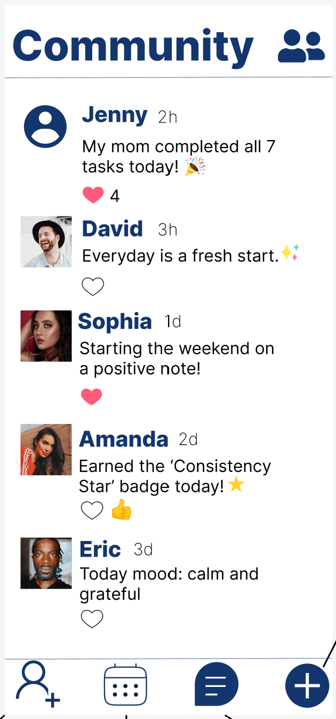

**Chat Interface:**

* Inbox list of contacts with message previews and timestamps.
* Conversation screen includes name header, avatars, and message bubble format.
* Input field and send button at the bottom.

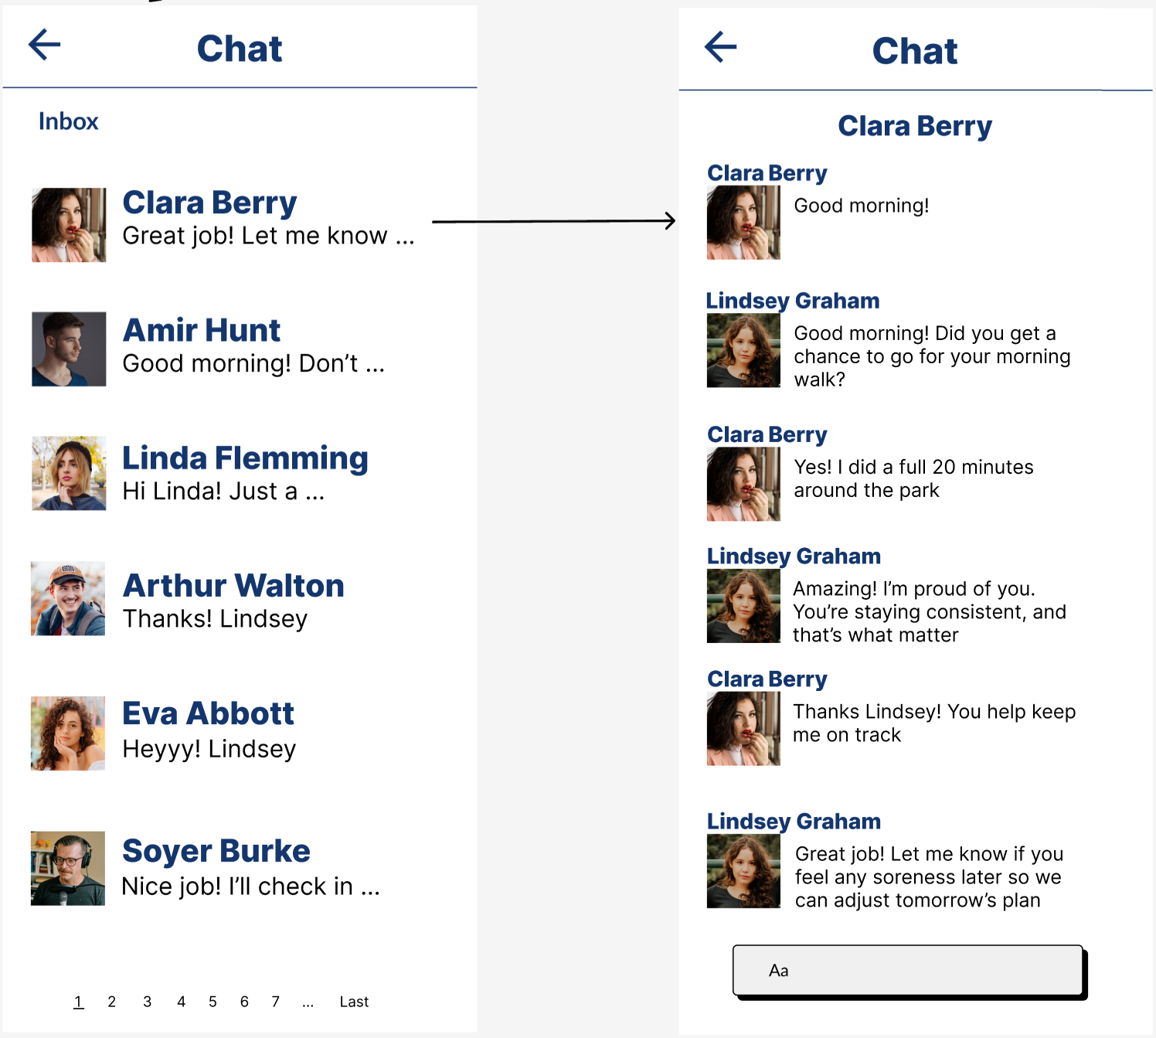

**Connect Screen:**

* Search bar and filter by contact type (Family, Friend, Caregiver).
* Suggested contacts and pending requests.
* ‘+’ and ‘Remove’ action buttons.

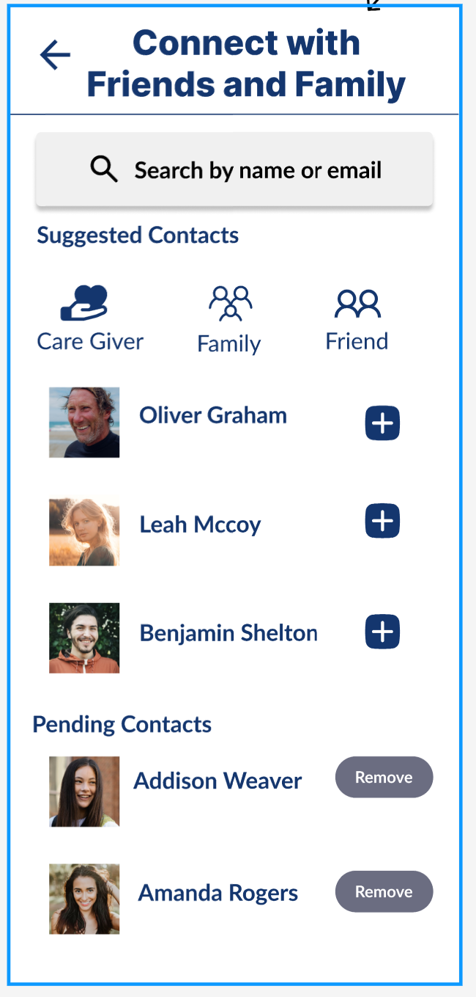

**Calendar:**

* Month view with highlighted care dates.
* Daily schedule view and patient list.
* Caregiver-exclusive action to “Schedule Care.”

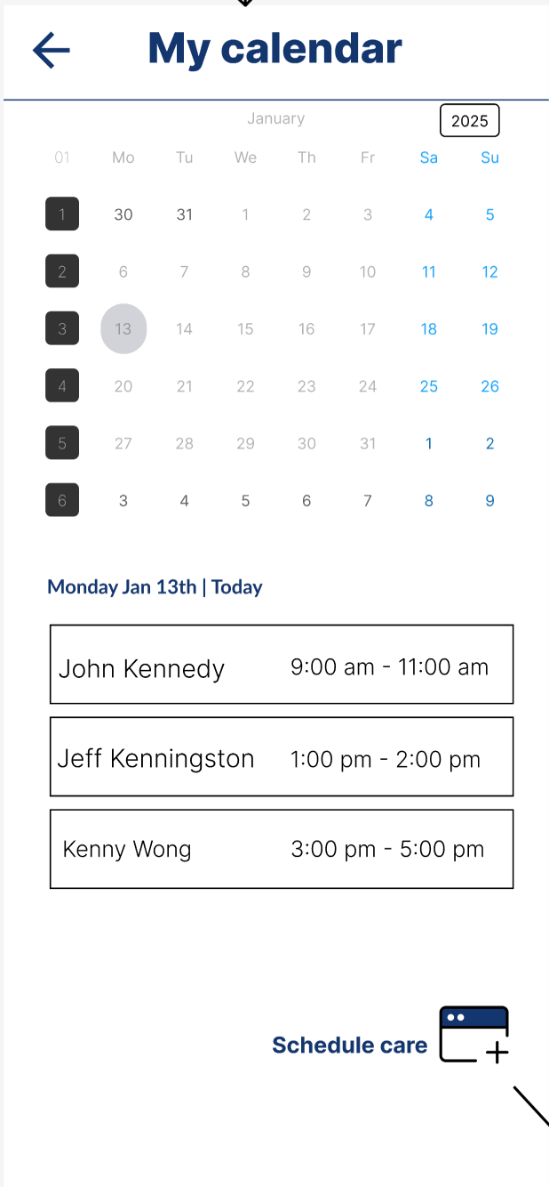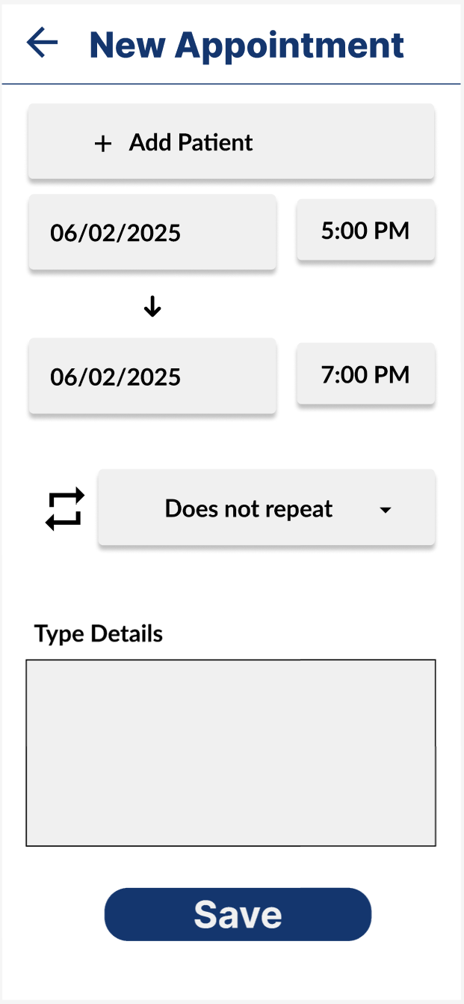

**Function-To-Screen Mapping Table**

|  |  |  |
| --- | --- | --- |
| **Function** | **Screen Name** | **Trigger/Action** |
| Post Status Update | Community Feed | Tap “+” or “New Post” button |
| View Feed | Community Feed | Auto-loaded on screen open |
| Like/Comment Post | Community Feed | Tap heart or comment bubble |
| View Inbox | Chat Inbox | Tap chat icon from navigation |
| Open Chat Thread | Chat Detail | Tap name from chat list |
| Search/Add Contact | Connect Screen | Enter name/email -> Tap “+” |
| Remove Contact | Connect Screen | Tap “Remove” on pending row |
| View Calendar | My Calendar | Tap calendar icon |
| Schedule Care (Caregiver Only) | New Appointment | Tap “Schedule Care” button |

# API Design Specification for CareConnect

This API specification defines the RESTful service endpoints used in the CareConnect mobile application to support healthcare coordination between patients, caregivers, and supporting systems. The API adheres to industry best practices for secure, scalable, and maintainable web services, using REST principles and JSON payloads. All endpoints are authenticated using Basic Authentication with username and password for general authentication. The application supports Single Sign-On (SSO) via Google as an Identity Provider (IDP) using OAuth for authentication in specific cases. Admin access uses JWT tokens issued by AWS for authentication and authorization.

## Key Design Principles

The CareConnect API is crafted with a clear vision: to be intuitive, secure, scalable, and resilient. Every design choice follows industry best practices to ensure seamless healthcare coordination while maintaining data integrity and security.

Resource-Oriented URIs form the backbone of the API, ensuring clarity and consistency by structuring endpoints around nouns rather than verbs. This simplifies interactions and improves maintainability.

Stateless interactions guarantee scalability. Every request is processed independently, without reliance on previous states, making the system robust and efficient.

Security is non-negotiable. Every API endpoint adheres to strict encryption, authentication, and compliance measures to protect user data. Least privilege access are fundamental safeguards that protect user data from unauthorized access will be in place.

To future-proof the API, versioning is embedded directly into the URI structure (e.g., `/v1/...`). This approach ensures smooth transitions when updates or new features are introduced, preserving backward compatibility.

Standardized error handling follows the RFC 7807 specification (`application/problem+json`), providing consistent and meaningful error responses. This helps developers quickly diagnose and resolve issues.

When handling large datasets, pagination is implemented using `limit` and `offset` parameters, ensuring optimal performance without overwhelming clients.

Where applicable, HATEOAS links enrich responses, making API navigation more intuitive by embedding relevant links directly within payloads.

By adhering to these principles, CareConnect delivers an API experience that is secure, scalable, and developer-friendly, ensuring healthcare providers and patients benefit from a high-performance platform.

## APIs

### Authentication & User Onboarding

|  |  |  |
| --- | --- | --- |
| **Endpoint** | **Method** | **Function** |
| /v1/auth/register | POST | Registers a new user with email/password, SSO, or SMS |
| /v1/auth/login | POST | Authenticates and returns access + refresh tokens |
| /v1/auth/logout | POST | Revokes access tokens |
| /v1/auth/password-reset | POST | Initiates password reset via email/SMS |
| /v1/auth/recover-account | POST | Recovers access using security verification |
| /v1/auth/verify-otp | POST | Verifies an OTP for phone-based registration |
| /auth/sso/redirect | GET | Redirects to external SSO login (Google, Microsoft, etc.). |
| /auth/sso/callback | POST | Handles post-SSO authentication response. |

**Security**: Rate-limited, Basic Authentication, JWT-based sessions, Cognito-integrated  
**Related Tables**: user, user_role, role

### User & Role Management

|  |  |  |
| --- | --- | --- |
| **Endpoint** | **Method** | **Function** |
| /v1/users/me | GET | Fetches authenticated user’s profile |
| `/v1/users/{id} | GET | Admin-only access to specific user profiles |
| /v1/users/{id} | PUT | Updates user information |
| /v1/users/{id} | DELETE | Deletes a user and related data |
| /v1/caregivers | POST | Creates caregiver profile |
| /v1/caregivers | GET |  |
| /v1/patients | POST | Creates patient profile |
| /v1/patients | GET | Lists patients accessible to the requester. |
| /v1/patients/{id}/link | POST | Links caregiver to patient |
| /v1/patients/{id}/unlink | POST | Unlinks caregiver from patient |
| /v1/patients/{id}/invite-family | POST | Grants family read-only access |
| /v1/patients/{id}/permissions | POST | Updates patient-specific permission assignments. |
| /v1/patients/{id}/archive | DELETE | Archives (soft-deletes) a patient profile. |

**Security**: RBAC enforced per role context  
**Related Tables**: caregiver_profile, patient_profile, caregiver_patient, family_member_link

### 2.3 Billing & Subscription

|  |  |  |
| --- | --- | --- |
| **Endpoint** | **Method** | **Function** |
| /v1/billing/plans | GET | Retrieves available subscription plans |
| /v1/subscriptions | POST | Initiates subscription using Stripe token |
| /v1/subscriptions/{id} | GET | Retrieves current subscription details |
| /v1/subscriptions/{id}/payment-method | PUT | Updates payment method |
| /v1/subscriptions/{id}/retry | POST | Attempts to retry failed payment. |
| /v1/subscriptions/{id}/cancel | POST | Cancels subscription |
| /v1//billing/history | GET | Retrieves user billing history. |
| /v1/webhook/stripe | POST | Stripe event listener (signed, idempotent) |

**Security**: PCI-DSS via Stripe Elements; webhook signed verification  
**Related Tables**: plan, subscription, payment_method, payment

### Scheduling & Notifications

|  |  |  |
| --- | --- | --- |
| **Endpoint** | **Method** | **Function** |
| /v1/care-schedules/template | POST | Create task templates. |
| /v1/care-schedules/custom | POST | Create one-off or recurring task. |
| /v1//care-schedules/patient/{id} | GET | List tasks for patient. |
| /v1//care-schedules/{id} | PUT | Update a scheduled task. |
| /v1/care-schedules/{id} | DELETE | Delete a task. |
| /v1/shifts | POST | Assign caregiver shift. |
| /v1/shifts | GET | List shift assignments. |
| /v1/calendar/shared | GET | Shared calendar view (caregiver-patient context). |
| /v1/alerts | POST | Trigger a manual alert. |
| /v1/alerts/missed-task | POST | System-generated alert for missed tasks. |
| /v1/notifications | GET | View user notifications. |
| /v1//notifications/read | POST | Mark a notification as read. |

**Security**: Access controlled by patient-caregiver linkage  
**Related Tables**: task_template, task, notification

### Health Data Tracking (Symptoms, Meals, Moods)

|  |  |  |
| --- | --- | --- |
| **Endpoint** | **Method** | **Function** |
| /v1/health/symptoms/default | GET | List default symptoms. |
| /v1/health/symptoms/custom | POST | Add custom symptom. |
| /v1/patients/{id}/symptoms | POST | Attach a symptom to a patient profile. |
| /v1/patients/{id}/symptoms | GET | List patient-specific symptoms. |
| /v1/health/symptoms/{id}/response | POST | Log symptom response |
| /v1/patients/{id}/symptoms/graph | GET | Graphical view of symptom trends. |
| /v1/meals/default | POST | Load default meal questions. |
| /v1//meals/custom | POST | Add custom meal question. |
| /v1/patients/{id}/meals/log | POST | Log meal entry |
| /v1/patients/{id}/meals/log | GET | Retrieve meal log entries. |
| /v1/patients/{id}/meals/log | GET | View meal logs. |
| /v1/patients/{id}/mood-trends | POST | Graph mood changes vs symptoms |
| /v1/moods | POST | Log patient mood. |
| /v1/alerts/mood | GET | Triggered alert for mood deterioration. |

**Security**: Symptoms and logs scoped by authenticated caregiver-patient relationship  
**Related Tables**: symptom, patient_symptom, symptom_log, meal_entry, mood_entry

### Communication & Media

|  |  |  |
| --- | --- | --- |
| **Endpoint** | **Method** | **Function** |
| /v1/messages | POST | Send secure message. |
| /v1/messages/conversation/{userId} | GET | Fetch conversation with another user. |
| /v1/calls/initiate | POST | Initiate audio/video call. |
| /v1/calls/accept | POST | Accept incoming call. |
| /v1/calls/end | POST | End ongoing call |
| /v1/sos/trigger | POST | Patient triggers emergency alert. |
| /v1/sos/acknowledge | POST | Caregiver acknowledges SOS. |
| /v1/checkins | POST | Create virtual check-in questionnaire |
| /v1/checkins/:id | GET | Retrieve check-in detail. |
| /v1/checkins/{id}/submit | POST | Submit patient check-in response. |
| /v1/media/upload | POST | Upload document/image (presigned S3 URL). |
| /v1/media/{id} | GET | View/download file. |
| /v1/media/{id} | DELETE | Delete media (if permitted). |
| /v1/voice/command | POST | Submit voice command for action. |

**Security**: End-to-end encryption for messages; media stored in S3 with signed URLs  
**Related Tables**: message, media_file

### AI & Assistant Services

|  |  |  |
| --- | --- | --- |
| **Endpoint** | **Method** | **Function** |
| /v1/ai/ask | POST | Query AI assistant (e.g. "how to track blood pressure?"). |
| /v1/ai/mood-detection | POST | Upload mood cue (image, text). |
| /v1/ai/analyze-mood | POST | Deep AI evaluation of emotional signals. |

**Security**: Requests authenticated and usage rate-limited  
**Note**: AI outputs are advisory, not clinical

**DB Impact**: No internal DB storage unless explicitly configured

### Telehealth Bridge

|  |  |  |
| --- | --- | --- |
| **Endpoint** | **Method** | **Function** |
| /v1/telehealth/schedule | POST | Schedule a Zoom telehealth session. |
| /v1/telehealth/join | POST | Join session via Zoom link. |
| /v1/telehealth/session/{id} | GET | View session details. |
| /v1/telehealth/questions | POST | Save pre-visit questions. |
| /v1/telehealth/questions | GET | Retrieve pre-visit questions. |

**Security**: Zoom API with JWT auth; patient/creator scoped; audit logging  
**Related Tables**: telehealth_session

### Analytics & Reporting

|  |  |  |
| --- | --- | --- |
| **Endpoint** | **Method** | **Function** |
| /v1/analytics/dashboard | GET | Return KPIs and health metrics. |
| /v1/analytics/export/csv | GET | Export data as CSV. |
| /v1/analytics/export/pdf | GET | Export printable summary. |
| /v1/analytics/live | GET | Real-time push (WebSocket or polling). |
| /v1/analytics/vitals | GET | Fetch raw biometric vitals. |

**Security**: Rate-limited per caregiver; export URL signed with 1-hour expiry  
**Derived From**: Aggregation from symptom_log, meal_entry, mood_entry, wearable_metric

### Wearables Integration

|  |  |  |
| --- | --- | --- |
| **Endpoint** | **Method** | **Function** |
| /v1/devices/wearables/link | POST | Connect to Fitbit, Apple Health (OAuth2). |
| /v1/devices/wearables/data | GET | Retrieve authorized wearable data. |
| /v1/devices/nest/link | POST | Link Google Nest camera. |
| /v1/devices/nest/events | GET | Retrieve camera motion/audio events. |
| /v1/devices/medication/scan | POST | Scan medication (e.g., barcode/NDC). |
| /v1/devices/medication/manual | POST | Manually enter medication. |
| /v1/devices/medication/schedule | GET | View patient medication schedule. |
| /v1/devices/alexa/command | POST | Send control command to Alexa. |

**Security**: OAuth 2.0 per provider (e.g., Fitbit, Apple Health)  
**Related Tables**: wearable_device, wearable_metric

### Gamification & Rewards

|  |  |  |
| --- | --- | --- |
| **Endpoint** | **Method** | **Function** |
| /v1/rewards | GET | Retrieve earned rewards. |
| /v1/rewards/claim | POST | Fetch wearable metrics. |
| /v1/messages/motivation/daily | GET | Retrieve daily motivational message. |

**Security**: Role-based rewards view   
**Related Tables**: achievement, user_achievement

### Security, Logging, Admin

|  |  |  |
| --- | --- | --- |
| **Endpoint** | **Method** | **Function** |
| /v1/admin/users | GET | Admin: view all users. |
| /v1/admin/audit-logs | GET | Admin: view access logs. |
| /v1/admin/system-status | GET | Real-time system health check. |
| /v1/admin/reports/billing | GET | Generate financial summary. |

**Security**: Internal use only. Admin token and role verification required  
**Related Tables**: Logs managed via AWS CloudWatch, audit trails in Lake Formation

## Error Handling Format

All error responses follow the application/problem+json media type:

{

"type": "<https://api.careconnect.health/errors/validation-error>",

"title": "Invalid input",

"status": 400,

"detail": "The email address is already registered.",

"instance": "/auth/register"

}

## API Versioning

All endpoints are prefixed with /v1. Future versions will use /v2, and backward compatibility will be preserved where feasible.

## Rate Limiting & Pagination

Standard rate limits apply per IP and user token. Pagination for collection endpoints is handled via:

?limit=25&offset=50

Default: limit=20

Max limit: 100

## Security Standards

At CareConnect, security is of utmost importance. Every API endpoint adheres to strict encryption, authentication, and compliance measures to protect user data. To ensure robust security:

HTTPS is enforced across all endpoints to safeguard data in transit, ensuring that all communications between clients and the server are encrypted.

Basic Authentication is used for general access, with Role-Based Access Control (RBAC) determining permissions dynamically. This ensures that caregivers, patients, and other users can only access the data they are authorized to view based on their roles within the application.

Single Sign-On (SSO) via Google as the Identity Provider (IDP) is supported using OAuth2 for secure user authentication in specific use cases, such as login through Google accounts.

Admin access is secured using JWT tokens issued by AWS Cognito to ensure token-based authentication and access control for administrative functions.

Sensitive data encryption is applied both in transit (TLS 1.3) and at rest (AES-256), ensuring that user data remains secure and protected from unauthorized access.

Furthermore, logging mechanisms track every API interaction, providing a comprehensive audit trail that supports compliance with HIPAA and GDPR requirements.

## Compliance & Auditing

All access to PHI and administrative actions are logged via AWS Lake Formation. The system is designed to be HIPAA and GDPR compliant.

## Tools & Integrations

CareConnect seamlessly integrates with industry-leading platforms to enhance user experience and streamline healthcare operations.

* Stripe handles secure billing, ensuring compliance with financial regulations.
* Zoom API powers telehealth sessions, enabling remote patient consultations.
* Fitbit API synchronizes health metrics, allowing users to track symptoms and activity levels effortlessly.
* OpenAI enriches patient interactions by providing AI-assisted recommendations and chat-based healthcare support.
* AWS S3 stores medical records and media securely, utilizing presigned URL authentication for file access.
* AWS Cognito underpins authentication and identity management, ensuring seamless user access.
* AWS EventBridge schedules automated healthcare tasks and reminders.

By leveraging these state-of-the-art technologies, CareConnect delivers a secure, efficient, and scalable healthcare API.

## OpenAPI Reference

The full API schema including request/response models, enums, field constraints, and examples is defined in the [OpenAPI 3.0 Specification](https://yzsebiid4c.execute-api.us-east-1.amazonaws.com/swagger-ui/index.html). This reference is the single source of truth for all consumer implementations.

# Data Models

This section presents the data modeling and database design for the CareConnect backend, targeting an AWS MySQL deployment. It translates the conceptual schema into a robust, scalable physical design and covers entity definitions, relationships, normalization, indexing, and AWS-specific considerations.

## Scope

The scope of this section is divided into four key areas:

* **Conceptual Model**: This model focuses on identifying and defining the high-level entities and their relationships within the system. It provides a broad understanding of the data structure without diving into implementation details.
* **Logical Model**: The logical model takes the conceptual design and refines it by normalizing the data into tables with defined attributes. This model is used to ensure data consistency and minimize redundancy while capturing all necessary information for the application.
* **Physical Model**: In this model, the design is translated into actual database structures such as MySQL Data Definition Language (DDL). This includes creating schemas, defining types, setting constraints, and creating indexes to optimize data retrieval and integrity.
* **AWS Deployment**: This involves configuring the deployment of the database on AWS using RDS (Relational Database Service) or Aurora. It includes setting up security measures, managing backups, and ensuring that the system is fully integrated with the AWS cloud environment for scalability and reliability.

## Conceptual Data Model

### Key Entities

### User: core identity (patients, caregivers, family, admins)

* **Role**: security roles (RBAC)
* **Profile**: PatientProfile, CaregiverProfile
* **Subscription**: plan enrollment and billing
* **Payment**: payment methods & transactions
* **Task** / **Notification**: scheduling & reminders
* **Health Data**: symptoms, symptom logs, meals, moods
* **WearableDevice** / **WearableMetric**
* **Communication**: messages, media files, telehealth sessions
* **Achievement**: gamification

### High-Level Relationships

In this section, we explore the key relationships between entities within the system at a high level. These relationships define how different components of the system interact with one another and provide an overview of the data flow. The relationships include both one-to-one and many-to-many associations, as well as hierarchical connections between various entities. Below is a summary of the primary relationships in the system:

* **A User may have multiple Roles (many-to-many)**: Users can be assigned multiple roles, which might include different levels of access or permissions within the system.
* **A PatientProfile is a one-to-one extension of User**: Each user can have a corresponding patient profile, allowing for user-specific patient information.
* **CaregiverProfile links to multiple patients (many-to-many)**: A caregiver can be associated with multiple patients, and likewise, a patient can have multiple caregivers, establishing a flexible care model.
* **A User may have multiple Subscriptions → one Plan**: Users can subscribe to multiple plans, with each subscription being associated with a specific plan.
* **TaskTemplate → Task → Notification**: A task template defines the structure of tasks, which in turn trigger notifications when completed or updated.
* **PatientSymptom → SymptomLog**: Each patient symptom can have associated symptom logs that track changes or updates over time.
* **PatientMealQuestion → MealEntry**: A set of questions related to a patient's meals is linked to individual meal entries, recording their responses or meal data.
* **WearableDevice → WearableMetric**: Wearable devices are associated with specific metrics that they collect, providing valuable data for monitoring a patient’s health.
* The below diagrams provide a visual representation of these relationships, helping to better understand how each entity connects and interacts within the system.

## Logical Data Model

All tables adhere to 3NF. Sensitive fields (e.g. medical_notes) use TEXT or JSON; enumerations use VARCHAR or native MySQL enums.

**7.3.1 Core Tables**

|  |  |
| --- | --- |
| **Table** | **Description** |
| app_user | Identity: email, password_hash, status |
| role | RBAC roles |
| user_role | join table |
| patient_profile | demographics, PHI notes |
| caregiver_profile | license, type |
| caregiver_patient | mapping caregiver ↔ patient |

**7.3.2 Billing**

|  |  |
| --- | --- |
| **Table** | **Description** |
| plan | subscription plans |
| subscription | user enrollments |
| payment_method | cards, PayPal tokens |
| payment | payment attempts |

**7.3.3 Scheduling & Notifications**

|  |  |
| --- | --- |
| **Table** | **Description** |
| task_template | predefined reminders |
| task | scheduled tasks |
| notification | sends (push, SMS, email) |

**7.3.4 Health Tracking**

|  |  |
| --- | --- |
| **Table** | **Description** |
| symptom | master list |
| patient_symptom | active symptoms per patient |
| symptom_log | scores & notes |
| meal_question | question bank |
| patient_meal_question | assigned questions |
| meal_entry | patient responses |
| mood_entry | mood diary |

**7.3.5 Wearables**

|  |  |
| --- | --- |
| **Table** | **Description** |
| wearable_device | linked device records |
| wearable_metric | time-series metrics |

**7.3.6 Communication & Media**

|  |  |
| --- | --- |
| **Table** | **Description** |
| message | in-app messaging |
| media_file | uploads, scans |
| telehealth_session | virtual visit records |

**7.3.7 Gamification**

|  |  |
| --- | --- |
| **Table** | **Description** |
| achievement | badges & points |
| user_achievement | earned badges |

## Data Dictionary

The Data Dictionary section provides a detailed description of the database schema, outlining each column in the relevant tables. For each column, the following attributes are specified: the Column Name, the Data Type, whether the column is a Primary Key (PK) or Foreign Key (FK), and a Description of the column's purpose and functionality within the system. This section ensures clarity and consistency in understanding how data is stored and related within the database, helping developers and stakeholders align the structure and flow of information.

### User

**Entity Name:** User

**Entity Description:** The user of the CareConnect application. Can be a caregiver, patient, or family member.

**Main Attributes of User:**

|  |  |  |  |
| --- | --- | --- | --- |
| **Name** | **Type** | **Description** | **Constraints** |
| id | BIGSERIAL | Unique user identifier. | PK |
| email | VARCHAR(254) | Login email address. | UQ |
| password_hash | CHAR(60) | Encrypted hash of password | --- |
| status | account_status (enum) | Account status. | Active or suspended status state. |
| created_at | DATETIME | Record creation timestamp. | --- |
| updated_at | DATETIME | Last updated timestamp. | --- |

### Role

**Entity Name:** Role

**Entity Description:** The role of the user.

**Main Attributes of Role:**

|  |  |  |  |
| --- | --- | --- | --- |
| **Name** | **Type** | **Description** | **Constraints** |
| id | BIGSERIAL | Unique role identifier. | PK |
| name | VARCHAR(50) | Role name (e.g. ADMIN, PATIENT). | UQ |

### User Role

**Entity Name:** User Role

**Entity Description:** The junction between User entity and Role entity.

**Main Attributes of User Role:**

|  |  |  |  |
| --- | --- | --- | --- |
| **Name** | **Type** | **Description** | **Constraints** |
| user_id | BIGINT | Unique user identifier. | PK, FK to app_user (id) |
| role_id | BIGINT | Unique role identifier. | PK, FK to role (id) |

### Patient Profile

**Entity Name:** Patient Profile

**Entity Description:** Represents the patient user’s profile information.

**Main Attributes of Patient Profile:**

|  |  |  |  |
| --- | --- | --- | --- |
| **Name** | **Type** | **Description** | **Constraints** |
| user_id | BIGINT | Unique user identifier. | PK, FK to app_user (id) |
| dob | DATE | Patient’s date of birth. | --- |
| sex | VARCHAR(10) | Sex of patient. | M/F/OTHER |
| medical_notes | TEXT | Fre-text of PHI notes | --- |

### Caregiver Profile

**Entity Name:** Caregiver Profile

**Entity Description:** Represents the caregiver user’s profile information.

**Main Attributes of Patient Profile:**

|  |  |  |  |
| --- | --- | --- | --- |
| **Name** | **Type** | **Description** | **Constraints** |
| user_id | BIGINT | Unique user identifier. | PK, FK to app_user (id) |
| type | caregiver_type (enum) | Type of caregiver | PROFESSIONAL/FAMILY |
| license_number | VARCHAR(100) | License number | --- |

### Caregiver Patient

**Entity Name:** Caregiver Patient

**Entity Description:** Represents the link between a caregiver and a patient.

**Main Attributes of Caregiver Patient:**

|  |  |  |  |
| --- | --- | --- | --- |
| **Name** | **Type** | **Description** | **Constraints** |
| caregiver_user_id | BIGINT | Caregiver’s user id. | PK, FK to caregiver_profile(user_id) |
| patient_user_id | BIGINT | Patient’s user id. | PK, FK to patient_profile(user_id |
| role | VARCHAR(20) | Role. | PRIMARY/SECONDARY. |
| linked_at | VARCHAR(20) | Timestamp of link. | --- |

### Plan

**Entity Name:** Plan

**Entity Description:** Represents the CareConnect plan type for billing purposes.

**Main Attributes of Plan:**

|  |  |  |  |
| --- | --- | --- | --- |
| **Name** | **Type** | **Description** | **Constraints** |
| id | BIGSERIAL | Unique plan identifier. | PK |
| code | VARCHAR(50) | Plan code (e.g. BASIC) | UQ |
| name | VARCHAR(100) | Human-readable name. | --- |
| price_cents | INT | Price in cents. | --- |
| billing_period | billing_period (enum) | Billing period of time. | MONTH. |

### Subscription

**Entity Name:** Subscription

**Entity Description:** Represents the user’s subscription

**Main Attributes of Subscription:**

|  |  |  |  |
| --- | --- | --- | --- |
| **Name** | **Type** | **Description** | **Constraints** |
| id | BIGSERIAL | Unique subscription identifier. | PK |
| user_id | BIGINT | Subscriber | FK to app_user (id) |
| plan_id | BIGINT | Chosen plan | FK to plan (id) |
| status | INT | Price in cents. | --- |
| started_at | DATETIME | Start time of subscription. | --- |
| current_period_end | DATETIME | End time of subscription. | --- |

### Payment Method

**Entity Name:** Payment Method

**Entity Description:** Represents the user’s payment method.

**Main Attributes of Subscription:**

|  |  |  |  |
| --- | --- | --- | --- |
| **Name** | **Type** | **Description** | **Constraints** |
| id | BIGSERIAL | Unique payment identifier. | PK |
| user_id | BIGINT | Owner. | FK to app_user (id) |
| provider | VARCHAR(20) | Payment provider. | CARD/ PAYPAL |
| stripe_token | VARCHAR(255) | External token for stripe. | --- |
| last4 | CHAR(4) | Last four digits of payment method. | --- |
| brand | VARCHAR(20) | Card brand. | --- |
| exp_month | SMALLINT | Expiry month. | --- |
| exp_year | SMALLINT | Expiry year. | --- |
| created_at | DATETIME | Timestamp payment was added. | --- |

### Payment

**Entity Name:** Payment

**Entity Description:** Represents the payment transaction.

**Main Attributes of Payment:**

|  |  |  |  |
| --- | --- | --- | --- |
| **Name** | **Type** | **Description** | **Constraints** |
| id | BIGSERIAL | Unique payment identifier. | PK |
| subscription_id | BIGINT | Subscription identifier. | FK to subscription (id) |
| payment_method_id | BIGINT | Payment method identifier. | FK to payment_method (id) |
| amount_cents | INT | Amount charged to user. | --- |
| status | payment_status (enum) | Payment status. | SUCCEEDED/FAILED |
| attempted_at | DATETIME | Payment attempt timestamp. | --- |

### Task Template

**Entity Name:** Task Template

**Entity Description:** Represents the task template.

**Main Attributes of Task Template:**

|  |  |  |  |
| --- | --- | --- | --- |
| **Name** | **Type** | **Description** | **Constraints** |
| id | BIGSERIAL | Unique template identifier. | PK |
| name | VARCHAR(100) | Template name. | --- |
| category | VARCHAR | Task category. | MEDICATION/MEAL/... |
| default_payload | JSON | Default JSON. | --- |

### Task

**Entity Name:** Task

**Entity Description:** Represents the task.

**Main Attributes of Task:**

|  |  |  |  |
| --- | --- | --- | --- |
| **Name** | **Type** | **Description** | **Constraints** |
| id | BIGSERIAL | Unique task identifier. | PK |
| patient_id | BIGINT | Patient. | FK to patient_profile (user_id) |
| template_id | BIGINT | Template. | FK to task_template (id) |
| title | VARCHAR(150) | Custom title. | --- |
| frequency | task_frequency (enum) | Frequency of task. | ONCE/DAILY/... |
| start_time | DATETIME | When to start the task. | --- |
| next_run | DATETIME | When to next run the task. | --- |
| created_by | BIGINT | Who created the task. | FK to app_user (id) |

### Notification

**Entity Name:** Notification

**Entity Description:** Represents the notification.

**Main Attributes of Notification:**

|  |  |  |  |
| --- | --- | --- | --- |
| **Name** | **Type** | **Description** | **Constraints** |
| id | BIGSERIAL | Unique notification identifier. | PK |
| user_id | BIGINT | User id of recipient. | FK to app_user (id) |
| task_id | BIGINT | Task identifier. | FK to task (id) |
| type | VARCHAR(50) | Type of task. | REMINDER. |
| channel | notification_channel (enum) | Type of channel notification | PUSH/SMS/EMAIL |
| sent_at | DATETIME | Notification send time. | --- |
| delivered_at | DATETIME | Notification delivery time. | --- |

### Symptom

**Entity Name:** Symptom

**Entity Description:** Represents the symptom of the patient.

**Main Attributes of Symptom:**

|  |  |  |  |
| --- | --- | --- | --- |
| **Name** | **Type** | **Description** | **Constraints** |
| id | BIGSERIAL | Unique symptom identifier. | PK |
| name | VARCHAR(100) | Symptom name. | UQ |
| critical_score | NT | Critical symptom score threshold. | --- |

### Patient Symptom

**Entity Name: Patient** Symptom

**Entity Description:** Represents the symptoms of the patient.

**Main Attributes of Patient Symptom:**

|  |  |  |  |
| --- | --- | --- | --- |
| **Name** | **Type** | **Description** | **Constraints** |
| patient_id | BIGINT | Patient identifier. | PK, FK to patient_profile (user_id) |
| symptom_id | BIGINT | Symptom name. | PK, FK to symptom (id) |
| active | BOOLEAN | If symptom is occurring or not. | ACTIVE/NOT ACTIVE |
| started_at | DATE | Activation date. |  |

### Symptom Log

**Entity Name:** Symptom Log

**Entity Description:** Represents the symptom log of the patient.

**Main Attributes of Symptom Log:**

|  |  |  |  |
| --- | --- | --- | --- |
| **Name** | **Type** | **Description** | **Constraints** |
| id | BIGSERIAL | Log identifier. | PK |
| patient_id | BIGINT | Patient identifier. | PK, FK to patient_profile (user_id) |
| symptom_id | BIGINT | Symptom name. | PK, FK to symptom (id) |
| score | INT | Symptom score severity. | ACTIVE/NOT ACTIVE |
| notes | TEXT | Symptom notes. | Free-text. |
| logged_at | DATETIME | Time of logged symptoms. |  |

### Meal Question

**Entity Name:** Meal Question

**Entity Description:** Represents a meal question.

**Main Attributes of Meal Question:**

|  |  |  |  |
| --- | --- | --- | --- |
| **Name** | **Type** | **Description** | **Constraints** |
| id | BIGSERIAL | Question identifier. | PK |
| text | VARCHAR(255) | Question prompt. | --- |

### Patient Meal Question

**Entity Name:** Patient Meal Question

**Entity Description:** Represents a patient’s meal question.

**Main Attributes of Patient Meal Question:**

|  |  |  |  |
| --- | --- | --- | --- |
| **Name** | **Type** | **Description** | **Constraints** |
| patient_id | BIGINT | Patient identifier. | PK, FK to patient_profile. |
| question_id | BIGINT | Meal question identifier. | PK, FK to meal_question |
| added_by | BIGINT | Which caregiver added the meal question. | FK to caregiver_profile |
| added_at | DATETIME | Question added time stamp. | --- |

### Meal Entry

**Entity Name:** Meal Entry

**Entity Description:** Represents a patient’s meal entry.

**Main Attributes of Meal Entry:**

|  |  |  |  |
| --- | --- | --- | --- |
| **Name** | **Type** | **Description** | **Constraints** |
| id | BIGSERIAL | Meal entry identifier. | PK |
| patient_id | BIGINT | Patient identifier. | PK, FK to patient_profile. |
| question_id | BIGINT | Meal question identifier. | PK, FK to meal_question |
| response_text | TEXT | Answer text. | --- |
| response_voice_url | VARCHAR | Audio URL. | --- |
| response_image_url | VARCHAR | Photo URL. | --- |
| logged_at | DATETIME | Time answer was logged. | --- |

### Mood Entry

**Entity Name:** Mood Entry

**Entity Description:** Represents a patient’s mood entry.

**Main Attributes of Mood Entry:**

|  |  |  |  |
| --- | --- | --- | --- |
| **Name** | **Type** | **Description** | **Constraints** |
| id | BIGSERIAL | Mood entry identifier. | PK. |
| patient_id | BIGINT | Patient identifier. | FK to patient_profile. |
| mood | mood_type (enum) | Mood of patient. | --- |
| notes | TEXT | Notes text. | Free-text. |
| logged_at | DATETIME | Time answer was logged. | --- |

### Wearable Device

**Entity Name:** Wearable Device

**Entity Description:** Represents a wearable device.

**Main Attributes of Wearable Device:**

|  |  |  |  |
| --- | --- | --- | --- |
| **Name** | **Type** | **Description** | **Constraints** |
| id | BIGSERIAL | Device identifier. | PK |
| user_id | BIGINT | User identifier. | FK to app_user. |
| provider | metric_type (enum) | Device provider. | FITBIT/... |
| external_id | VARCHAR(128) | Vendor identifier. | --- |
| linked_at | DATETIME | Link time. | --- |
| revoked_at | DATETIME | Unlink time. | --- |

### Wearable Metric

**Entity Name:** Wearable Metric

**Entity Description:** Represents a metric of a wearable device.

**Main Attributes of Wearable Metric:**

|  |  |  |  |
| --- | --- | --- | --- |
| **Name** | **Type** | **Description** | **Constraints** |
| id | BIGSERIAL | Metric identifier. | PK |
| device_id | BIGINT | User identifier. | FK to wearable_device. |
| metric | metric_type (enum) | Metric. | HEART_RATE/... |
| value | NUMERIC | Measured metric values. | --- |
| recorded_at | DATETIME | Recorded time metrics. | --- |

### Message

**Entity Name:** Message

**Entity Description:** Represents a message.

**Main Attributes of Message:**

|  |  |  |  |
| --- | --- | --- | --- |
| **Name** | **Type** | **Description** | **Constraints** |
| id | BIGSERIAL | Message identifier. | PK |
| sender_id | BIGINT | Sender identifier. | FK to app_user. |
| receiver_id | BIGINT | Receiver identifier. | FK to app_user. |
| msg_type | message_type (enum) | Message text. | TEXT/AUDIO/... |
| content | TEXT | Body or URL. | --- |
| sent_at | DATETIME | Send time. | --- |

### Media File

**Entity Name:** Media File

**Entity Description:** Represents a media file.

**Main Attributes of Media File:**

|  |  |  |  |
| --- | --- | --- | --- |
| **Name** | **Type** | **Description** | **Constraints** |
| id | BIGSERIAL | File identifier. | PK |
| uploader_id | BIGINT | Uploader identifier. | FK to app_user. |
| patient_id | BIGINT | Patient identifier. | FK to patient_profile. |
| file_type | VARCHAR(40) | File type. | MIME type |
| object_key | VARCHAR(512) | Object key. | S3 key |
| size_bytes | BIGINT | File size. | --- |
| uploaded_at | DATETIME | Media upload time. |  |

### Telehealth Session

**Entity Name:** Telehealth Session

**Entity Description:** Represents a telehealth session.

**Main Attributes of Telehealth Session:**

|  |  |  |  |
| --- | --- | --- | --- |
| **Name** | **Type** | **Description** | **Constraints** |
| id | BIGSERIAL | Session identifier. | PK |
| creator_id | BIGINT | Creator identifier. | FK to caregiver_profile. |
| patient_id | BIGINT | Patient identifier. | FK to patient_profile. |
| zoom_meeting_id | VARCHAR(120) | External meeting identifier. | --- |
| starts_at | DATETIME | Start time. | --- |
| ends_at | DATETIME | End time. | --- |
| status | session_status (enum) | Telehealth session status. | SCHEDULED/... |

### Achievement

**Entity Name:** Achievement

**Entity Description:** Represents an achievement.

**Main Attributes of Achievement:**

|  |  |  |  |
| --- | --- | --- | --- |
| **Name** | **Type** | **Description** | **Constraints** |
| id | BIGSERIAL | Achievement identifier. | PK |
| code | VARCHAR(50) | Badge code. | UQ |
| title | VARCHAR(100) | Display name. | --- |
| points | INT | Points awarded amount. | --- |

### User Achievement

**Entity Name:** User Achievement

**Entity Description:** Represents a user achievement.

**Main Attributes of User Achievement:**

|  |  |  |  |
| --- | --- | --- | --- |
| **Name** | **Type** | **Description** | **Constraints** |
| user_id | BIGINT | User identifier. | PK, FK to app_user. |
| achievement_id | BIGINT | Achievement identifier. | PK, FK to achievement. |
| earned_at | DATETIME | Time achievement was earned. | --- |

### Location

**Entity Name:** Location

**Entity Description:** Represents a location.

**Main Attributes of Location:**

|  |  |  |  |
| --- | --- | --- | --- |
| **Name** | **Type** | **Description** | **Constraints** |
| location_id | BIGINT | location identifier. | PK |
| latitude_position | DOUBLE PRECISION | Latitude position. | --- |
| longitude_position | DOUBLE PRECISION | Longitude position. | --- |

## Physical Data Model

### Schemas & Convention

This section outlines the database schema design conventions and standards that will be followed to ensure consistency, type safety, and efficient data storage. The following conventions will be applied:

* **Engine and Charset:** All tables use ENGINE=InnoDB for transactions and FK support. charset utf8mb4, collation utf8mb4_0900_ai_ci for full‐Unicode (emoji).
* **Primary keys use** BIGINT UNSIGNED AUTO_INCREMENT where auto-increment is needed; foreign keysBIGINT UNSIGNED: Foreign keys will be defined as BIGINT UNSIGNED to maintain consistency with primary key types, ensuring compatibility in relationships across tables.
* **Timestamps use** DATETIME(6) for UTC timestamps; defaults to CURRENT_TIMESTAMP(6)for UTC storage: This helps avoid time zone issues and provides a standardized format for timestamp storage.
* **JSON data stored in JSON**: Any data that is stored in JSON format will use the MySQL JSON data type, which offers better performance and flexibility.
* **Enumerations defined as MySQL enums for type safety**: Enumerations will be defined as MySQL enums. This ensures type safety and prevents invalid data entries by restricting values to a predefined set of allowed values.

These conventions aim to maintain a clean, efficient, and consistent database structure, promoting both data integrity and scalability.

### Enum Types

CREATE TYPE account_status AS ENUM ('ACTIVE','SUSPENDED');

CREATE TYPE caregiver_type AS ENUM ('PROFESSIONAL','FAMILY');

CREATE TYPE subscription_status AS ENUM ('ACTIVE','SUSPENDED','GRACE','CANCELLED');

CREATE TYPE payment_status AS ENUM ('SUCCEEDED','FAILED');

CREATE TYPE billing_period AS ENUM ('MONTH');

CREATE TYPE task_frequency AS ENUM ('ONCE','DAILY','WEEKLY');

CREATE TYPE notification_channel AS ENUM ('PUSH','SMS','EMAIL');

CREATE TYPE mood_type AS ENUM ('HAPPY','NEUTRAL','SAD','ANXIOUS','OTHER');

CREATE TYPE metric_type AS ENUM ('HEART_RATE','STEPS','SPO2');

CREATE TYPE message_type AS ENUM ('TEXT','VOICE','VIDEO');

CREATE TYPE session_status AS ENUM ('SCHEDULED','LIVE','ENDED','CANCELLED');

### Table DDL

CREATE TABLE app_user ( id BIGINT UNSIGNED AUTO_INCREMENT PRIMARY KEY, email VARCHAR(254) NOT NULL UNIQUE, password_hash CHAR(60) NOT NULL, status ENUM('ACTIVE','SUSPENDED') NOT NULL DEFAULT 'ACTIVE', created_at DATETIME(6) NOT NULL DEFAULT CURRENT_TIMESTAMP(6), updated_at DATETIME(6) NOT NULL DEFAULT CURRENT_TIMESTAMP(6) ON UPDATE CURRENT_TIMESTAMP(6) ) ENGINE=InnoDB CHARSET=utf8mb4 COLLATE=utf8mb4_0900_ai_ci;

CREATE TABLE user_role ( user_id BIGINT UNSIGNED NOT NULL, role_id BIGINT UNSIGNED NOT NULL, PRIMARY KEY (user_id, role_id), FOREIGN KEY (user_id) REFERENCES app_user(id) ON DELETE CASCADE, FOREIGN KEY (role_id) REFERENCES role(id) ON DELETE CASCADE ) ENGINE=InnoDB CHARSET=utf8mb4 COLLATE=utf8mb4_0900_ai_ci;

CREATE TABLE patient_profile ( user_id BIGINT UNSIGNED PRIMARY KEY, dob DATE, sex VARCHAR(10), medical_notes TEXT, FOREIGN KEY (user_id) REFERENCES app_user(id) ON DELETE CASCADE ) ENGINE=InnoDB CHARSET=utf8mb4 COLLATE=utf8mb4_0900_ai_ci;

CREATE TABLE caregiver_profile ( user_id BIGINT UNSIGNED PRIMARY KEY, type ENUM('PROFESSIONAL','FAMILY') NOT NULL, license_number VARCHAR(100), FOREIGN KEY (user_id) REFERENCES app_user(id) ON DELETE CASCADE ) ENGINE=InnoDB CHARSET=utf8mb4 COLLATE=utf8mb4_0900_ai_ci;

CREATE TABLE caregiver_patient ( caregiver_user_id BIGINT UNSIGNED NOT NULL, patient_user_id BIGINT UNSIGNED NOT NULL, role ENUM('PRIMARY','SECONDARY') NOT NULL DEFAULT 'PRIMARY', linked_at DATETIME(6) NOT NULL DEFAULT CURRENT_TIMESTAMP(6), PRIMARY KEY (caregiver_user_id, patient_user_id), FOREIGN KEY (caregiver_user_id) REFERENCES caregiver_profile(user_id) ON DELETE CASCADE, FOREIGN KEY (patient_user_id) REFERENCES patient_profile(user_id) ON DELETE CASCADE ) ENGINE=InnoDB CHARSET=utf8mb4 COLLATE=utf8mb4_0900_ai_ci;

CREATE TABLE plan ( id BIGINT UNSIGNED AUTO_INCREMENT PRIMARY KEY, code VARCHAR(50) NOT NULL UNIQUE, name VARCHAR(100) NOT NULL, price_cents INT UNSIGNED NOT NULL, billing_period ENUM('MONTH') NOT NULL DEFAULT 'MONTH' ) ENGINE=InnoDB CHARSET=utf8mb4 COLLATE=utf8mb4_0900_ai_ci;

CREATE TABLE subscription ( id BIGINT UNSIGNED AUTO_INCREMENT PRIMARY KEY, user_id BIGINT UNSIGNED NOT NULL, plan_id BIGINT UNSIGNED NOT NULL, status ENUM('ACTIVE','SUSPENDED','GRACE','CANCELLED') NOT NULL DEFAULT 'ACTIVE', started_at DATETIME(6) NOT NULL DEFAULT CURRENT_TIMESTAMP(6), current_period_end DATETIME(6), FOREIGN KEY (user_id) REFERENCES app_user(id) ON DELETE CASCADE, FOREIGN KEY (plan_id) REFERENCES plan(id) ON DELETE RESTRICT ) ENGINE=InnoDB CHARSET=utf8mb4 COLLATE=utf8mb4_0900_ai_ci;

CREATE TABLE payment_method ( id BIGINT UNSIGNED AUTO_INCREMENT PRIMARY KEY, user_id BIGINT UNSIGNED NOT NULL, provider ENUM('CARD','PAYPAL') NOT NULL, stripe_token VARCHAR(255), last4 CHAR(4), brand VARCHAR(20), exp_month TINYINT UNSIGNED, exp_year SMALLINT UNSIGNED, created_at DATETIME(6) NOT NULL DEFAULT CURRENT_TIMESTAMP(6), FOREIGN KEY (user_id) REFERENCES app_user(id) ON DELETE CASCADE ) ENGINE=InnoDB CHARSET=utf8mb4 COLLATE=utf8mb4_0900_ai_ci;

CREATE TABLE payment ( id BIGINT UNSIGNED AUTO_INCREMENT PRIMARY KEY, subscription_id BIGINT UNSIGNED NOT NULL, payment_method_id BIGINT UNSIGNED, amount_cents INT UNSIGNED NOT NULL, status ENUM('SUCCEEDED','FAILED') NOT NULL, attempted_at DATETIME(6) NOT NULL DEFAULT CURRENT_TIMESTAMP(6), FOREIGN KEY (subscription_id) REFERENCES subscription(id) ON DELETE CASCADE, FOREIGN KEY (payment_method_id) REFERENCES payment_method(id) ON DELETE SET NULL ) ENGINE=InnoDB CHARSET=utf8mb4 COLLATE=utf8mb4_0900_ai_ci;

## Physical Design Considerations

To ensure optimal performance and scalability for the database, the following physical design considerations will be implemented:

**Indexes**

* **FK columns auto-indexed**: Foreign key columns will be automatically indexed to improve query performance when joining tables based on these keys.
* **Multi-column indexes**: Multi-column indexes will be added to improve the performance of queries involving the combination of patient_id and logged_at in tables such as symptom_log, meal_entry, and wearable_metric. This will speed up data retrieval for time-based queries on these time-series tables.

**Partitioning**

* **Time-series tables partitioning**: Tables that store time-series data, such as wearable_metric, symptom_log, and meal_entry, will be range-partitioned by month. This approach helps with scaling as the data grows, improving performance for querying specific time ranges by limiting the amount of data to scan.

**VACUUM & Autovacuum**

* **Autovacuum tuning**: Autovacuum thresholds will be adjusted for high-write tables to ensure that table bloat is kept in check, especially in systems with frequent inserts or updates. This helps maintain database performance and space utilization.

**Connection Pooling**

* **Connection management**: To efficiently handle database connections and reduce overhead, connection pooling will be implemented using Amazon RDS Proxy or PgBouncer. These tools help manage database connections more effectively, allowing for better resource utilization and improved application performance.

## AWS MySQL Deployment

For the AWS deployment of MySQL, the following configurations will be applied to ensure high availability, security, and efficient performance:

* **Engine**: The database will be deployed using Amazon Aurora MySQL or RDS for MySQL(v8+), providing robust and scalable solutions for handling MySQL workloads with enhanced performance and availability.
* **High availability**: A Multi-AZ deployment will be used, with automated failover capabilities. This ensures that the database remains highly available in the event of hardware or infrastructure failure, minimizing downtime and ensuring continuous operation.
* **Read scaling**: To handle analytics workloads and reduce the load on the primary database instance, read replicas will be deployed. This allows read-heavy queries, such as reports and analytics, to be offloaded from the primary instance, ensuring optimal performance.
* **Encryption**: Both at-rest encryption using KMS (Key Management Service) and in-transit encryption via SSL will be enabled to ensure that data is protected both while stored in the database and while being transferred over the network.
* **Backups**: Automated daily snapshots will be taken to ensure data durability and to allow for quick recovery in case of failure. Additionally, point-in-time recovery (PITR) will be enabled to restore the database to any specific point in time, offering flexibility in recovery.
* **Monitoring**: To ensure the health and performance of the database, CloudWatch metrics will be used to monitor key performance indicators (KPIs). Additionally, Enhanced Monitoring will be enabled for more granular insights into query performance, allowing for proactive troubleshooting and performance tuning.

## Security & Compliance

In terms of network security, the deployment will be configured within private subnets, with access restricted to authorized personnel via a bastion host or a VPN connection. For identity and access management (IAM), we will leverage IAM authentication for database credentials, provided it is supported by the database system in use.

To ensure data protection, encryption will be enforced for data-at-rest through AWS KMS-managed encryption. Additionally, data-in-transit will be safeguarded by requiring SSL/TLS encryption for all communications, ensuring secure data exchange across the network.

Audit logging will be implemented by enabling MySQL’s audit extension to maintain detailed logs of database activities for compliance and security monitoring purposes. Furthermore, the principle of least privilege will be adhered to by ensuring that separate roles are defined for the application and read-only reporting purposes, minimizing the exposure of sensitive data to only those who need it.

## Backup & Recovery

For backup and recovery, automated daily snapshots will be taken and retained for a period ranging from 7 to 30 days, providing a reliable recovery point in case of failures. Additionally, a point-in-time recovery mechanism will be configured with a retention window between 5 and 35 days, enabling the restoration of the database to a specific point in time.

Manual snapshots will be created before making significant schema changes to ensure recoverability in case of any issues introduced during the update process. In the event of a disaster, a cross-region read replica promotion strategy will be employed, allowing the system to continue functioning by promoting a read replica to primary status, thus minimizing downtime and ensuring business continuity.

Figure 1

Entity-Relationship Diagram for CareConnect  
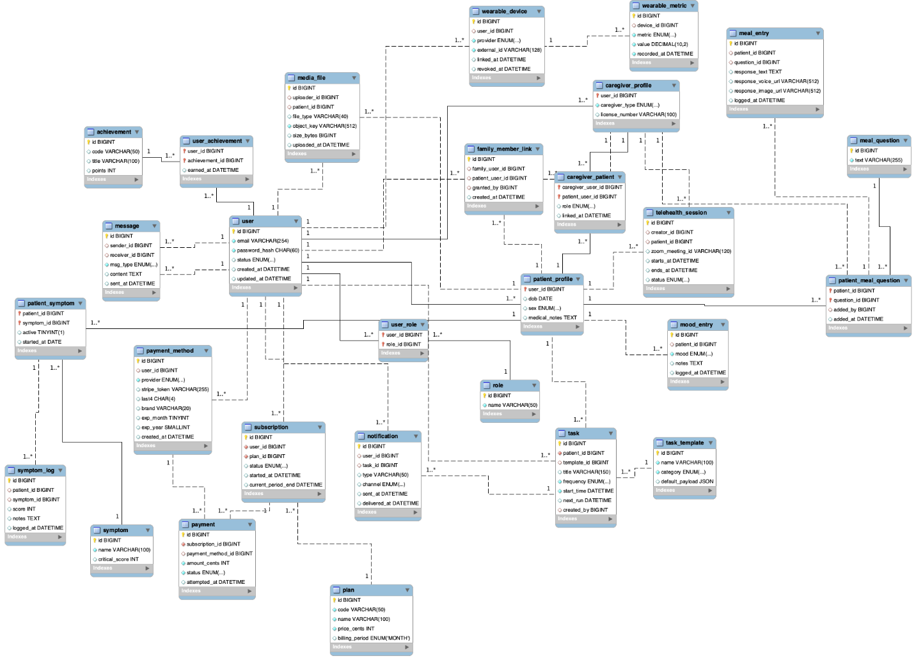

# UI/UX Design

## Onboarding & Authentication

### Welcome Screen

#### Module Description:

The Welcome Screen serves as the entry point for users launching the CareConnect app. It introduces users to the platform and prompts them to identify their role-either as a Caregiver or a Patient. Based on this selection, the application navigates the user to the corresponding login or registration process, enabling a personalized role-specific user experience.

The design emphasizes simplicity, accessibility, and clarity, ensuring that users can quickly begin the onboarding process. The screen layout follows mobile-first principles and aligns with accessibility standards, featuring large touch targets and intuitive navigation.

#### Image(s)

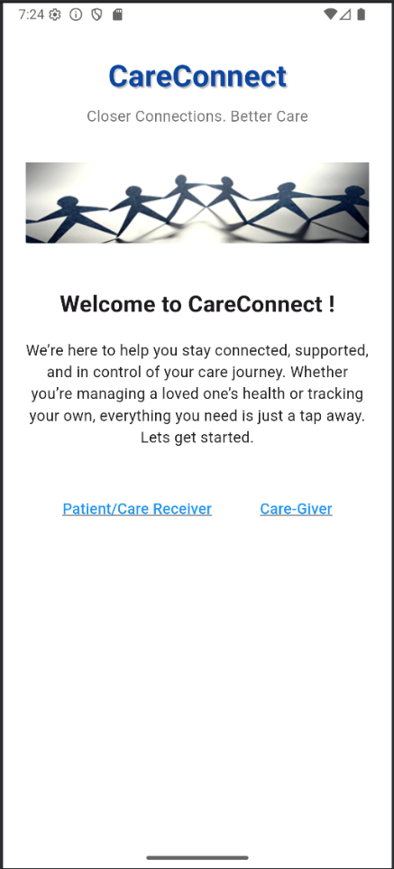

#### Internal UI Functionality

|  |  |
| --- | --- |
| **ID** | **Description** |
| IUF-WS-1 | Display static welcome banner with appropriate resolution based on device screen size. |
| IUF-WS-2 | Render two primary call-to-action buttons labeled “Caregiver” and “Patient” respectively. |
| IUF-WS-3 | Apply responsive layout using MediaQuery and SafeArea for device compatibility. |
| IUF-WS-4 | Maintain consistent usage using shared color palette and typography from ThemeData. |

#### External UI Functionality

|  |  |
| --- | --- |
| **ID** | **Description** |
| EUF-WS-1 | Click on “Caregiver” button, navigate to CaregiverLoginScreen. |
| EUF-WS-2 | Click on “Patient” button, navigate to PatientLoginScreen. |
| EUF-WS-3 | Load appropriate screen transitions as defined in the navigation route configuration. |
| EUF-WS-4 | Log user role selection in session state. |

**UI/UX Design for Custom Task Scheduling Screen**

**Module Description**

Custom Task Scheduling is a tool caregivers use to make and plan specific tasks for each patient, including exercise, taking medicines, or visiting the doctor. This screen allows caregivers to organize info like the task's name, time, and recurrence. Because the user interface is streamlined and straightforward, caregivers easily handle their patients' daily care tasks.

**UI/UX Features**

1. **Task Title Input**:
   1. **Functionality**: A place where caregivers can type out what the task is about. The field needs to be checked before implementation to ensure the title is not blank and clearly explains the task.
   2. **Design**: The text input should have an explicit placeholder (e.g., "Task name"), and the input field should be spacious to allow for multiple words.
   3. **Example**: "Give medication," "Walk for 30 minutes."
2. **Time Selection**:
   * **Functionality**: An icon that looks like a clock or time picker that gives caregivers a specific finishing time. As a result, the caregiver can manage tasks for every time of the day they need them.
   * **Design**: A way for caregivers to pick a specific time using a pop-up window. The time must be shown in 24 hours, with a toggle for AM and PM. Caregivers should be able to choose fifteen-minute intervals for the time they spend.
   * **Example**: 8:00 AM, 3:30 PM, etc.
3. **Recurrence Options**:
   * **Functionality**: A group of settings that let caregivers choose the task frequency (daily, weekly, or any other set number). Because of this feature, patients will not have to re-enter their routine medications daily.
   * **Design**: A toggle button or a dropdown list with options for:
     + **Daily**: Tasks repeat every day.
     + **Weekly**: Tasks repeat on selected days of the week.
     + **Custom**: Caregivers can choose specific dates or intervals for task repetition.
   * **Example**: "Repeat every Monday, Wednesday, and Friday," "Repeat daily."
4. **Priority Setting**:
   * **Functionality**: A feature that allows caregivers to assign a priority level to each task (e.g., low, medium, high). This ensures that the most important tasks are highlighted.
   * **Design**: A color-coded priority dropdown with three levels. High priority could be red, medium priority could be yellow, and low priority could be green.
   * **Example**: Tasks marked as high priority may appear at the top of the schedule, while low-priority tasks are placed later in the list.
5. **Save and Cancel Buttons**:
   * **Functionality**: Two buttons at the bottom of the screen allow caregivers to either save the task or discard the changes they made. The save button should be prominent, while the cancel button should be smaller and placed to the right of the save button.
   * **Design**: The save button should be green to indicate a positive action, while the cancel button should be gray or neutral to avoid confusion.
   * **Example**: The save button should trigger a confirmation toast message upon successful task creation, such as "Task saved successfully."
6. **Confirmation and Error Messages**:
   * **Functionality**: If the caregiver inputs invalid data (e.g., selecting a past time), the system should prompt the user with a clear, actionable error message. After saving a task, a confirmation message should be shown.
   * **Design**: Error messages should be displayed in red with a small icon (e.g., an exclamation mark). Confirmation messages should appear in green with a check mark.
   * **Example**: "The time selected has already passed. Please choose a future time."
7. **Responsiveness and Mobile-first Design**:
   * **Functionality**: The design needs to be adjusted to screens of all sizes and tablets to ensure the site is user-friendly.
   * **Design**: The design should be responsive, letting groups of elements stack on phones and keeping its structure smooth on bigger screens.
   * **Example**: On mobile, the task title input might span the full width of the screen, while on tablet, it could be placed next to the time selection field for a more compact layout.

**UI Flow**

1. **Start Screen**: The caregiver navigates to the Custom Task Scheduling screen from the main dashboard.
2. **Task Details**: The caregiver fills out the task name, selects a time, chooses the recurrence, and sets the priority.
3. **Validation**: If any required fields are empty or contain invalid data, an error message prompts the caregiver to fix the issues.
4. **Save Task**: After validating the task, the caregiver clicks "Save," the task is added to the patient's care plan.
5. **Confirmation**: A confirmation message appears, and the caregiver is returned to the dashboard.

### User Registration

#### Module Description:

In-App Messaging enables private, real-time communication between caregivers and patients within the CareConnect app. From the user’s dashboard, a “Messages” section shows active conversation threads with other users. Tapping on a conversation opens a chat view, where messages appear as speech bubbles aligned left or right depending on the sender. Each message displays a timestamp and an indicator for unread messages. At the bottom of the chat view is a text input field and a send button; the user can type a message (and optionally attach images or voice notes if supported) and then tap the send icon to post it. Incoming messages are delivered instantly, keeping the conversation live, and the chat interface automatically scrolls to show the newest messages. The messaging interface emphasizes clarity and ease of use. Avatars or initials identify the sender next to each message. The input area is always visible and can expand for longer text. Notifications (push or in-app badges) alert users to new messages when they are not actively viewing the chat. Error handling is important: if a message fails to send (for example, due to network issues), the app displays an error icon or text with an option to retry. Overall, the design of In-App Messaging focuses on making communication natural and accessible, ensuring users can keep track of conversations with simple, intuitive controls.

#### Image(s)

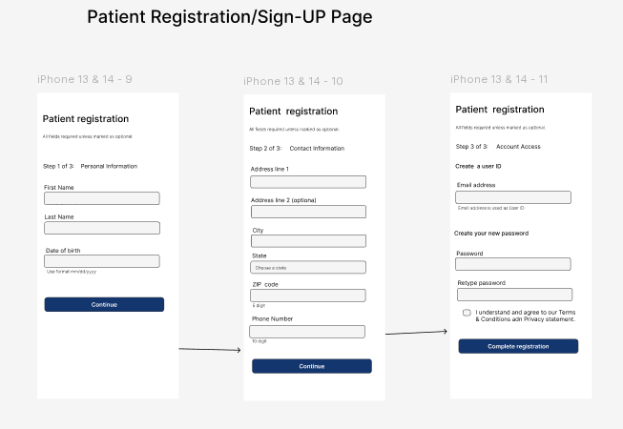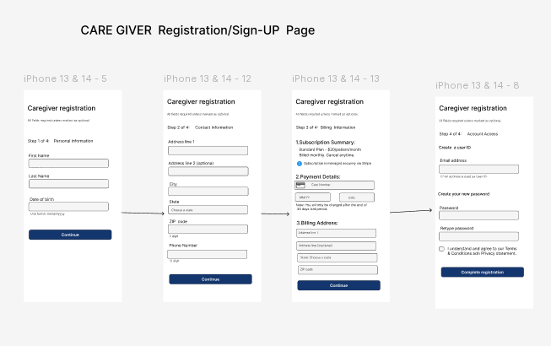

#### Internal UI Functionality

|  |  |
| --- | --- |
| **ID** | **Description** |
| IUF-UR-1 | Display registration form with input fields for name, email, and password (with confirmation). |
| IUF-UR-2 | Validate user inputs in real-time and highlight errors (e.g., invalid email format, weak password). |
| IUF-UR-3 | Include a show/hide toggle for the password field to allow user verification. |
| IUF-UR-4 | Present a Terms of Service checkbox, enabling the Register button only when checked. |
| IUF-UR-5 | Display a link to the Login screen ("Already have an account? Sign in."). |

#### External UI Functionality

|  |  |
| --- | --- |
| **ID** | **Description** |
| EUF-UR-1 | On tapping "Register", submit the form data to the authentication service API. |
| EUF-UR-2 | If registration succeeds, navigate to the role selection or welcome screen. |
| EUF-UR-3 | If registration fails, display an error dialog with the server response. |
| EUF-UR-4 | Trigger sending of a verification email and show a confirmation message on success. |
| EUF-UR-5 | On tapping "Sign in", navigate back to the Login screen. |

### Login/Logout Flows

#### Module Description:

This section covers how existing users sign in to and out of the CareConnect app. The Login screen allows patients and caregivers to enter their email address and password to access their account. It may also provide alternative sign-in options (such as Google or Microsoft single sign-on buttons) if supported. The form clearly labels each input and includes a “Show/Hide” toggle on the password field for convenience. A “Forgot Password?” link is available beneath the password field to start the password recovery process. If the user enters invalid credentials, the system displays an inline error message (for example, “Incorrect email or password”) to help the user correct the issue. Once the user successfully logs in, the app navigates to the appropriate dashboard (Patient or Caregiver dashboard) with a smooth transition. For the Logout flow, each dashboard includes a visible logout option (for example, in a menu or toolbar). When the user taps “Logout,” the app ends the session and returns the user to the Welcome screen. The logout action provides immediate feedback (such as a brief confirmation message or animation) to indicate that the user has been signed out. Overall, the login/logout process is seamless and intuitive, allowing users to quickly and confidently access or exit their accounts as needed.

#### Image(s)

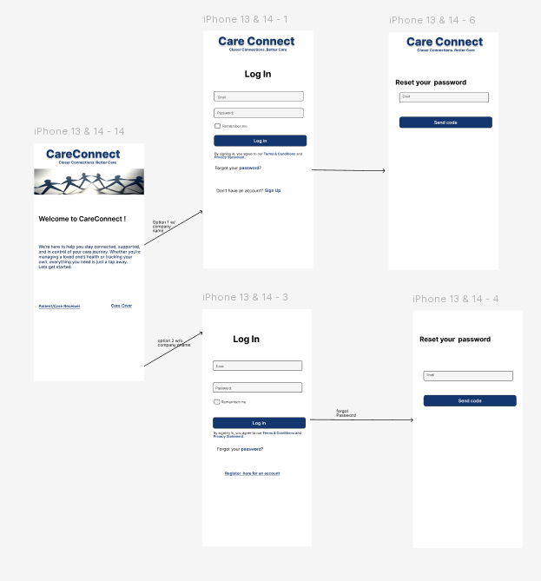

#### Internal UI Functionality

|  |  |
| --- | --- |
| **ID** | **Description** |
| IUF-LL-1 | Display login form with fields for username/email and password. |
| IUF-LL-2 | Include a show/hide toggle for the password field. |
| IUF-LL-3 | Enable the Login button only when all required fields are valid. |
| IUF-LL-4 | Provide "Forgot password?" and "Register" links below the form. |
| IUF-LL-5 | Maintain consistent styling (colors, typography) matching the app theme. |
| IUF-LL-6 | On logout, clear user-specific UI elements and return to the Welcome screen. |

#### External UI Functionality

|  |  |
| --- | --- |
| **ID** | **Description** |
| EUF-LL-1 | On tapping "Login", submit credentials to the authentication service. |
| EUF-LL-2 | If login succeeds, navigate to the user's dashboard or home screen. |
| EUF-LL-3 | If login fails, display an error message (e.g., invalid credentials). |
| EUF-LL-4 | On tapping "Logout", terminate the session and navigate to the Welcome screen. |
| EUF-LL-5 | On tapping "Forgot password?", navigate to the Password Reset flow. |

### Password Reset & Recovery (For all Users)

#### Module Description:

#### This module will explain how a user can reset their password and recover their account.

#### Image(s):

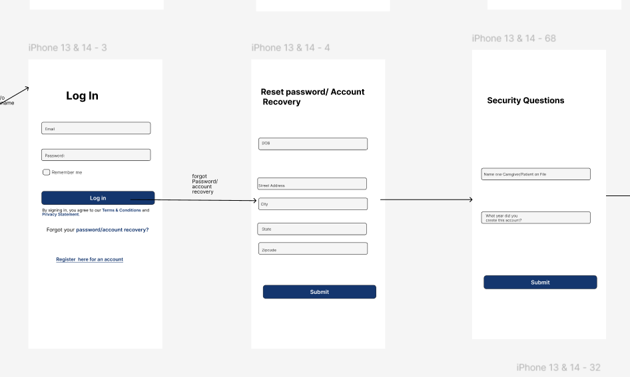

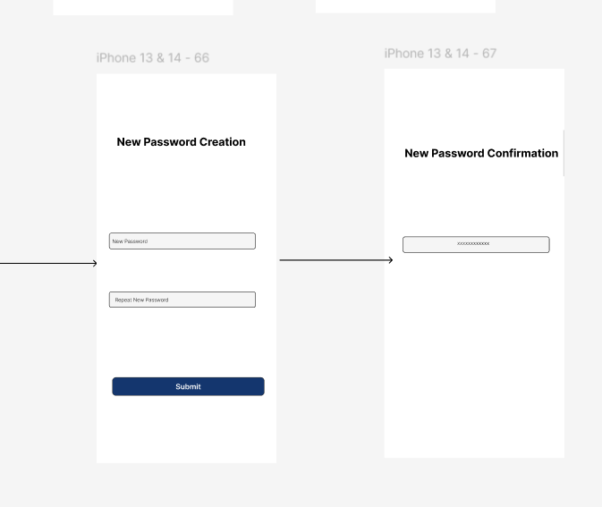

#### Internal UI Functionality

|  |  |
| --- | --- |
| **ID** | **Description** |
| IUF-WS-1 | The user shall click on “forgot password/account recovery” on the home page. |
| IUF-WS-2 | The user answers the questions correctly and presses “submit”. |
| IUF-WS-3 | The patient creates a new password, types it twice, and clicks “submit”. |

#### External UI Functionality

|  |  |
| --- | --- |
| **ID** | **Description** |
| EUF-WS-1 | The application goes to a page where the user shall input their date of birth and address. |
| EUF-WS-2 | The application verifies that the answers are correct and brings them to a screen where they have to enter a new password. |
| EUF-WS-3 | The application verifies that the password is typed correctly twice and resets the password and account. |

## Billing & Subscription Management

### Plan Definition & Pricing Tiers

#### Module Description:

#### Image(s):

#### Internal UI Functionality

|  |  |
| --- | --- |
| **ID** | **Description** |
| IUF-WS-1 |  |

#### External UI Functionality

|  |  |
| --- | --- |
| **ID** | **Description** |
| EUF-WS-1 |  |

### Subscription Activation

#### Module Description:

#### Image(s):

#### Internal UI Functionality

|  |  |
| --- | --- |
| **ID** | **Description** |
| IUF-WS-1 |  |

#### External UI Functionality

|  |  |
| --- | --- |
| **ID** | **Description** |
| EUF-WS-1 |  |

### Payment Methods & Failover

#### Module Description:

#### Image(s):

#### Internal UI Functionality

|  |  |
| --- | --- |
| **ID** | **Description** |
| IUF-WS-1 |  |

#### External UI Functionality

|  |  |
| --- | --- |
| **ID** | **Description** |
| EUF-WS-1 |  |

### Billing Failure & Handling

#### Module Description:

#### Image(s):

#### Internal UI Functionality

|  |  |
| --- | --- |
| **ID** | **Description** |
| IUF-WS-1 |  |

#### External UI Functionality

|  |  |
| --- | --- |
| **ID** | **Description** |
| EUF-WS-1 |  |

## User Roles & Management

### Caregiver Profile

#### Module Description:

The Caregiver Profile screen allows the Caregiver to modify their display name, phone number, email address, and physical address, as well as view their unique QR Code and change their profile picture.

#### Image(s):

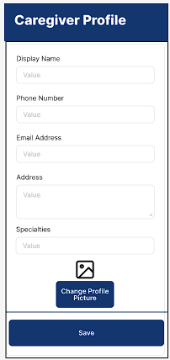

#### Internal UI Functionality

|  |  |
| --- | --- |
| **ID** | **Description** |
| IUF-CP-1 | Enable input for display name, phone number, email address, physical address, specialties, and profile picture upload. |
| IUF-CP-2 | Apply form validation of input fields before saving. |
| IUF-CP-3 | Store locally before sending it to server in case of connection loss. |

#### External UI Functionality

|  |  |
| --- | --- |
| **ID** | **Description** |
| EUF-CP-1 | New caregiver information is available for viewing on the Patient Dashboard screen. |

### Patient Profile

#### Module Description:

The Patient Profile screen allows the Patient to modify their display name, phone number, email address, and physical address, as well as view their unique QR Code and change their profile picture.

#### Image(s):

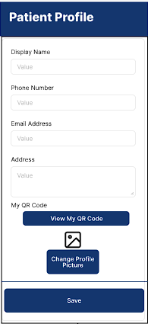

#### Internal UI Functionality

|  |  |
| --- | --- |
| **ID** | **Description** |
| IUF-PP-1 | Enable input for display name, phone number, email address, physical address, and profile picture upload. |
| IUF-PP-2 | Enable view access of unique QR Code. |
| IUF-PP-3 | Apply form validation of input fields before saving. |
| IUF-PP-4 | Store locally before sending it to server in case of connection loss. |

#### External UI Functionality

|  |  |
| --- | --- |
| **ID** | **Description** |
| EUF-PP-1 | New patient information is available for viewing on the Caregiver Dashboard screen. |

### Multi-Caregiver Support

#### Module Description:

Multi-Caregiver Support allows more than one caregiver to be linked to a patient at once. Multiple caregivers, with varying specialties, can provide care for a patient and support their needs. Patients can have multiple caregivers and caregivers can be linked to multiple patients.

#### Image(s): N/A

#### Internal UI Functionality

|  |  |
| --- | --- |
| **ID** | **Description** |
| IUF-MCS-1 | Allow multiple caregivers to be linked to a patient. |

#### External UI Functionality

|  |  |
| --- | --- |
| **ID** | **Description** |
| EUF-MCS-1 | All linked caregivers display on the Patient Dashboard. |
| EUF-MCS-2 | All linked patients display on the Caregiver Dashboard. |

### Profile Linking

#### Module Description:

Profile linking of Caregiver to Patient gives the Caregiver access to view, edit, and delete Patient records. Using the QR Code from the Patient’s Profile screen, the Caregiver can link to the Patient through the Add New Patient form.

#### Image(s):

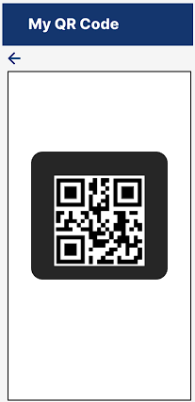

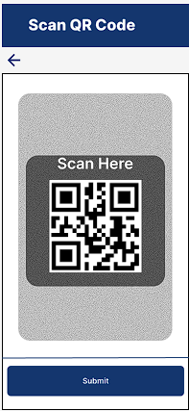

#### Internal UI Functionality

|  |  |
| --- | --- |
| **ID** | **Description** |
| IUF-PL-1 | Enable patient viewing of unique QR Code. |
| IUF-PL-2 | Enable caregiver scanning of QR Code on Add New Patient screen. |
| IUF-PL-3 | Autofill information on the Add New Patient form fields. |
| IUF-PL-4 | Apply form validation of input fields before saving. |
| IUF-PL-5 | Store locally before sending it to server in case of connection loss. |

#### External UI Functionality

|  |  |
| --- | --- |
| **ID** | **Description** |
| EUF-PL-1 | Unique QR Code is generated for each patient user in My Profile. |
| EUF-PL-2 | Submission of Add New Patient form submits link between caregiver and patient. |

### Access Control & Permissions

#### Module Description:

User roles are managed through authentication in the login process. Caregivers are given all functional features to take care of, monitor, and call with their patients. Patients are given limited functional features aligned with displaying their symptoms, health, and wellness.

#### Image(s):

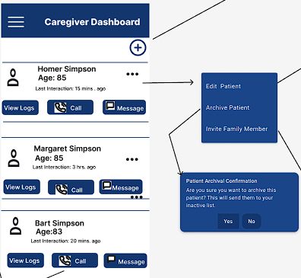

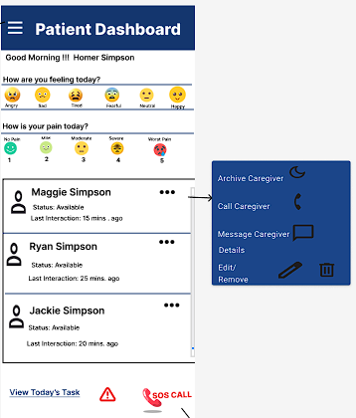

#### Internal UI Functionality

|  |  |
| --- | --- |
| **ID** | **Description** |
| IUF-ACP-1 | Caregiver Dashboard hold all functional features for caregiver’s needs. |
| IUF-ACP-2 | Patient Dashboard hold all functional features for patient’s needs. |

#### External UI Functionality

|  |  |
| --- | --- |
| **ID** | **Description** |
| EUF-ACP-1 | Family member roles have “read only” access to patient records. |

### Family “Read-Only” Access

#### Module Description:

Family “Read-Only” Access allows the approved family members to take care of the Patient. They can view the Patient’s record (symptoms, care schedules and caregiver notes).However, they don’t have access to modify or delete any patients record.

#### Image(s):

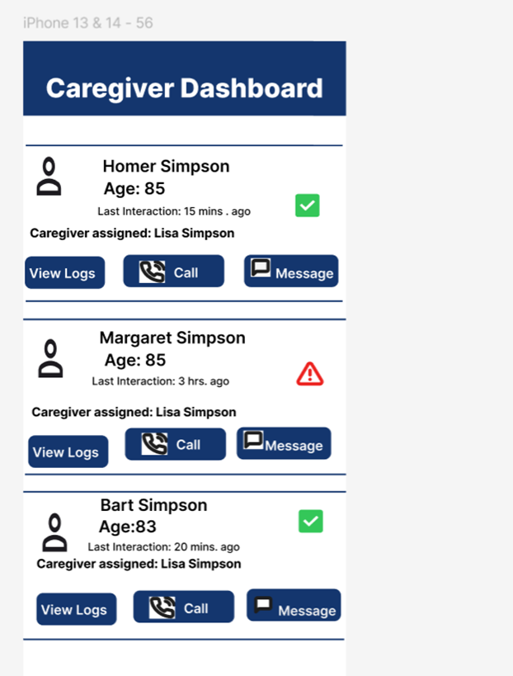

#### Internal UI Functionality

|  |  |
| --- | --- |
| **ID** | **Description** |
| IUF-WS-1 | * Invited Family Member will be given role-based access. Restricting to read only access. |
| IUF-WS-2 | * Fetch real-time patient data. (symptoms, schedule) |
| IUF-WS-3 | * Disabled functions such as “Edit”, “Add”, “Call” |

#### External UI Functionality

|  |  |
| --- | --- |
| **ID** | **Description** |
| EUF-WS-1 | * View patient profile with name, age, caregiver assigned. |
| EUF-WS-2 | * Access read-only version of shared document. |

## Dashboards

### Caregiver Dashboard

#### Module Description:

The Patient Dashboard (Caregiver View) is the primary interface for the caregiver. It provides a complete interactive setting where they can monitor, manage, communicate and care their patients. The dashboard displays the list of patient data at a glance along with some quick access menus.

#### Image(s):

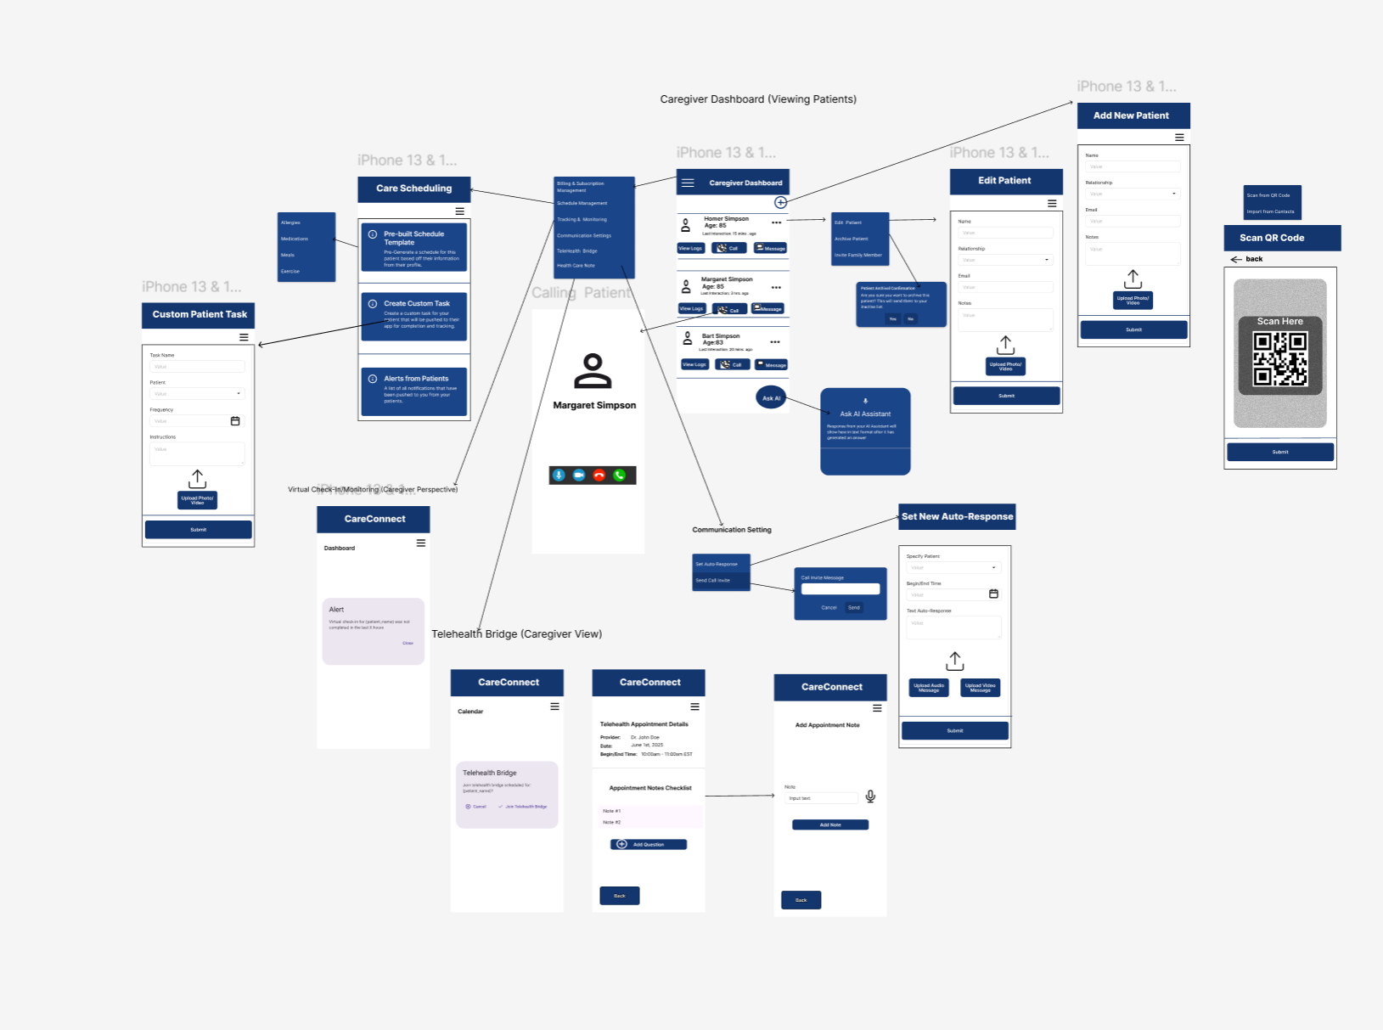

#### Internal UI Functionality:

|  |  |  |
| --- | --- | --- |
| **ID** | **Internal Functionality** | **Description** |
| PDB-IUF-1 | Data Fetching | Retrieves data from the backend using caregiver ID. |
| PDB-IUF-2 | State Management | Keeps the track of the list of patients, user role etc. |
| PDB-IUF-3 | Role-Based Access | Shows/hides action menu based on the role. |
| PDB-IUF-4 | Navigation Routing | Handles screen transition |
| PDB-IUF-5 | Error Handling | Displays fallback UI when data fails to load |
| PDB-IUF-6 | Action Handling | Executes code for action like add/edit/archive etc. |

#### External UI Functionality:

|  |  |  |
| --- | --- | --- |
| **ID** | **External Functionality** | **Description** |
| PDB-EUF-1 | Patient Card | Displays Patient name, profile pic and last interaction |
| PDB-EUF-2 | Ellipsis menu | Open actional options available |
| PDB-EUF-3 | Edit option | Navigates to update patient details |
| PDB-EUF-4 | Floating Action (“+”) button | Opens a form to add new patient |
| PDB-EUF-5 | View Logs button | Directs caregiver to view full logs (symptoms, meal, task and adherence history) |
| PDB-EUF-6 | Call Button | Initiates a call conversation with the patient |
| PDB-EUF-7 | Message | Opens message to chat with patients. |

### Patient Dashboard

#### Module Description:

The Patient Dashboard is the user’s main landing screen upon successful login. It provides a centralized interface for patients to manage their health tasks, track wellness data, and stay connected with their caregivers. The dashboard presents scheduled tasks, mood and pain tracking icons, assigned caregiver information, and immediate access to emergency features.

The design prioritizes simplicity, emotional comfort, and mobile accessibility to support elderly users or those with limited technical skills. The layout is scrollable with modular cards and icon-driven interactions. Real-time updates ensure dynamic feedback based on the patient’s actions and caregiver responses.

Key features include:

* Daily care tasks (e.g., medications, check-ins)
* Mood and pain self-reporting using visual icons
* Caregiver contact panel (chat, call)
* Emergency SOS button
* Motivational messages and visual encouragement

#### Image(s):

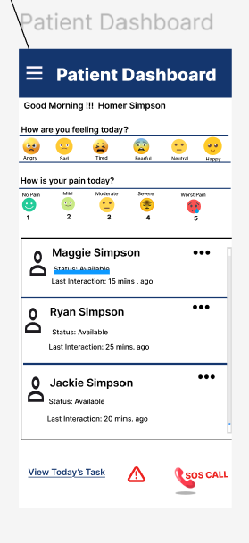

#### Internal UI Functionality

|  |  |
| --- | --- |
| **ID** | **Description** |
| IUF-WS-1 Mood | Allows the patient to record emotional state and pain level using face icons. Results are logged and alerts may be triggered based on severity. |
| IUF-WS-2 Task Checklist | Displays a checklist of daily health tasks and marks them as complete. |
| IUF-WS-3 Motivational Banner | Shows daily motivational quotes or messages to support patient morale. |
| IUF-WS-4 SOS Alert Button | Provides a quick emergency response feature to trigger caregiver or EMS alerts. |

#### External UI Functionality

|  |  |
| --- | --- |
| **ID** | **Description** |
| EUF-WS-1 caregiver Communication Module | Enables in-app messaging and voice calling between patient and caregiver. Interfaces with Communication Service and Telehealth Bridge securely. |
| EUF-WS-2 Task Reminder Sync | Sync scheduled task data with the backend to enable push reminders. |
| EUF-WS-3 Mood/Pain Escalation Alerts | Triggers backend alert flow if patient reports critical symptom values. |

### Patient Action Icons

#### Module Description: This module explains the Patient Action icons on the Patient Dashboard. The “moon icon” will Archive a caregiver so that no one can see them on the dashboard. The “telephone icon” will call a caregiver that is selected. The “chat box icon” will message the caregiver that is selected. The” pencil icon” will allow for editing caregiver information. The “trashcan icon” will allow the caregiver to delete a caregiver from their dashboard. The patient will also be able to click on a face on how they are feeling and click on a face (numbered pain scale) on what their pain is like? The “red phone” is for Emergency SOS to alert the caregiver of their location. If the Caregiver doesn't respond, then two other points of contact will be reached out to. If they do not respond, then 911 EMS will be called.

#### Image(s):

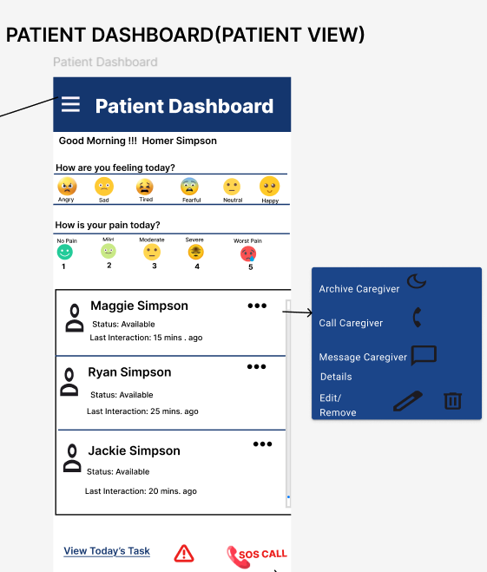

#### Internal UI Functionality

|  |  |
| --- | --- |
| **ID** | **Description** |
| IUF-WS-1 | Archive caregiver: Tapping the **moon icon** archives a caregiver, hiding them from the dashboard view. |
| IUF-WS-2 | Edit caregiver: Tapping the pencil icon opens a form to edit caregiver information. |
| IUF-WS-3 | Delete caregiver: Tapping the **trashcan icon** removes the caregiver from the dashboard. |
| IUF-WS-4 | Mood selection: Patient can tap on a **face icon** to indicate how they are feeling. |
| IUF-WS-5 | Pain scale input: Patient can tap on a **numbered pain face icon** to record pain level. |

#### External UI Functionality

|  |  |
| --- | --- |
| **ID** | **Description** |
| EUF-WS-1 | Call caregiver: Tapping the **telephone icon** initiates a phone call to the selected caregiver. |
| EUF-WS-2 | Message caregiver: Tapping the **chat box icon** opens a message window to communicate with the selected caregiver. |
| EUF-WS-3 | Emergency SOS: Tapping the **red phone icon** sends an SOS alert to the caregiver with patient location. If no response, two backup contacts are notified. If still no response, 911 EMS is contacted. |

### Caregiver Action Icons

#### Module Description: This module will go over the Action Icons for the Caregiver Dashboard. The “plus sign” will go to another screen to add more patients. The “three dots” pulls up another menu listing Edit Patient, Archive Patient, and Invite Family Member. The “three horizontal lines icon” with bring up another listing of items, My Profile, Billing & Subscription Management, Schedule Managment, Tracking & Monitoring, Communication settings (Telehealth Bridge, Health Care Note, SOS Notification and Notification Setting). The circle “Ask AI” icon will bring you to a screen to the AI Assistant page. The “telephone icon” will call a patient that is selected. The “chat box icon” will message the patient that is selected.

#### Image(s):

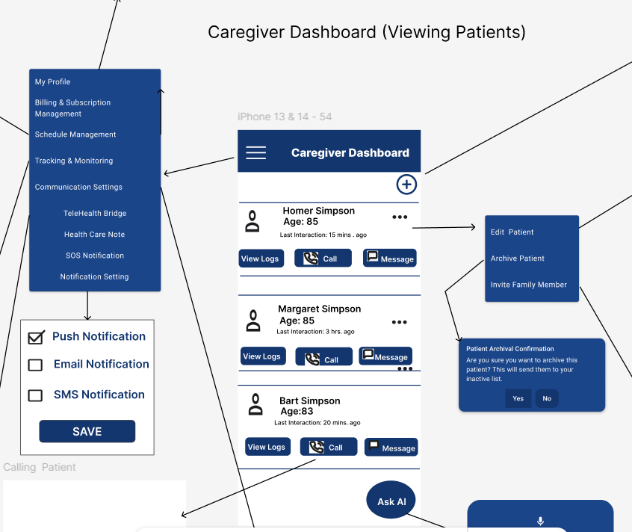

#### Internal UI Functionality

|  |  |
| --- | --- |
| **ID** | **Description** |
| IUF-WS-1 | Add Patient: Tapping the **plus sign icon** navigates to a screen for adding new patients. |
| IUF-WS-2 | Patient Options Menu: Tapping the **three dots icon** opens a menu with options to Edit Patient, Archive Patient, and Invite Family Member. |
| IUF-WS-3 | Caregiver Menu: Tapping the **three horizontal lines icon** opens a menu with options including My Profile, Billing & Subscription Management, Schedule Management, Tracking & Monitoring, and Communication Settings (Telehealth Bridge, Health Care Note, SOS Notification, and Notification Settings). |
| IUF-WS-4 | Ask AI: Tapping the **circular Ask AI icon** brings the user to the AI Assistant page. |

#### External UI Functionality

|  |  |
| --- | --- |
| **ID** | **Description** |
| EUF-WS-1 | Call Patient: Tapping the **telephone icon** initiates a phone call to the selected patient. |
| EUF-WS-2 | Message Patient: Tapping the **chat box icon** opens a messaging interface to communicate with the selected patient. |

## Scheduling & Notifications

### Pre-Defined Care Templates

#### Module Description: This screen allows caregivers to quickly assign a predefined care routine such as "Medication," "Meals," "Daily Walk," or "Bathing" to a patient. Each template comes with default time suggestions and can be customized afterward.

#### Image(s):

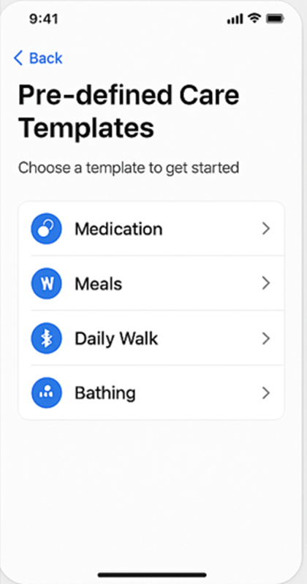

#### Internal UI Functionality

|  |  |
| --- | --- |
| **ID** | **Description** |
| **IUF-PCT-1** | Render list of available care templates dynamically from local config or backend service. |
| **IUF-PCT-2** | Display template-specific icons and color coding for visual recognition. |
| **IUF-PCT-3** | Allow tap-to-select behavior and transition to task preview screen. |

#### External UI Functionality

|  |  |
| --- | --- |
| **ID** | **Description** |
| **EUF-PCT-1** | When a caregiver taps a template, navigate to a task creation screen with pre-filled data. |
| **EUF-PCT-2** | Sync selected care template with patient care plan via backend API. |

### Custom Task Scheduling

#### Module Description: This interface lets caregivers schedule ad-hoc tasks with custom names, time, and recurrence patterns. It supports multiple days and time options.

#### Image(s):

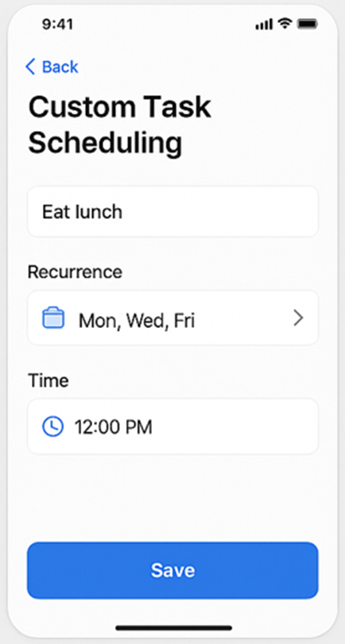

#### Internal UI Functionality

|  |  |
| --- | --- |
| **ID** | **Description** |
| **IUF-CTS-1** | Enable input for custom task title, recurrence, and time selection. |
| **IUF-CTS-2** | Apply form validation on task fields before saving. |
| **IUF-CTS-3** | Store locally before sending to server in case of connection loss. |

#### External UI Functionality

|  |  |
| --- | --- |
| **ID** | **Description** |
| **EUF-CTS-1** | On save, post custom task data to the Scheduling API. |
| **EUF-CTS-2** | Show confirmation toast and return to caregiver dashboard. |

### Notification Channels

#### Module Description:

Notification Channels allows caregivers to send the reminders/alerts/system messages via push notification, email alerts and/or SMS messages.

#### Image(s):

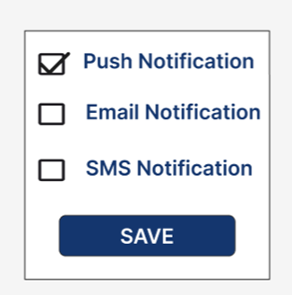

#### Internal UI Functionality

|  |  |
| --- | --- |
| **ID** | **Description** |
| IUF-WS-1 | * Load user notification preferences from the database |
| IUF-WS-2 | * Update preferred channels (Push, Email, SMS) based on user selection. |
| IUF-WS-3 | * Trigger notification logic from schedule |

#### External UI Functionality

|  |  |
| --- | --- |
| **ID** | **Description** |
| EUF-WS-1 | * User receives in-app push reminder |
| EUF-WS-2 | * Caregivers receive email alerts for emergency events or missed check-ins. |
| EUF-WS-3 | * Patients receive SMS notification for critical reminder if enabled. |

### Reminder & Escalation Rules

#### Module Description:

The Remindera & Escalation Rulesmodule in CareConnect enables the automated delivery and tracking of scheduled health-related tasks It ensures patient compliance by issuing reminders and initiating escalation protocols if a task is missed.

Reminders are delivered via push notification. If a task is not acknowledged within a predefined grace period, the system escalates the alert to caregivers or backup contacts. This ensures timely follow-up and reduces health risks caused by non-compliance.

#### Image(s):

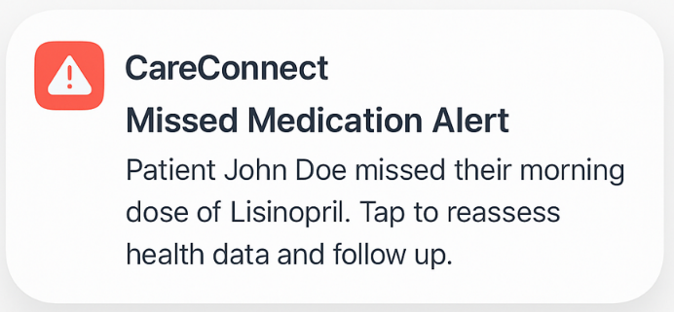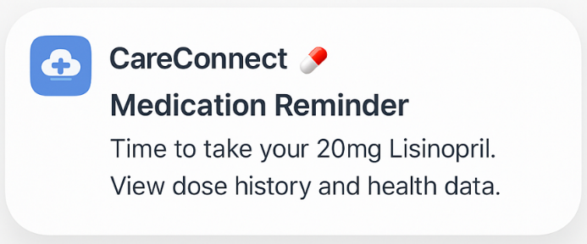

#### Internal UI Functionality

|  |  |
| --- | --- |
| **ID** | **Description** |
| IUF-RER-1 | Scheduled task creation with assigned due time. |
| IUF-RER-2 | Grace period countdown logic triggers if user does not acknowledge reminder |
| IUF-RER-3 | Caregiver dashboard shows alert log with timestamps and acknowledgment tracking |

#### External UI Functionality

|  |  |
| --- | --- |
| **ID** | **Description** |
| EUF-RER-1 | Push notification sent to patient at scheduled reminder time |
| EUF-RER-2 | If no response, escalation alert sent to caregiver |
| EUF-RER-3 | |  | | --- | |  |   Patient or caregiver can acknowledge via external notification tap, redirecting into CareConnect |

### Caregiver Shift & Scheduling

#### Module Description: This module allows caregivers to set their working hours or shifts in the app. Patients and other caregivers can see when someone is on duty. Recurring shift options are supported.

#### Image(s):

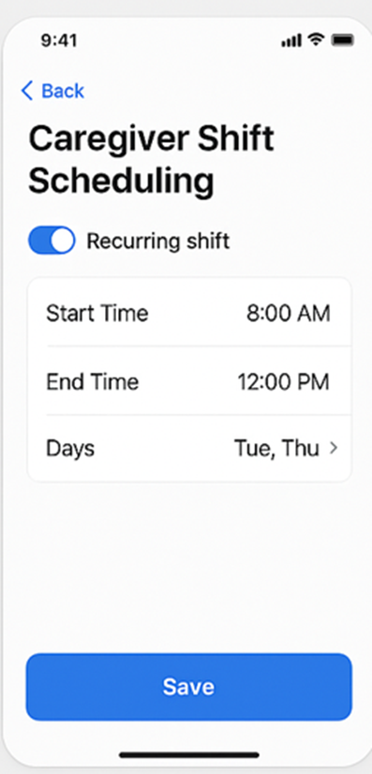

#### Internal UI Functionality

|  |  |
| --- | --- |
| **ID** | **Description** |
| **IUF-CSS-1** | Render time pickers and weekday toggles for start and end times. |
| **IUF-CSS-2** | Store schedule preferences using local state management before sync. |
| **IUF-CSS-3** | Toggle to enable/disable recurring schedule logic. |

#### External UI Functionality

|  |  |
| --- | --- |
| **ID** | **Description** |
| **EUF-CSS-1** | On save, post caregiver schedule to Shift API. |
| **EUF-CSS-2** | Schedule shows up on patient calendar view for shift visibility. |

## Health & Data Tracking

### Patient Symptom Tracking

#### Module Description:

#### Image(s):

#### Internal UI Functionality

|  |  |
| --- | --- |
| **ID** | **Description** |
| IUF-WS-1 |  |

#### External UI Functionality

|  |  |
| --- | --- |
| **ID** | **Description** |
| EUF-WS-1 |  |

### Meal & Nutrition Tracking

#### Module Description:

#### Image(s):

#### Internal UI Functionality

|  |  |
| --- | --- |
| **ID** | **Description** |
| IUF-WS-1 |  |

#### External UI Functionality

|  |  |
| --- | --- |
| **ID** | **Description** |
| EUF-WS-1 |  |

### Mood & Wellness Tracking

#### Module Description:

#### Image(s):

#### Internal UI Functionality

|  |  |
| --- | --- |
| **ID** | **Description** |
| IUF-WS-1 |  |

#### External UI Functionality

|  |  |
| --- | --- |
| **ID** | **Description** |
| EUF-WS-1 |  |

## AI Integration

### AI Mood Detection

#### Module Description:

This feature leverages artificial intelligence models to detect a patient’s mood using a combination of image data (e.g., facial expressions), video feeds, and text entries. The system processes these multimodal inputs to infer emotional states, enhancing the accuracy and automation of mood tracking for caregivers.

#### Image(s):

#### Internal UI Functionality

|  |  |
| --- | --- |
| **ID** | **Description** |
| IUF-WS-1 | Enables secure collection and submission of patient-provided videos, images, and text entries via the UI. |
| IUF-WS-2 | Displays real-time status of media processing (e.g., "Processing," "Analyzing," or "Complete") within the interface. |
| IUF-WS-3 | Interfaces with backend AI services to preprocess data and retrieve inferred mood results. |
| IUF-WS-4 | Presents confidence scores and timestamps alongside mood entries in the UI for internal validation. |
| IUF-WS-5 | Supports integration of inferred mood data into the patient’s timeline/mood history module. |
| IUF-WS-6 | Provides caregivers with a toggle/view to compare AI-inferred moods and manually entered mood logs. |
| IUF-WS-7 | Restricts access and visibility based on user role, ensuring only authorized users can view or update mood data. |

#### External UI Functionality

|  |  |
| --- | --- |
| **ID** | **Description** |
| EUF-WS-1 | Allows patients to submit video recordings, images, or text entries through an intuitive upload interface. |
| EUF-WS-2 | Displays progress indicators and confirmation messages after media is submitted. |
| EUF-WS-3 | Provides caregivers with a dashboard view of AI-inferred mood states, including mood labels and timestamps. |
| EUF-WS-4 | Enables caregivers to view trends or patterns over time based on AI-detected mood history. |
| EUF-WS-5 | Offers caregivers a side-by-side view of AI-inferred moods and manually logged mood entries. |
| EUF-WS-6 | Allows authorized users to filter mood data by time period, mood type, or input source (video/image/text). |
| EUF-WS-7 | Ensures all displayed mood data is accompanied by privacy disclaimers and confidence indicators. |

### Ask AI

#### Module Description:

This feature allows caregivers to interact with an AI assistant to ask simple, non-clinical healthcare-related questions. The AI assistant is designed to provide informative, conversational responses that do not require the expertise of a licensed medical professional. Questions can be submitted via text or voice input, offering flexibility and ease of use.

#### Image(s):

#### Internal UI Functionality

|  |  |
| --- | --- |
| **ID** | **Description** |
| IUF-WS-1 | Provides a backend interface to receive and process caregiver-submitted questions via text or converted voice input. |
| IUF-WS-2 | Interfaces with a speech-to-text service to convert voice input to text for processing. |
| IUF-WS-3 | Sends text input to the AI model and receives a structured, contextually relevant response. |
| IUF-WS-4 | Flags questions that potentially require clinical judgment and triggers the appropriate advisory message. |
| IUF-WS-5 | Logs all queries and responses in a secure database for quality assurance and future audits. |
| IUF-WS-6 | Associates AI interactions with the authenticated user for access control and traceability. |
| IUF-WS-7 | Appends a standard disclaimer to all AI-generated responses indicating they do not constitute medical advice or a substitute for physician care. |

#### External UI Functionality

|  |  |
| --- | --- |
| **ID** | **Description** |
| EUF-WS-1 | Allows caregivers to enter questions through a text input field or by recording voice input. |
| EUF-WS-2 | Provides visual feedback during voice recording and transcription processes. |
| EUF-WS-3 | Displays the AI-generated response in a clear, conversational format along with a standard disclaimer. |
| EUF-WS-4 | Alerts the user with a warning when a submitted question may require professional medical input. |
| EUF-WS-5 | Offers a history view of previously submitted questions and corresponding AI responses. |
| EUF-WS-6 | Restricts access to authorized caregiver users. |
| EUF-WS-7 | Supports natural language questions and handles varied phrasing with consistent, readable output. |

## Communication & Media

### In-App Messaging

#### Module Description:

In-App Messaging enables private, real-time communication between caregivers and patients within the CareConnect app. From the user’s dashboard, a “Messages” section shows active conversation threads with other users. Tapping on a conversation opens a chat view, where messages appear as speech bubbles aligned left or right depending on the sender. Each message displays a timestamp and an indicator for unread messages. At the bottom of the chat view is a text input field and a send button; the user can type a message (and optionally attach images or voice notes if supported) and then tap the send icon to post it. Incoming messages are delivered instantly, keeping the conversation live, and the chat interface automatically scrolls to show the newest messages.

The messaging interface emphasizes clarity and ease of use. Avatars or initials identify the sender next to each message. The input area is always visible and can expand for longer text. Notifications (push or in-app badges) alert users to new messages when they are not actively viewing the chat. Error handling is important: if a message fails to send (for example, due to network issues), the app displays an error icon or text with an option to retry. Overall, the design of In-App Messaging focuses on making communication natural and accessible, ensuring users can keep track of conversations with simple, intuitive controls.

#### Image(s):

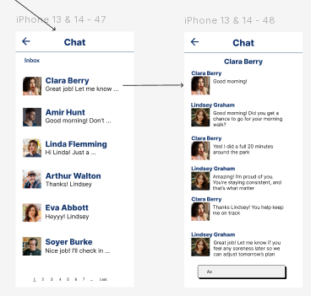

#### Internal UI Functionality

|  |  |
| --- | --- |
| **ID** | **Description** |
| IUF-IM-1 | Display the chat thread with messages formatted as chat bubbles (including sender name and timestamp). |
| IUF-IM-2 | Provide a persistent text input field and "Send" button at the bottom. |
| IUF-IM-3 | Enable real-time updates of the conversation as new messages arrive. |
| IUF-IM-4 | Automatically scroll the chat view to the latest message on send/receive. |
| IUF-IM-5 | Show a typing indicator when the other party is composing a message. |

#### External UI Functionality

|  |  |
| --- | --- |
| **ID** | **Description** |
| EUF-IM-1 | On tapping "Send", post the message to the communication (chat) service API. |
| EUF-IM-2 | When a new message is received via WebSocket or push, append it to the chat UI. |
| EUF-IM-3 | Fetch conversation history from the server when opening the chat screen. |
| EUF-IM-4 | Notify the server when messages are read or delivered (if applicable). |
| EUF-IM-5 | On message send failure, display an error notification to the user. |

### Audio & Video Calls

#### Module Description:

Audio and Video Calling allows caregivers and patients to have live voice and video conversations directly within the CareConnect app. Calls can be initiated from the In-App Messaging screen or from a user’s profile (by tapping a call icon next to a contact). When a call is initiated, the recipient sees an incoming call notification screen with “Accept” and “Decline” options. If the call is answered, the app transitions to the Call screen, which displays the video feed (if video is enabled) or a placeholder icon (if audio-only). During the call, the interface shows basic controls: a mute microphone button, a toggle for the camera (on/off), and an end-call button. The caller’s and recipient’s names (or photos) are shown so users know who is on the call. The UI clearly indicates call status (for example, connecting, ringing, in-call) and shows call duration once connected.

The design emphasizes usability and safety. Controls must be large enough to tap easily, and the layout should not distract from the video feed during a video call. When video calling, the app shows the user’s own camera view in a small picture-in-picture overlay. For audio calls, the UI presents a large phone icon and the participants’ names. If the network connection is poor, the app may display a notification or automatically switch to audio-only mode to maintain the call. When the call ends, the user returns to the previous screen (for example, the chat or dashboard). Overall, the Audio and Video Calling interface ensures communication is as effortless as possible, giving caregivers and patients a convenient way to connect in real time.

#### Image(s):

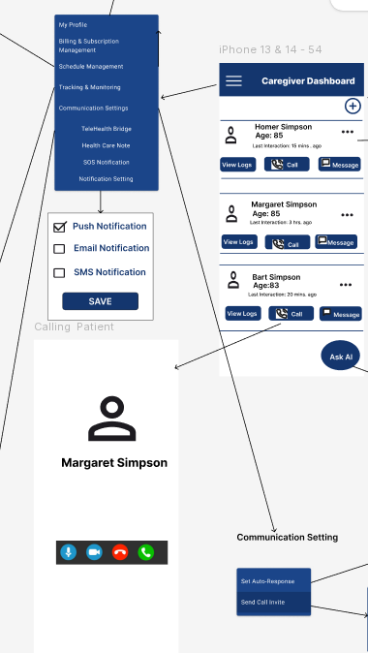

#### Internal UI Functionality

|  |  |
| --- | --- |
| **ID** | **Description** |
| IUF-AV-1 | Provide UI controls for mute/unmute, camera on/off, and hang-up during the call. |
| IUF-AV-2 | Render the remote video feed prominently with the local preview in a smaller overlay. |
| IUF-AV-3 | Show call status and duration (e.g., connecting, active, elapsed time) on the screen. |
| IUF-AV-4 | Display an incoming call dialog with caller information and Accept/Decline options. |
| IUF-AV-5 | Allow the user to switch between front and rear cameras during the call. |

#### External UI Functionality

|  |  |
| --- | --- |
| **ID** | **Description** |
| EUF-AV-1 | On tapping "Call", initiate a signaling request to establish an audio/video session. |
| EUF-AV-2 | On accepting an incoming call, send a response to connect and start the media streams. |
| EUF-AV-3 | On ending a call, send a hang-up signal to the call service and terminate media streams. |
| EUF-AV-4 | If the call fails or is rejected, display an error message and return to the previous screen. |

### Emergency SOS Mode

#### Module Description:

The Emergency SOS interface shall allow patients to alert their selected caregiver of an emergency SOS notification. When preparing the emergency SOS notification, the application will request the patient’s permission to record their live location and last 30 seconds of audio. The caregiver shall be notified with the requirement to acknowledge the notification. Once the caregiver acknowledges the notification, the caregiver is shown the patient’s current location and the last 30 seconds of audio provided by the patient.

#### Image(s):

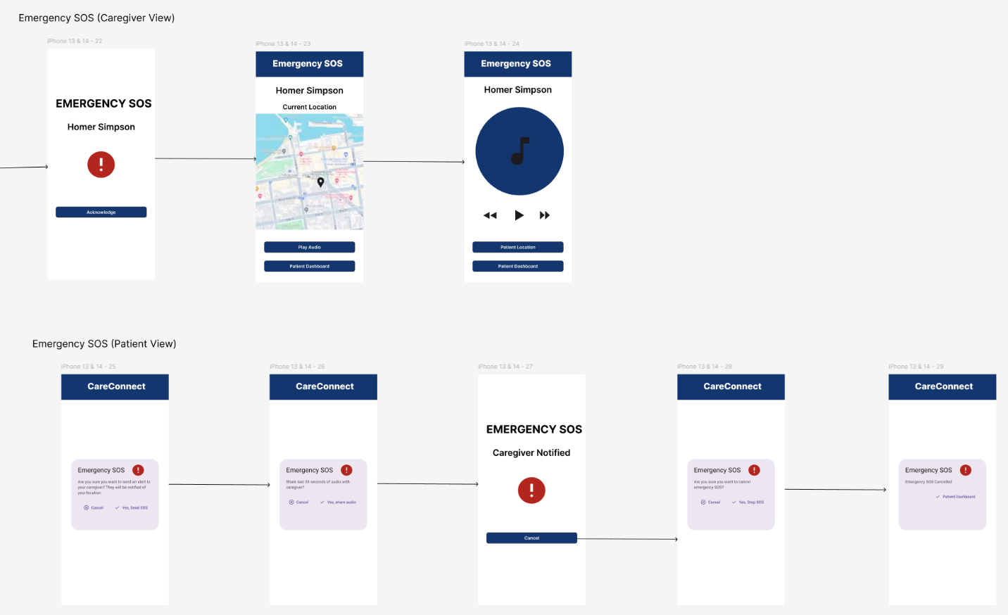

#### Internal UI Functionality

|  |  |
| --- | --- |
| **ID** | **Description** |
| IUF-WS-1 | The “play” icon will play the patient’s last 30 seconds of audio. |
| IUF-WS-2 | The map will show the caregiver the patient’s location |

#### External UI Functionality

|  |  |
| --- | --- |
| **ID** | **Description** |
| EUF-WS-1 | The “Patient Dashboard” button will redirect user to the patient/caregiver dashboard. |
| EUF-WS-2 | The “Acknowledge” button will direct the caregiver to the patient’s Emergency SOS details screen. |
| EUF-WS-3 | The “Play Audio” button will direct the caregiver to the audio screen. |
| EUF-WS-4 | The “Patient Location” button will direct the caregiver back to the patient’s Emergency SOS details screen. |
| EUF-WS-5 | The “Cancel” button will direct the patient to the cancel warning screen. |
| EUF-WS-6 | The “Yes” button will process the location and audio shared from the patient to the caregiver. |

### Virtual Check-In

#### Module Description:

The Virtual Check-In is the primary interface for caregivers to create pre-set questions that notify patients in an hourly cadence of their configuration. The patients shall receive a notification to complete their virtual check-in that they may agree to complete or cancel. If they choose to cancel, then the virtual check-in shall re-notify the patient after a certain period of time. If they agree to complete the virtual check-in, then the patients will complete the virtual check-in and submit their answers to the caregiver.

#### Image(s):

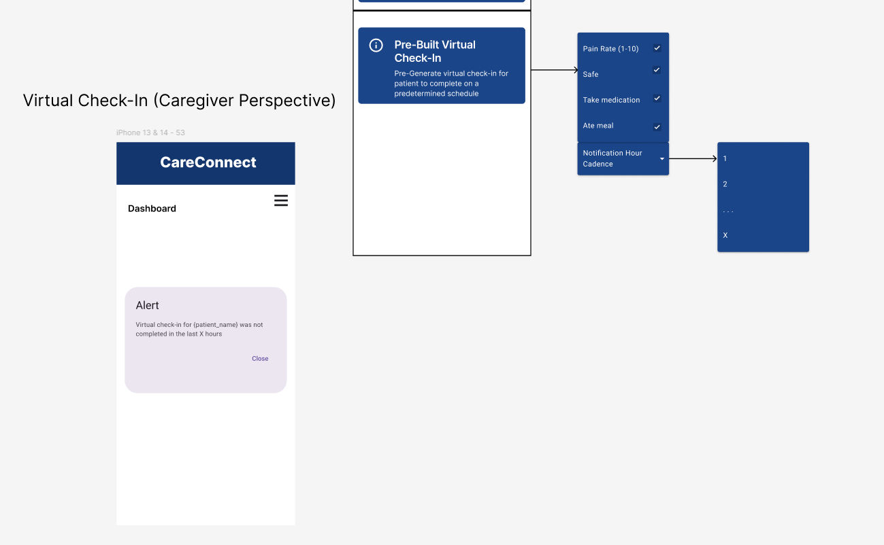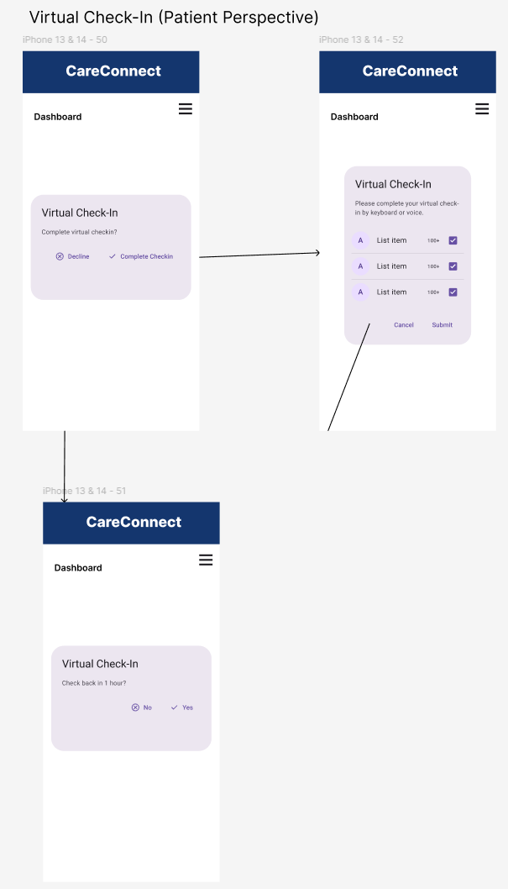

#### Internal UI Functionality

#### External UI Functionality

### Media Uploads

#### Module Description:

This module allows signed-in caregivers and patients to upload supported media files—such as photos (JPG, PNG) and documents (PDF)—CareConnect for documentation or care coordination purposes. All files must comply with predefined format and size restrictions. Uploaded files are automatically scanned for malware and policy violations before being securely stored and made accessible only to authorized users. This feature has a **high** priority due to its role in care documentation and patient communication.

#### Image(s):

#### Internal UI Functionality

|  |  |
| --- | --- |
| **ID** | **Description** |
| IUF-WS-1 | Enables upload of media files via the app interface for authorized users. |
| IUF-WS-2 | Invokes the backend malware/policy scanning service upon file submission. |
| IUF-WS-3 | Updates the document repository interface to reflect uploaded files. |

#### External UI Functionality

|  |  |
| --- | --- |
| **ID** | **Description** |
| EUF-WS-1 | Allows caregivers and patients to select and upload supported files from their devices. |
| EUF-WS-2 | Displays upload progress and success/failure messages with appropriate feedback. |
| EUF-WS-3 | Provides access to previously uploaded files in a secure document repository. |

### Voice-Activated Commands

#### Module Description:

The Voice-Activated Commands interface expands accessibility by integrating voice interaction into CareConnect. Clear indicators are used to apprise users of when the system is ready to receive commands, actively processing speech, responding to commands, or needs clarification for the previous command.

#### Image(s):

#### Internal UI Functionality

|  |  |
| --- | --- |
| **ID** | **Description** |
| IUF-VAC-1 | Clicking the “Voice Command” button initiates listening mode, with visual and auditory cues. |
| IUF-VAC-2 | Speaking the activation keyword initiates listening mode, with visual and auditory cues. |
| IUF-VAC-3 | Temporary overlay appears and audio plays to confirm the successful execution of a command |
| IUF-VAC-4 | Dialog box appears and audio plays to report the unsuccessful execution of a command and requests clarification or repeated attempts at command input. |

#### External UI Functionality

|  |  |
| --- | --- |
| **ID** | **Description** |
| EUF-VAC-1 | User voice input triggers actions on other screens or modules. |
| EUF-VAC-2 | User voice input can navigate to other screens. |
| EUF-VAC-3 | User voice input can fill forms on screen. |

### Telehealth Bridge

#### Module Description:

The Telehealth Bridge interface shall let caregivers and patients meet with the requested healthcare provider. The caregiver and patient shall be able to utilize text or voice to create appointment notes before the appointment for reference. The caregiver and patient shall have the option to either cancel the telehealth bridge process or accept the notification and continue to the telehealth bridge call.

#### Image(s):

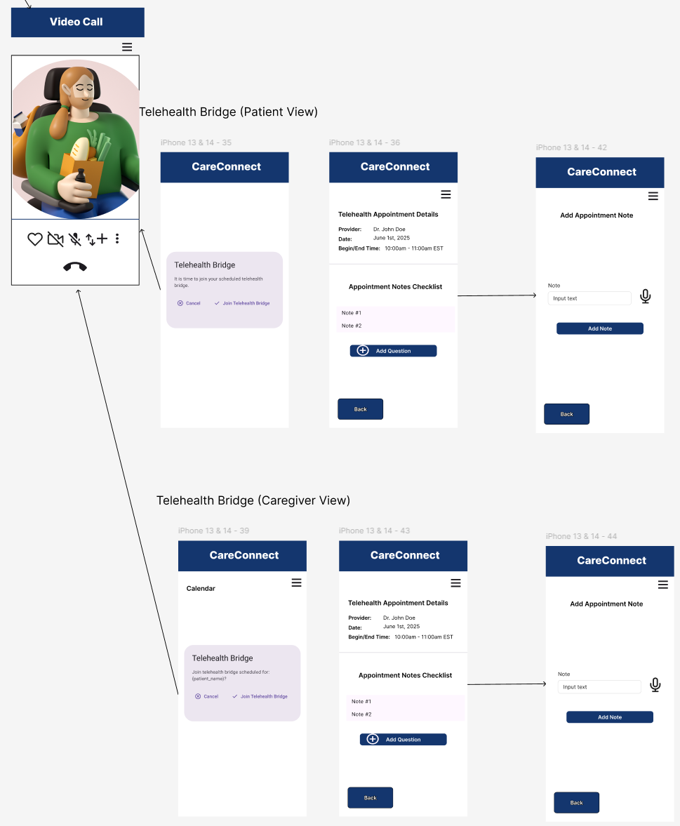

#### Internal UI Functionality

|  |  |
| --- | --- |
| **ID** | **Description** |
| IUF-WS-1 | The menu icon will open the menu options of the CareConnect app. |
| IUF-WS-2 | The “input text” text field will take in the user’s text input. |

#### External UI Functionality

|  |  |
| --- | --- |
| **ID** | **Description** |
| EUF-WS-1 | The “Back” button will take the user back to the previous screen. |
| EUF-WS-2 | The “Cancel” button will close the screen. |
| EUF-WS-3 | The “Add Question” button will send the user to the Add Appointment screen. |
| EUF-WS-4 | The “Add Note” button will save the note to the back-end storage. |
| EUF-WS-5 | The microphone icon will save the patient’s voice note to the back-end storage. |
| EUF-WS-6 | The “Join Telehealth Bridge” button will redirect the user to the 3rd party messaging service to join a call. |

## Device Integration & Interactions

### Wearables

#### Module Description:

The Wearables module allows users to connect third-party health tracking devices,Fitbit,Apple Health**, and** Google Health Connect to the CareConnect application. Through this integration, key health data (e.g., steps, heart rate) can be automatically synced and used to support caregiver and patient engagement, activity monitoring, and adherence tracking. The connection process includes secure authorization, selective data sharing preferences, and sync history.

#### Image(s):

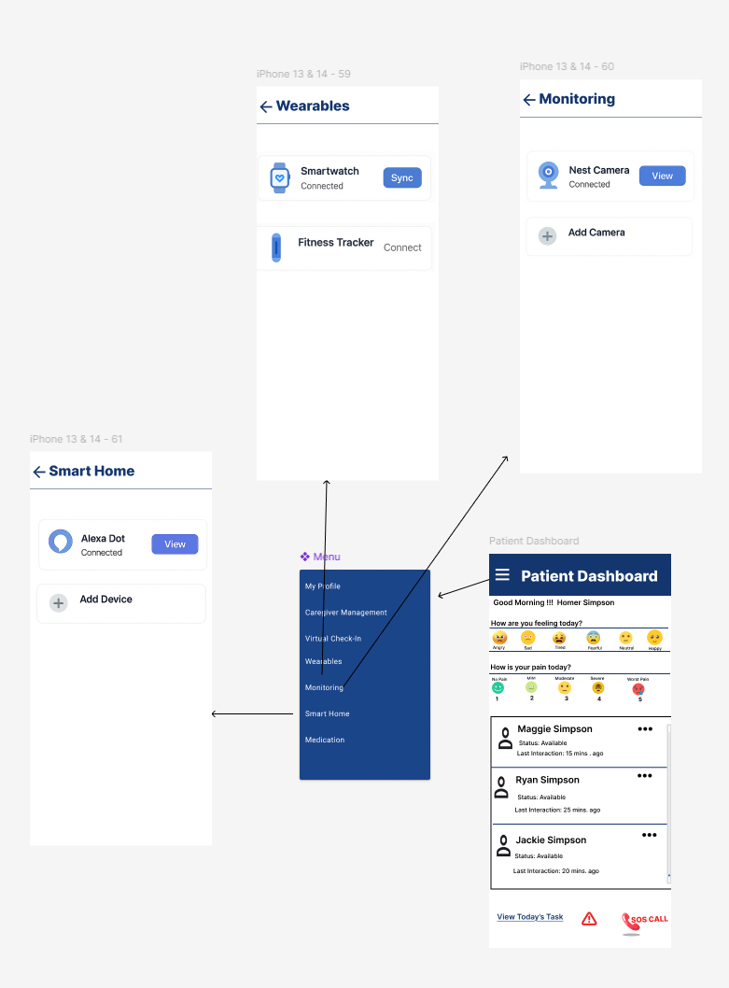

#### Internal UI Functionality

|  |  |
| --- | --- |
| **ID** | **Description** |
| IUF-DII-1 | Tapping the "Connect" button on the wearables screen a separate screen appears displaying instructions to connect (Fitbit, Apple Health, Google Health Connect). |
| IUF-DII-2 | If a wearable is already connected, it appears with a “Sync Now” option. |
| IUF-DII-3 | A successful connection updates the dashboard view to reflect active connection status and sync. |

#### External UI Functionality

|  |  |
| --- | --- |
| **ID** | **Description** |
| EUF-DII-1 | When a user selects a wearable source, the app initiates an OAuth or native permissions screen provided by the third-party service to authorize data sharing |
| EUF-DII-2 | f the external authorization fails or is denied, an error message is shown with the option to retry or return. |
| EUF-DII-3 | Upon successful authentication, a confirmation screen appears showing the integration is complete, with the option to sync immediately or return to dashboard. |

### Home Monitoring Integration

#### Module Description:

The Home Integration module enables users to connect Nest cameras and Alexa-compatibledevices to CareConnect. This allows for environmental awareness through live camera feeds and hands-free interaction with alexa compatible device via voice commands. Users can monitor patient surroundings, receive real-time motion alerts, and interact with Alexas compatible devices.

#### Image(s):



#### Internal UI Functionality

|  |  |
| --- | --- |
| **ID** | **Description** |
| IUF-HM-1 | Users initiate setup by tapping “Add Smart Device” or “Add Camera” |
| IUF-HM-2 | Nest-connected cameras are shown with a view option to trigger a live tile to allow users to tap for full-screen viewing. |
| IUF-HM-3 | |  | | --- | |  | | Alexa-compatible devices (e.g., smart plugs, lights) appear in a list. | |
| IUF-HM-4 | A device dashboard shows device status. |

#### External UI Functionality

|  |  |
| --- | --- |
| **ID** | **Description** |
| EUF-HM-1 | Nest integration uses Google authentication and Smart Device Management API to access camera feeds. |
| EUF-HM-2 | Alexa integration redirects users to Amazon to link their account and authorize access to smart home devices. |
| EUF-HM-3 | After successful linking, CareConnect retrieves the list of controllable Alexa-compatible devices via the Alexa Smart Home API. |

### Medication Management 2.0

#### Module Description:

The Medication Management module allows users to add medications by scanning theNational Drug Code (NDC) barcode. The scanned data is used to query the OpenFDAAP**I**, which returns detailed medication information such as drug name, manufacturer, and usage details. Users can then edit dosage and frequency before saving to their profile.

#### Image(s):

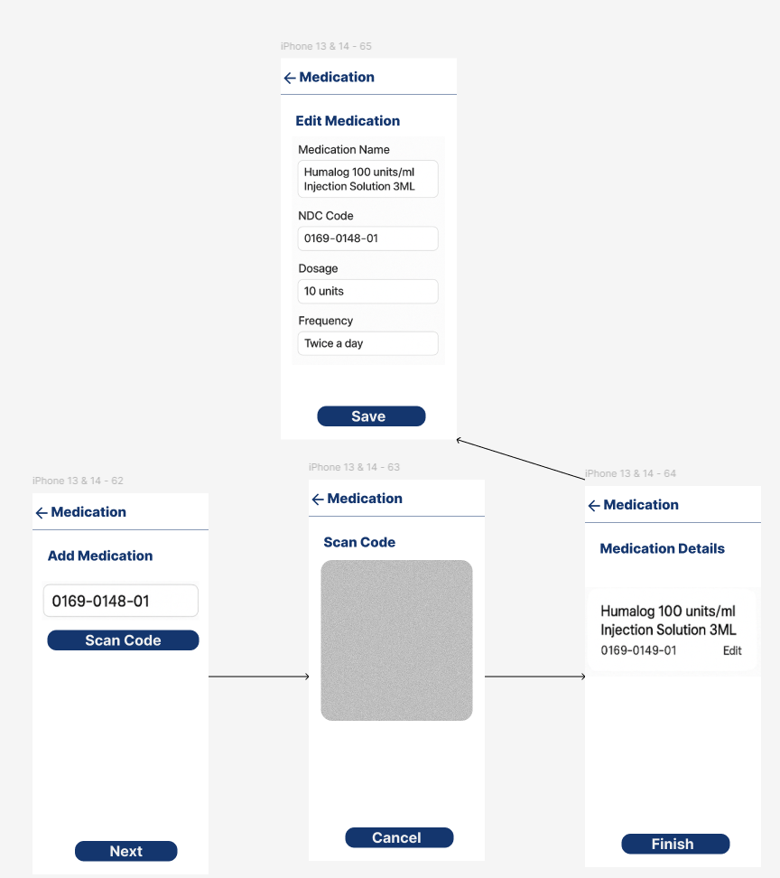

#### Internal UI Functionality

|  |  |
| --- | --- |
| **ID** | **Description** |
| IUF-MM-1 | Users access the “Medication” screen and tap the “Scan” button to open the camera scanner. |
| IUF-MM-2 | |  | | --- | |  | | Upon successful scan, a loading state is shown while querying OpenFDA for medication data. | |
| IUF-MM-3 | Retrieved data is displayed in a pre-filled form where user can edit dosage, frequency, and notes. |
| IUF-MM-4 | \Selection “Finish” saves the medication and adds it to the active medications list. |

#### External UI Functionality

|  |  |
| --- | --- |
| **ID** | **Description** |
| EUF-MM-1 | The app sends the scanned NDC code to OpenFDA’s API and awaits the response. |
| EUF-MM-2 | If the response is successful, it populates medication fields like brand name, route, and dosage form. |

## Gamification

### Provide rewards to completed tasks

#### Module Description:

This module tracks user engagement across daily tasks such as hydration, medication, and check-ins. Upon completion, XP is awarded and progress is tracked toward badges and level-ups. This encourages consistent participation through visual reinforcement and positive feedback mechanisms.

#### Image(s):

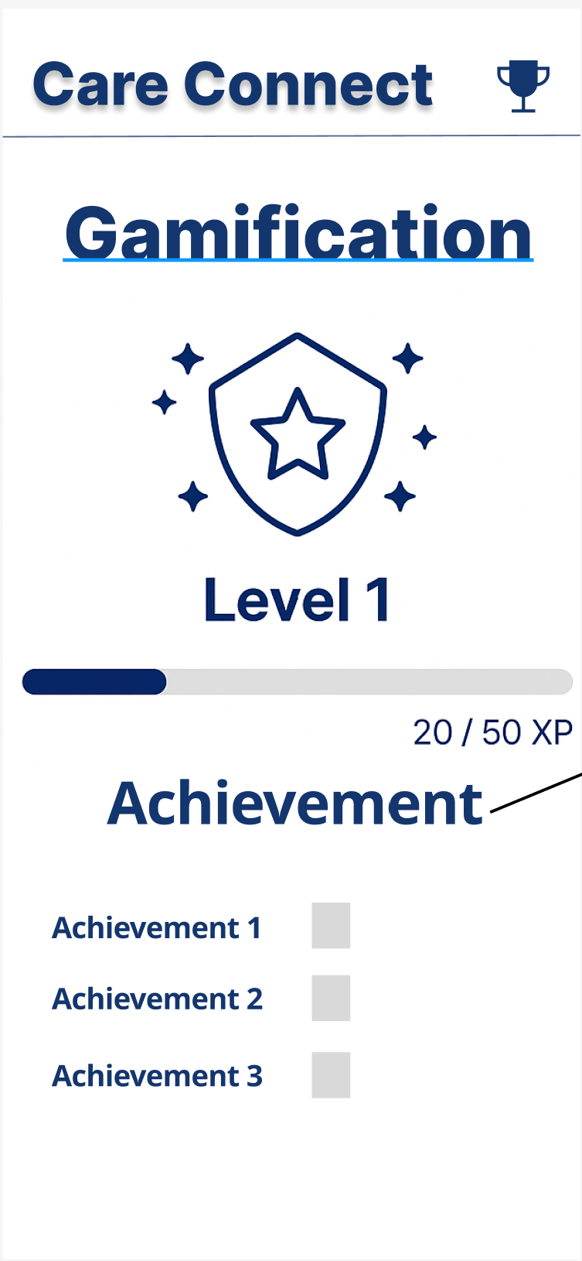 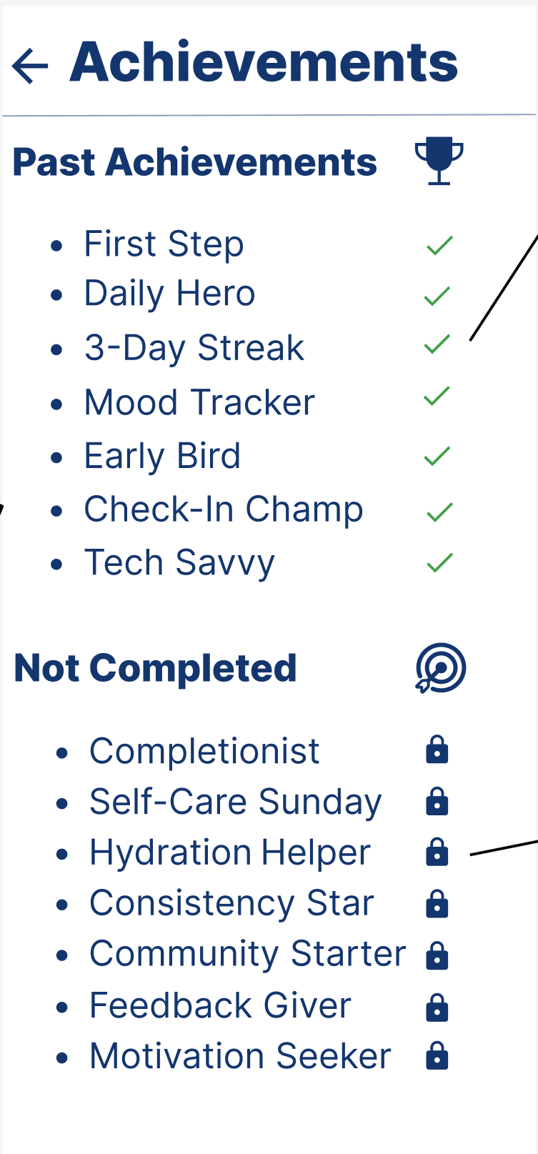 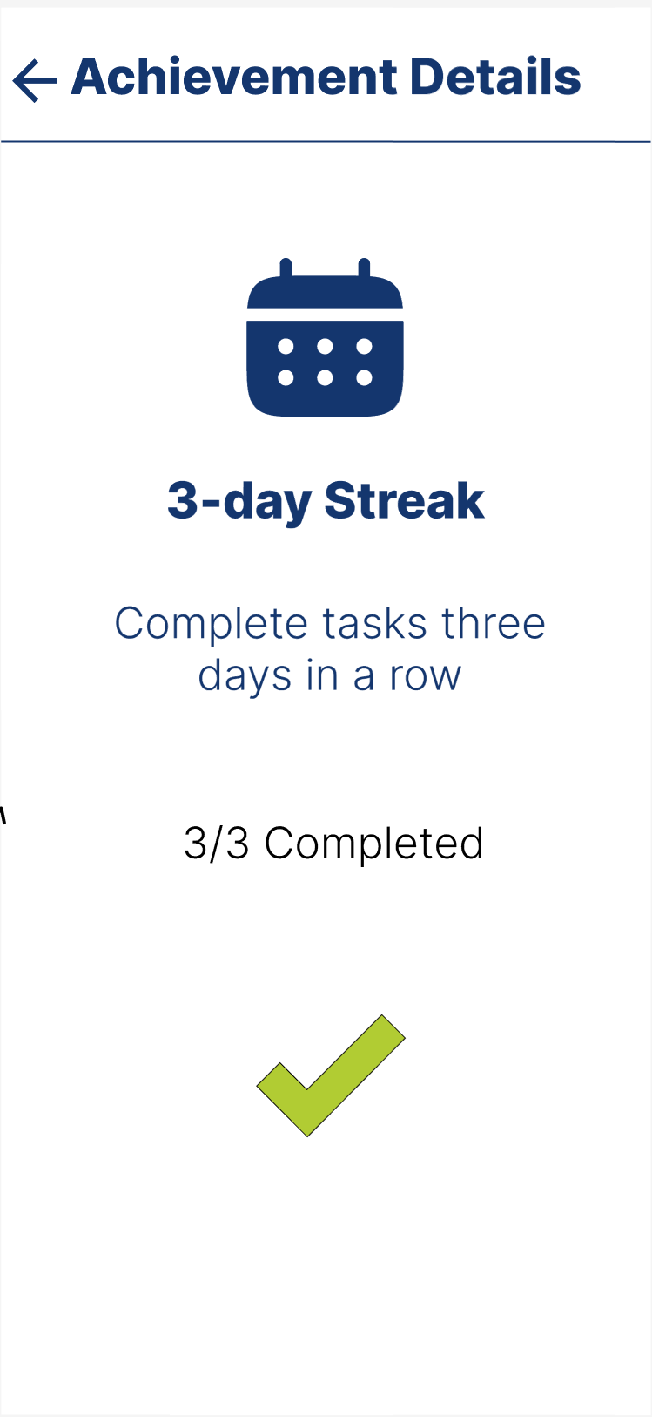

#### Internal UI Functionality

|  |  |
| --- | --- |
| **ID** | **Description** |
| IUF-WS-1 | Dynamically update XP and level after task compeltion |
| IUF-WS-2 | Display visual progress bar and earned badges based on API responses |
| IUF-WS-3 | Allow user to tap achievements to open detailed view with progress tracking |

#### External UI Functionality

|  |  |
| --- | --- |
| **ID** | **Description** |
| EUF-WS-1 | Retrieves XP, level, and badge data from back end /v1/gamification/stats |
| EUF-WS-2 | Posts task completion events to /v1/tasks/complete for XP allocation |
| EUF-WS-3 | Pulls individual achievement progress from /v1/gamification/achievements |

### Daily motivation messages on dashboard

#### Module Description:

This module offers motivational prompts on the dashboard to encourage users to stay on track with their health goals. Messages may include streak reminders, encouragement to log mood or hydration, or shout-outs for recent achievements.

#### Image(s):

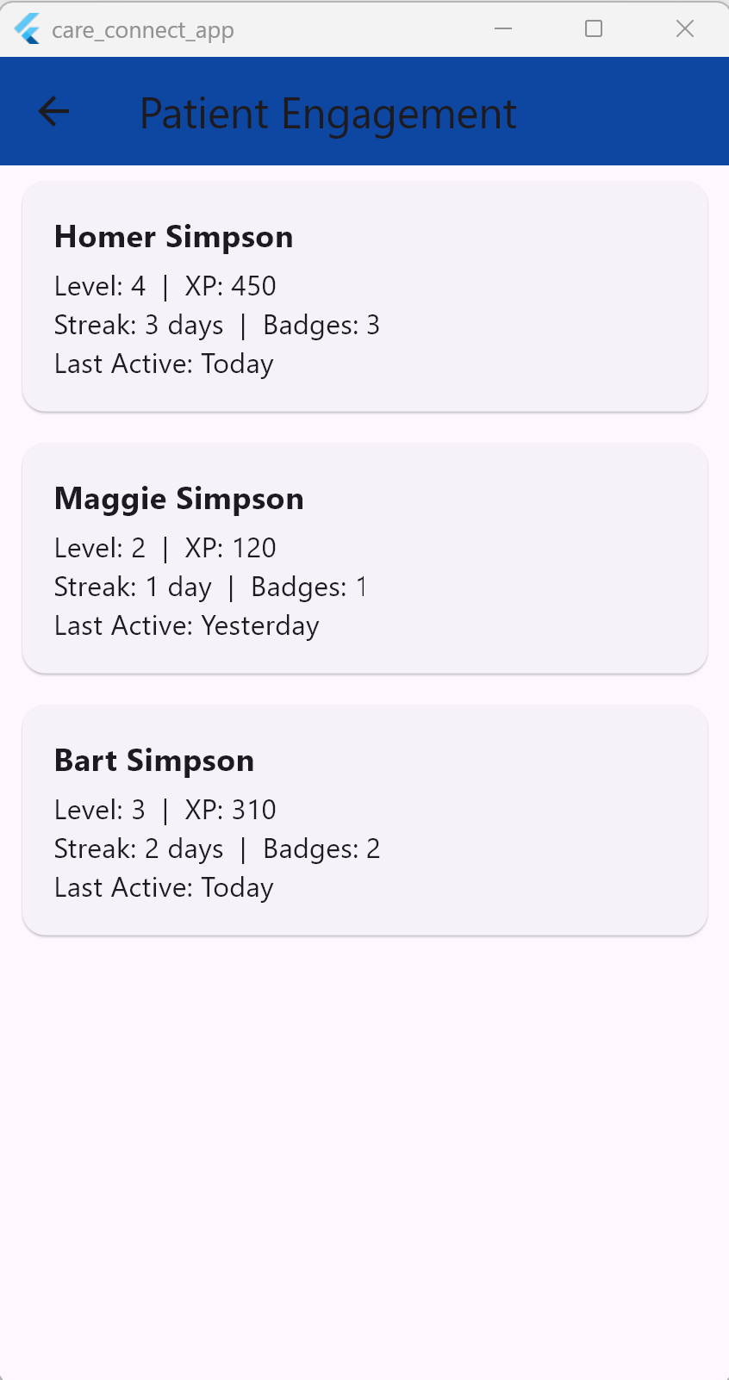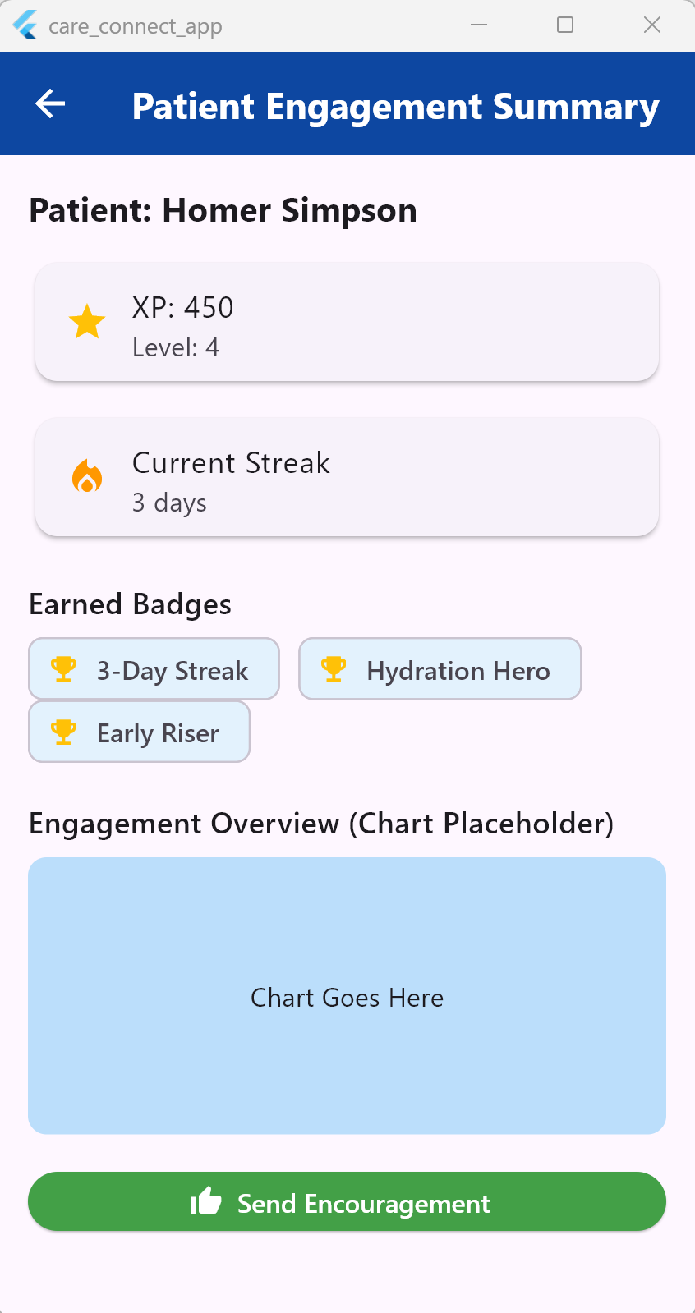

#### Internal UI Functionality

|  |  |
| --- | --- |
| **ID** | **Description** |
| IUF-WS-1 | Display random or condition-triggered motivational messages on dashboard |
| IUF-WS-2 | Show badge/streak cards inline on main dashboard for instant feedback |

#### External UI Functionality

|  |  |
| --- | --- |
| **ID** | **Description** |
| EUF-WS-1 | Pulls daily XP and streak info from backend /v1/gamification/stats |
| EUF-WS-2 | Uses conditional logic (e.g., 3-day streak) to determine message content |

## Social Networking

### Connect with other users

#### Module Description:

The Connect with Other Users module allows patients to build their support network by adding caregivers, friends, or family members. This feature encourages social accountability and emotional support through shared updates and private chat.

Users can search for others using names or emails and send connection requests. Once accepted, connected suers can view each other’s community posts and intiate chat conversations. Pending requets anad suggested connections are also displayed for ease of use.

#### Image(s):

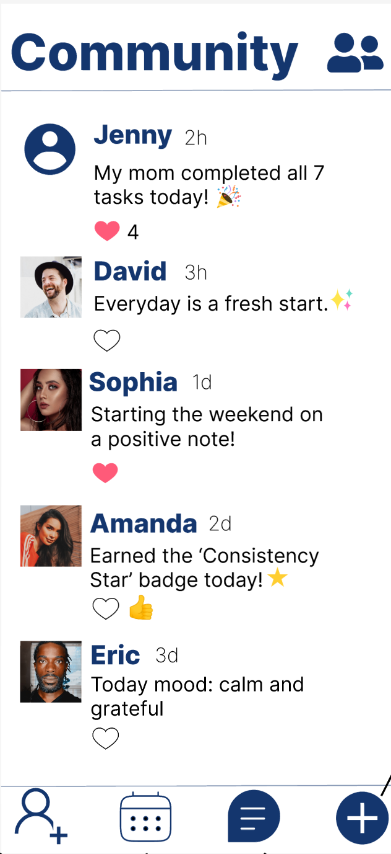 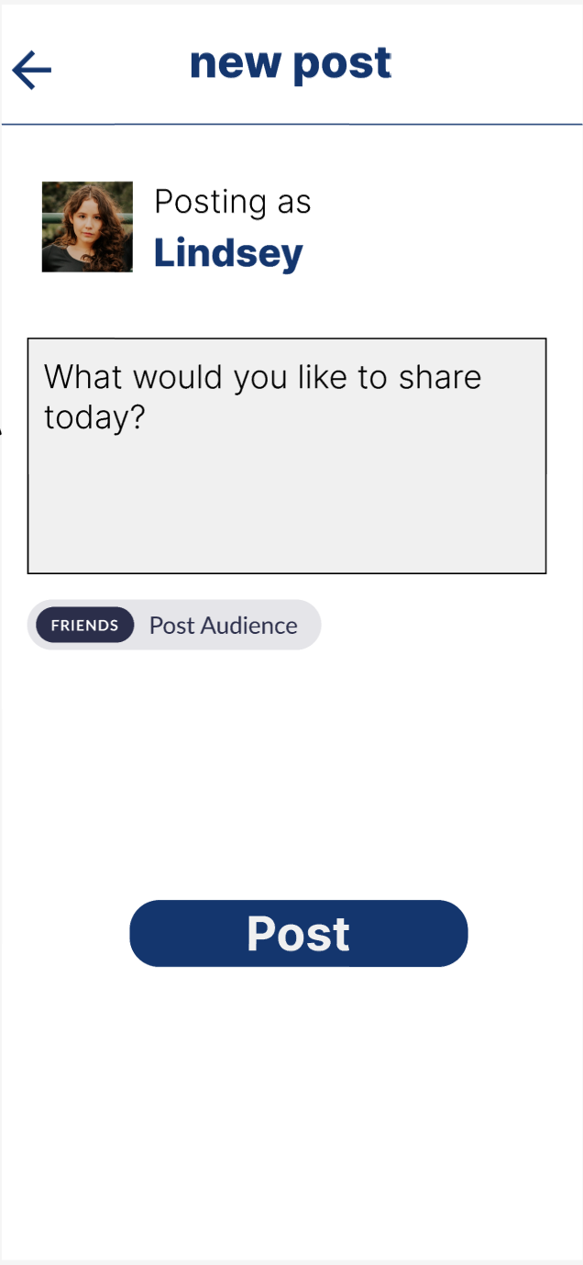 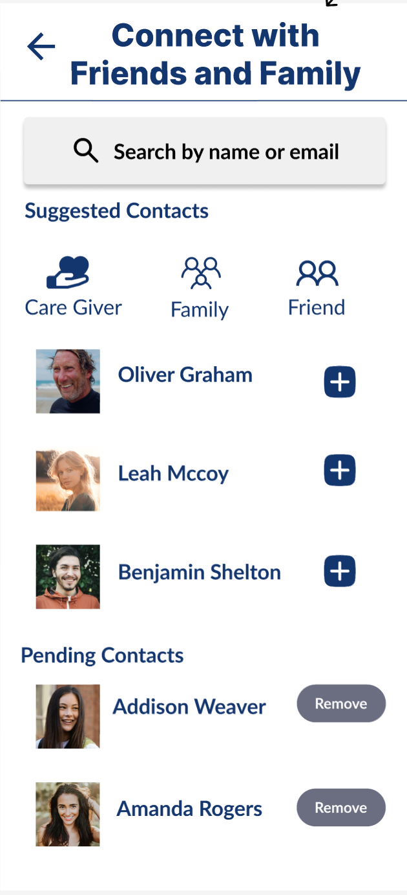

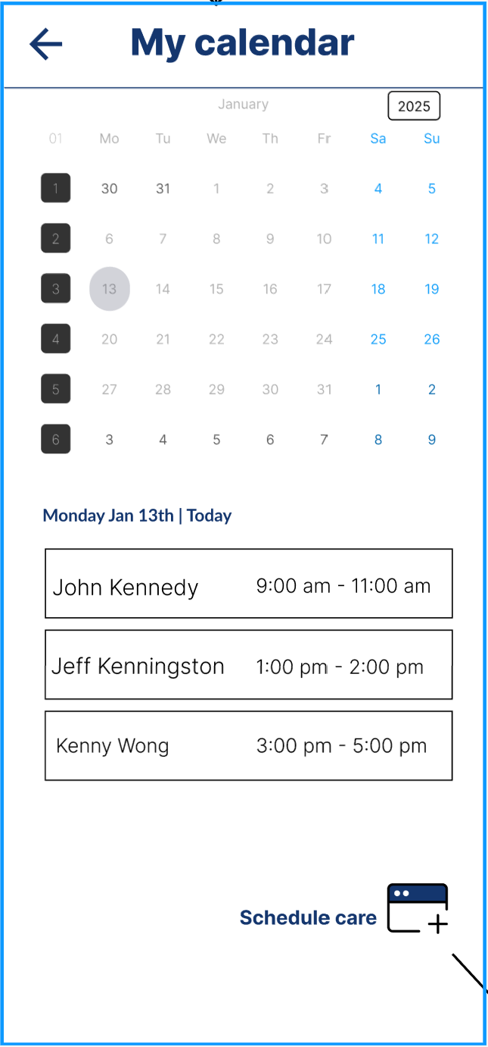 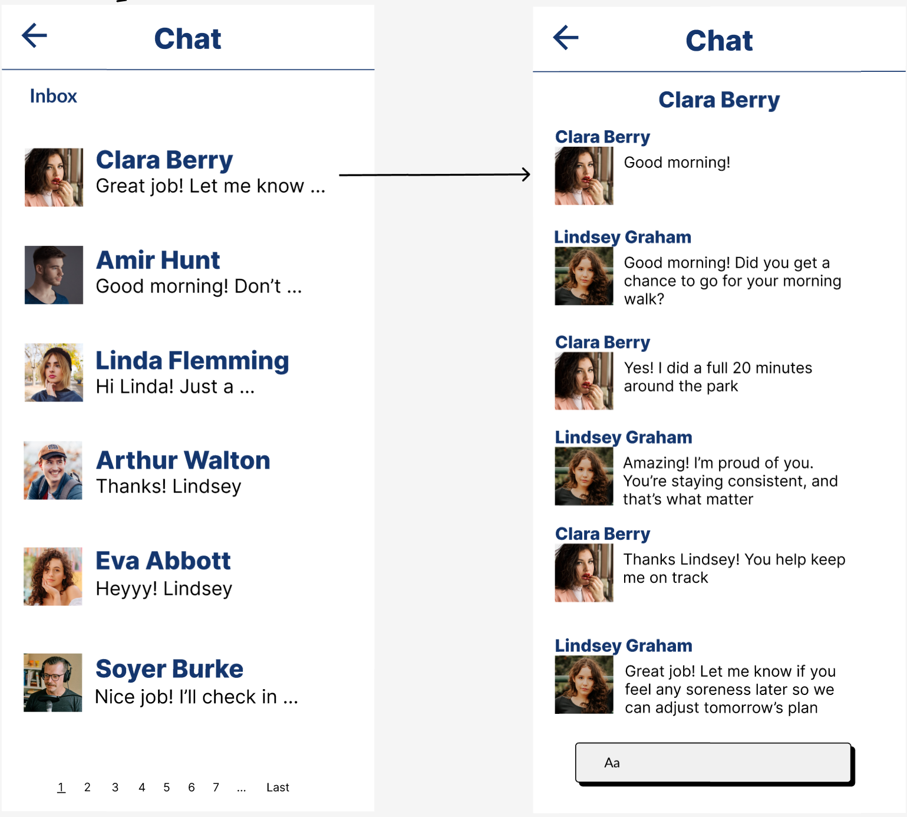

#### Internal UI Functionality

|  |  |
| --- | --- |
| **ID** | **Description** |
| IUF-WS-1 | Display list of suggested users with role filters (Caregiver, Family, Friend) |
| IUF-WS-2 | Search bar with autocomplete for anme or email |
| IUF-WS-3 | “+” button next to each suggested contact to send connection request |
| IUF-WS-4 | “Remove” button for pending connection requests |
| IUF-WS-5 | Tabs or icons that filter suggestions by relationship type |

#### External UI Functionality

|  |  |
| --- | --- |
| **ID** | **Description** |
| EUF-WS-1 | Backend call to /api/social/searchUsers?query= to populate suggestions |
| EUF-WS-2 | POST to /api/social/sendRequest when user taps “+” to connect |
| EUF-WS-3 | DELETE to /api/social/removeRequest for canceling a pending request |
| EUF-WS-4 | GET /api/social/getPendingConnections to retrieve all current pending requests |
| EUF-WS-5 | GET /api/social/suggestions to load dynamic recommendations |

### Post Updates and Interact (Community Feed)

#### Module Description:

The Community Feed allows users to share status updates, achievements, thoughts, or motivation with their network. This feature is designed to promote emotional support, social motivation, and community building within CareConnect.

Each post displays the author’s name, profile image, timestamp, message content, and interactive options such as like and react. Users can scroll through a chronological feed, like others’ posts, and view reaction counts.

This module plays a key role in fostering a sense of connection among patients and caregivers by making progress and encouragement visible.

#### Image(s);



#### External UI Functionality

|  |  |
| --- | --- |
| ID | Description |
| IUF-WS-1 | Display list of community posts in reverse chronological order |
| IUF-WS-2 | Each post includes user name, profile image, time, and text |
| IUF-WS-3 | Reaction icons (like, heart, thumbs up) below each post |
| IUF-WS-4 | Post input field with emoji picker and submit button |
| IUF-WS-5 | Real-time UI update when new post is added or liked |

#### External UI Funcitonality

|  |  |
| --- | --- |
| ID | Description |
| EUF-WS-1 | GET /api/community/posts to retrieve recent posts |
| EUF-WS-2 | POST /api/community/newPost to submit a new post |
| EUF-WS-3 | POST /api/community/react with post ID and reaction type |
| EUF-WS-4 | GET /api/community/reaction?postId= to fetch reaction counts |
| EUF-WS-5 | WebSocket/real-time notification support for new post alerts (optional) |

### Chat with Connected Users

#### Module Description:

The Chat Module enables direct 1-on-1 communication between connected users (e.g., patients and caregivers). This allows for timely check-ins, support messages, and scheduling coordination. The chat interface displays a contact list, message history, typing indicators, timestamps, and message delivery status.

This module helps reinforce relational care by enabling consistent communication outside of appointments and structured tasks.

#### Image(s):



#### Internal UI Functionality

|  |  |
| --- | --- |
| ID | Description |
| IUF-WS-1 | Display list of connected users (contacts) in sidebar or top tab |
| IUF-WS-2 | Tapping on a contact opens chat history view |
| IUF-WS-3 | Input field for typing and sending messages |
| IUF-WS-4 | Timestamp and alignment based on sender/receiver |
| IUF-WS-5 | Typing indicator UI (optional) |
| IUF-WS-6 | Scrollable message history with infinite scroll (pagination support) |

#### External UI Functionality

|  |  |
| --- | --- |
| ID | Description |
| EUF-WS-1 | GET /api/chat/conversations?userId= to retrieve list of connected users |
| EUF-WS-2 | GET /api/chat/messages?conversationId= to retrieve message history |
| EUF-WS-3 | POST /api/chat/sendMessage send new message with message content and receiver ID |
| EUF-WS-4 | GET /api/communication/unread – Retrieve count of unread messages |
| EUF-WS-5 | Future: GET /api/communication/status – Poll for live status (e.g., “online”, “typing”) |
| EUF-WS-6 | Requests routed securely through Application Load Balancer, Communication Service inside Private Subnet B |

## Analytics & Reporting

### Dashboard metrics

#### Module Description:

#### Image(s):

#### Internal UI Functionality

|  |  |
| --- | --- |
| **ID** | **Description** |
| IUF-WS-1 |  |

#### External UI Functionality

|  |  |
| --- | --- |
| **ID** | **Description** |
| EUF-WS-1 |  |

### Report Exports

#### Module Description:

#### Image(s):

#### Internal UI Functionality

|  |  |
| --- | --- |
| **ID** | **Description** |
| IUF-WS-1 |  |

#### External UI Functionality

|  |  |
| --- | --- |
| **ID** | **Description** |
| EUF-WS-1 |  |

### Real-time vs. Batching

#### Module Description:

#### Image(s):

#### Internal UI Functionality

|  |  |
| --- | --- |
| **ID** | **Description** |
| IUF-WS-1 |  |

#### External UI Functionality

|  |  |
| --- | --- |
| **ID** | **Description** |
| EUF-WS-1 |  |

# Security Considerations

The following section discusses the various security considerations that will be taken while developing the CareConnect application. This section was made with reference from OpenAI (OpenAI, 2025).

### Data Privacy & HIPAA Compliance

Ensure all Protected Health Information (PHI) is encrypted at rest and in transit (e.g., AES-256, TLS 1.2+).

Confirm the use of role-based access control (RBAC) to limit PHI access to authorized users only.

Validate audit logs are generated for access to PHI and other sensitive user actions (e.g., login, data view/edit/delete).

Conduct PHI minimization checks—ensure only necessary health information is collected and processed.

### Authentication & Authorization

Test for multi-factor authentication (MFA) support for users, especially administrators and caregivers.

Validate strong password policies (length, complexity, expiration, etc.).

Verify secure session management (e.g., session timeouts, secure cookies, refresh token expiry).

Ensure OAuth 2.0/OpenID Connect flows (if used) are implemented securely.

### Secure Data Transmission

Confirm TLS/SSL is enforced on all web and API endpoints.

Test for man-in-the-middle (MITM) resistance via certificate pinning (especially for mobile clients).

Ensure sensitive data is never transmitted over unencrypted channels (e.g., avoid HTTP for login or API).

### API Security

Verify authentication/authorization is enforced on all API endpoints.

Check for rate limiting and throttling to protect against brute-force or DDoS attacks.

Conduct input validation and protection against common vulnerabilities (e.g., SQL injection, XSS, CSRF, JSON injection).

Test for insecure direct object references (IDOR).

### Data Storage & Backup

Ensure PHI is encrypted in storage (e.g., mobile local storage, cloud DBs, backups).

Verify data retention policies comply with HIPAA and that data is deleted securely when no longer needed.

Confirm automatic secure backup strategies are in place and tested for disaster recovery.

### Mobile Application Security

Ensure the app prevents screen recording or captures of PHI on sensitive screens (where applicable).

Test for secure handling of push notifications (avoid sending PHI in notifications).

Use secure storage solutions (e.g., Keychain, Keystore) for tokens, credentials.

Conduct static and dynamic analysis of mobile apps for vulnerabilities.

### AI-Powered Features

Validate AI components do not process or expose PHI unless strictly required.

Test AI assistance interactions for data leakage, inference attacks, or inappropriate content generation.

Ensure AI models respect data minimization and are hosted securely.

### Emergency Response Features

Test for real-time reliability and secure handling of emergency signals/data.

Confirm data shared with third parties during emergencies complies with minimum necessary HIPAA principle.

### Subscription Billing Security

API endpoint: POST /v1/subscriptions

This endpoint is used when a caregiver subscribes to CareConnect’s paid service. It initiates the billing process and stores their subscription status.

Payload: { token: 'stripe_token' }

These are the steps:

1. Verify Stripe token

2. Create subscription record in DB

3. Charge using Stripe API

4. Return status: ACTIVE or FAILED

Retry on failure: exponential backoff (1h, 4h, 24h), fallback to PayPal if available.

Subscription statuses: ACTIVE, SUSPENDED, GRACE_PERIOD Log audit events for payment attempts and status changes.

### Security Testing & Monitoring

Conduct regular penetration testing and vulnerability scanning.

Integrate Static Application Security Testing (SAST) and Dynamic Application Security Testing (DAST) tools.

Monitor system logs for anomalous activity and set up intrusion detection systems (IDS).

# Error Handling

System-wide error handling must ensure resilience, transparency, and user guidance across both client and server layers. On the client side, Flutter applications should display contextual, user-friendly error dialogs (e.g., “Service unavailable, please try again”) while gracefully handling known failure states without crashing. On the server side, microservices should implement retry strategies—such as exponential backoff—for transient errors, and circuit breakers to prevent cascading failures. All critical errors and failed requests should be logged centrally via AWS CloudWatch, tagged with request IDs and user context for traceability. For users, the system should provide clear recovery paths, such as retry options, offline modes (where applicable), and visual cues for degraded functionality. Additionally, certain high-priority issues may trigger in-app notifications or alerts to inform users of ongoing disruptions and next steps (OpenAI, 2025).

# Performance & Scalability

### Objectives

This section defines the key goals and non-functional requirements related to system performance and scalability. We aim the application to:

* Maintain low latency (< 300 ms) for API responses under expected load.
* Support a growing user base—from pilots to enterprise-scale—through scalable architecture.
* Ensure system availability during peak usage
* Enable proactive identification of performance issues before they impact users.

### Key Metrics

|  |  |
| --- | --- |
| **Metric** | **Target** |
| API response time | < 300 ms (median), < 500 ms (95th percentile) |
| Resource utilization | CPU < 70%, Memory < 75% |
| Auto-scaling trigger | Scale-out at > 70% CPU usage |
| Error rate | < 1% failed requests |

These metrics provide benchmarks for performance testing, capacity planning, and real-time monitoring.

### Scalability Strategy

#### Horizontal Scaling

* **Event‑based and Serverless workflows**: We use AWS Lambda for short-lived tasks enabling scale-to-zero and cost-efficiency.

#### Load Balancing and Throttling

* **AWS API Gateway:** distributes incoming requests evenly across service instances.
* **Auto-scaling policies:** increase container instances when CPU usage exceeds threshold and decrease when usage falls.

### Monitoring and Capacity Management

* **Real-time monitoring**: Use CloudWatch to track metrics such as latency, throughput, system utilization, and cache hit rates.
* **Alerting**: Define alarms if any key metrics cross thresholds
* **Capacity planning**: Monitor trends over time to anticipate scaling needs and add capacity early when growth trends are identified.

### Bottleneck Mitigation

Identified performance bottlenecks will be addressed as follows:

|  |  |
| --- | --- |
| **Bottleneck** | **Mitigation Strategy** |
| High CPU usage | Add containers  optimize code  tune JVM/compile settings |
| Slow database queries | Add appropriate indexes  introduce read replicas |
| Network latency between services | Move to same VPC  adjust task placement |

### Review Cadence

* **Pre-release testing**: Perform full test suite before each major release.
* **Post-deployment audits**: Weekly metric reviews for latency/throughput.
* **Post-mortems**: After any performance incident, document root cause and update capacity triggers or architecture.

# Testing Strategy

|  |  |
| --- | --- |
| Strategy | Description |
| Perform Testing on different level | * Unit Testing * Integration Testing * System Testing * Regression Testing |
| Perform different types of Testing | * Functional testing (Patient Dashboard, Notification, SOS) * API Testing(Test REST API using Swagger/Postman) * UI Testing(Check layout) * Security Testing(Focus on HIPAA/GDPR) |
| Use Proper test Tools | * Mobile/UI Testing: Flutter Driver * API Testing: Postman/Swagger * Automation/CI: Code Magic * Bug Tracking: GitHub |
| Have proper Entry/Exit Criteria | * All developed functionalities will have proper Entry/Exit Criteria * All test cases should be executed |

# Deployment Strategy

Our deployment strategy can be initiated after approval from our leaders, one approval as now from the manager or technical lead will be enough. Below is a more detailed process on the CI/CD part.

## Deployment preparation

To be able to automate our deployment processes and make it secure, we will be storing secrets on the platforms we are going to use. That means we will store secrets AWS, Code Magic on Github environment variables. On our CodeMagic environment, we will store a set of secrets from platforms like Google Play Store, Apple Store that will allow us to push our app versions.

## CI/CD Flows

### Backend

Github Actions will automate the creation of releases for our code on certain events on the code based and execute all the steps.

Terraform is executed as part of the same pipeline, ensuring that infrastructure (Lambda, API Gateway, Database, IAM roles, etc.) is always in sync with the application code.

**Trigger**: A push on the *backend* folder inside of CareConnect code base.

**Tools**: Github (Actions), Terraform, AWS

**Steps**:

* On Github Actions (Workflows)
  + - 1. Checkout Code
      2. Run Tests & Build artifact (a zip file)
      3. Build & upload the zip to S3
      4. A set of EventBridge rules and Step Function will:

1. Deploy to AWS Lambda
2. Publish new version
3. Update the API Gateway integration
4. Notify Team

### Frontend

Github Actions will automate the creation of releases for our code on certain events on the code based on a folder.

#### Web Version

**Trigger**: A push on the *frontend* folder inside of CareConnect code base.

**Tools**: Github (Actions), Terraform, AWS (Amplify)

**Steps**:

* On Github Actions (Workflows)

1. Terraform apply to provision/update Amplify Hosting
2. Flutter build and deploy to Amplify

#### Mobile Versions

**Trigger**: A push on the *frontend* folder inside of CareConnect code base.

**Tools**: CodeMagic, Apple Store, Play Store

**Steps**:

* On CodeMagic

1. Run tests
2. Build APK/IPA

3. Distribute to stores

# Known Issues & Limitations

There are currently no known issues or limitations identified for the MVP release of CareConnect.